USER MANUAL:
Advanced Autonomous MUltiple Spacecraft Testbed (ADAMUS)

Contact Information
Office: Mechanical and Aerospace Engineering Building A, Room 308 (352-392-6230)
Lab: Mechanical and Aerospace Engineering Building A, Room 211

University of Florida,
Gainesville, FL 32608
Contents
Revision History vi
Table of Figures vii
Table of Tables vii
Hardware Overview 1
Attitude Stage 3
Translation Stage 9
Counterbalancing System 12
Software Overview 14
Desktop Computers 14
Europa Specs: 15
Callisto Specs: 15
PC104 Computers 15
Demos 16
Open Loop 17
Lyapunov 3DOF Rotation 17
Lyapunov FuelLim 5DOF 18
Lyapunov FuelLim 6DOF 18
Shutdown Procedure 20
Common Tasks 21
Filling the Tanks 21
Removing the Attitude Stage 22
Placing the Attitude Stage on the Translational Stage 23
Creating and Compiling Software using Simulink and RTAI 24
Move Files to and from PC104 25
Balancing the attitude stage 25
Running the RTAI complied code 26
Running an Experiment – 5DOF 26
Running an Experiment – 6DOF 27
Updating a Library Block 29
Adding a New Demo 29
Adding a New Library Block 29
PhaseSpace Alignment – ADAMUS Style 30
PhaseSpace Rigid Body Capture 35
Connecting to Arduino Uno 35
Maintenance 36
Cleaning the feet (often) 36
Cleaning the pulley bushings 36
Cleaning the bushings 36
Cleaning the vertical guides (often) 40
Replacing the tanks 40
Suspending the testbed 40
Replacing the filling hardware 42
Knicks in the epoxy floor 42
The ADAMUS Simulink Toolbox 43
Actuators 43
Motion Control System 43
Relay Board 43
Controllers 44
LQRY Solution 44
Lyapunov Controller 44
Non-Linear Quaternion Feedback 45
FileIO 45
Read Vector From File 45
ToFile 46
Image Processing 46
Firewire Frame Grabber 46
Image Processor 46
Observers 47
State Estimator 47
Sensors 48
DAQ 48
KVH DSP-300 FOG 48
KVH DSP-300 FOG 1 48
Metris iGPS Position Measurement 48
Ocean Server Battery Controller 48
PNI Micro-Mag 3-axis Magnetometer 48
PhaseSpace 48
Simulators 49
6-DoF Rigid Body Satellite Dynamics 49
Linear Reference Model 49
Orbital Perturbations 49
Sensor Package 49
Transformations 50
PreventJumps 50
reorderQ_0to4, reorderQ_4to0 51
quaternion to modified Rodrigues parameters 51
UDP Comms 51
Byte Pack, Byte Unpack 51
Linux & Win32 UDP Receive Binary, Linux & Win 32 UDP Send Binary 51
clock signal 51
The ADAMUS Code Library 51
Scripts 51
stateTransitionGen.m 51
headerTemplate.m 51
InitializeControl.m 51
InitializeDynamics.m 51
Functions 52
plotData 52
plotDataFrom 52
plotRobot3D 53
Models 53
Linux_Control.mdl 53
PC104_Control_new.mdl 53
PC104_Control_paper.mdl 54
Unlinked_PhaseSpace.mdl 54
S-functions (non-library) 54
sfun_PhaseSpaceAll.c 54
sfun_readAnalogPin.c 54
Troubleshooting 55
ssh to pc104 does not work 55
Desktop computer cannot connect to the ADAMUS server 55
PC104 will not turn on/show a magenta LED 55
The puck has a solid green light – won’t transmit data 56
Many errors similar to mxCalloc when compiling 56
Connecting the PC104 to a monitor and keyboard 56
The handle fell off of the fill nozzle! D: 56
Sfunction using shared library mex’s but gives linker errors when compiling 57
The quaternion data is corrupted – Sign flipping Issue 57
Program Aborted prematurely in Labview 57
Known Issues 58
Reading pdfs from Firefox can crash the desktop computer 58
Only one battery of the two on the AS actually works 58
Vertical guides are warped 58
Thrusters 8 & 9, 11 & 12 are swapped 58
Thrusters 3, 4 and 6 are not working 58
Notes for the Future 58
Contacts and Support 59
APPENDIX A – Setting up the desktop computer 1
APPENDIX B – Setting up PC104 1
APPENDIX C – Setting up Arduino Uno 1

Revision History
Date | Version | Description | Author
1/2011 | 0.1 | Compatible PC104 Setup Instructions Written | Chris Shake
2/15/2011 | 0.2 | Updated Configuration of RTAI 3.7 with Ubuntu 9.04 and Compatible PC104 setup Instructions | Kelsey Saulnier
5/8/2012 | 1.0 | Initial Draft | Dr. Riccardo Bevilacqua
1/15/2013 | 2.0 | Reorganized Draft | Dave Guglielmo
3/19/2013 | 2.1 | Edit: Reorganized Draft | Kelsey Saulnier
11/20/2013 | 3.0 | Beginning Again | Kelsey Saulnier
12/1412015 | 3.1 | Updates after system moved to UF | Sanny Omar

Table of Figures
Figure 1: ADAMUS Robot 2
Figure 2: Spherical Bearing 3
Figure 3: Attitude Stage (AS) with parts 1-16 labeled. 4
Figure 4: Attitude Stage Pneumatics 6
Figure 5: Attitude Stage Electrical 7
Figure 6. Charging port and power button for AS 8
Figure 7. Balancing Platform on Attitude Stage 9
Figure 8: Translation Stage 10
Figure 9: Translation Stage Pneumatics 11
Figure 10: Counterbalancing System 12
Figure 11: Counterbalancing Deck 13
Figure 12: Counterbalancing Deck Electrical 14
Figure 13: Puck Connector 16
Figure 14: Electronics ON/OFF Switch 16
Figure 15: (Left) 6V Battery Plastic Connectors. (Right) Relay Circuit Power Shown Disconnected. Connect Red Wire in Hole Farthest from Ground Connection to Supply Power. 19
Figure 16: The Arduino Reset Button. 19
Figure 17. Air Input Ports for AS, TS, and CB 22
Figure 18: Attitude Stage on Stand 23
Figure 19: Counterbalancing Deck Tie Down 27
Figure 20: (Left) 6V Battery Plastic Connectors. (Right) Relay Circuit Power Shown Disconnected. Connect Red Wire in Hole Farthest from Ground Connection to Supply Power. 28
Figure 21: The Arduino Reset Button. 28
Figure 22: The Alignment Object. 30
Figure 23: Air tubing plug. 37
Figure 24: Pulley circle, with its air system detached, being lifted off the vertical gudes. 38
Figure 25: Lifting the central column and CD off of the vertical guides. 38
Figure 26: Removing bushings from their casings. (Left) Removing bushings from central column. (Right) removing bushings from CD. 39
Figure 27: Using a vertical guiding shaft and Swiffer pad to remove the CD bushings. 39
Figure 28: Location of Zip Tie for Hanging Stages 41
Figure 29: Counterbalancing and Translation Stages Docking System 42
Figure 30: plotRobot3D outputs 3D cube graphs of the robot experiment. They can be rotated to also give 2D views. 53
Figure 31: Power connection to the PC104. 56
Figure 32: Broken fill handle. The picture shows the order the parts need to go back together. 57

Table of Tables
Table 1: Attitude Stage Components 4
Table 2: Translational Stage Components 10
Table 3: Counterbalancing Deck Components 13

Hardware Overview

The hardware at the ADAMUS lab consists of a 6-DOF spacecraft GNC test bed. The test bed operates using air bearings to minimize friction and using a counter-balance system to provide a simulated zero-g environment for the spacecraft test bed.
The test bed consists of two main components. The first is the attitude state (AS) which represents the spacecraft and contains 12 cold gas thrusters, a mass balancing system, and the onboard computer. The second is the translational stage (TS) which facilitates the minimal friction planar motion and provides the simulated zero-g environment for the AS. The two stages are connected via a spherical air bearing which allows the AS limited 3-DOF of rotation. The 3-DOF of translational motion are provided by three linear air pads which allow the TS to glide across an epoxy floor and by the counterbalance system which operates using air bearing pulleys to provide the vertical DOF.
All motion of the test bed is provided by the 12 cold gas thrusters on the AS which are in turn controlled by the onboard computer via a peripheral I/O board and relay board. Figure 1 shows the test bed with the two stages connected. Information about the position and attitude of the AS is collected using a PhaseSpace Impulse System (PhaseSpace system). The PhaseSpace system operates using an array of cameras situated around the testbed floor which read the position of LEDs fixed to the AS. Based on the position of each LED, the PhaseSpace system calculates the position and attitude of the body frame (located at the center of mass of the AS) and streams the information to the on-board computer over WiFi.
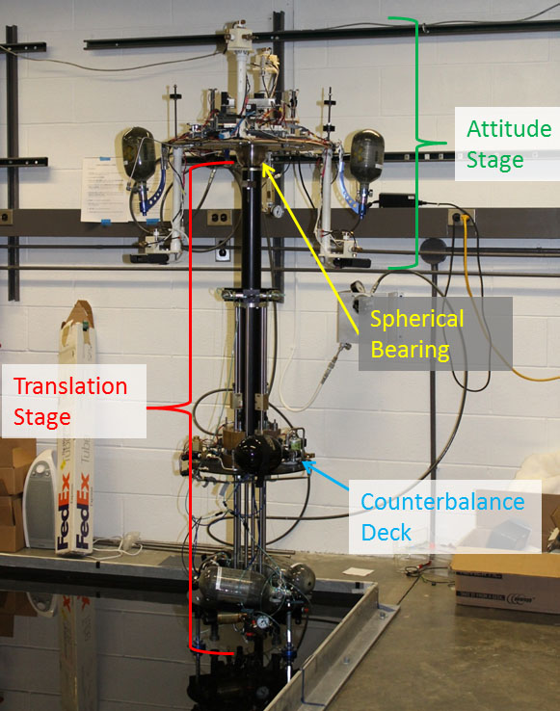
Figure 1: ADAMUS Robot
On the translation stage, counterbalance deck (which can be seen above the bottom platform in Figure 1) is used to counterbalance the mass of the AS and supporting column. To effectively simulate a zero-gravity environment, the central platform must be the same weight as the AS. For preliminary balancing, stationary weights are added to the central platform until the two platforms weight roughly the same amount. This is not enough however because as the thrusters are used on the AS to control the motion of the test bed, the air tanks deplete which changes the mass of the AS. This change in mass has been measured to be 300g. To compensate for the change of mass of the AS, two air tanks matching those that provide the thruster fuel are on the counterbalance deck. On the AS, the on-board computer can read the pressure of the thruster tanks and wirelessly relay that information to an Arduino Uno and WiFly expansion board located on the counterbalance deck. The Arduino then reads the pressure from the tanks on the counterbalance deck and air is released from these tanks to ensure that the pressure of the counterbalance deck tanks matches the pressure of the AS tanks. The Arduino controls the tank pressures by utilizing a relay to activate magnetic latching valves that release air from the tanks. The relay also shields the Arduino from voltage spikes from the latching valve solenoid. The Arduino, relay circuit, and pressure transmitter are powered by a 9V battery while the magnetic latching valve has its own 6V power source and is activated by the relay circuit. A diagram of this circuit can be seen in Figure 5.

Attitude Stage

The AS represents a satellite and provides the three rotational degrees of freedom of the testbed. The rotational degrees of freedom are provided by a spherical air bearing, shown in Figures 1 and 2, which serves to connect the AS to the TS central column. The major pneumatic and electrical components of the AS are listed in Table 1.

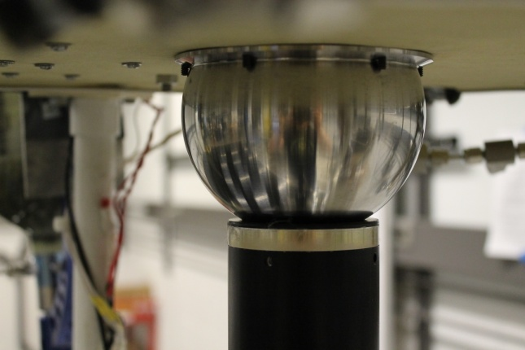
Figure 2: Spherical Bearing

The AS is composed of a disc made of composite material (fiber glass and high density foam) connected to the spherical air bearing. The air bearing floats on a cushion of air released by the TS column, enabling the AS to rotate in a nearly torque free environment (assuming it was balanced correctly). Attached to the AS are four arms made of ABS and PVC. Two arms extend upwards and the other two arms extend downwards. The arms are attached symmetrically to the disc to facilitate mass balancing and to provide a symmetric thruster layout. There are three thrusters mounted orthogonally on the end of each arm. Using a unique combination of active thrusters it is possible to obtain independent translational and/or rotational motions. The AS provides full 360° freedom in yaw but the structure limits it to ±30 about the pitch and roll axes. Figure 3 lists all the parts that make up the attitude stage.
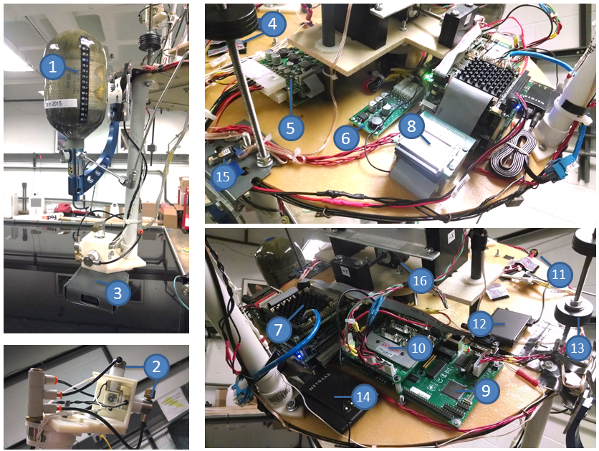
Figure 3: Attitude Stage (AS) with parts 1-16 labeled.

Table 1: Attitude Stage Components
# | Component Name | Part Number | Manufacturer
 | Platform | Custom | RPI
 | Spherical Bearing | Custom | D&K
 | Regulator | 1247-2 | Aqua Environment
 | Pressure Sensor | A-10 | WIKA
1 | 4000 psi, 50cu, Paintball Air tanks | P07B-001 | Luxfer
2 | Solenoid Valves (x12) | EH2012 | Gems Sensors
2 | Thrusters (x12) | 12-056 | Gordon Engineering
3 | Battery Pack x2 | BA95HC-FL(discontinued?) | OceanServer
4 | Power Button | ADLS15PC – cable kit | ADL Embedded Solutions
5 top | Battery Management Module | BB-04SR | OceanServer
5 bottom | DC-ATX Converter | DC123SR | OceanServer
6 | DC-DC Step-Up Converter | DC1U-1VR | OceanServer
7 top | PC104 Computer | ADLS15PC | ADL Embedded Solutions
7 middle | PC104 I/O Board | DMM-32DX-AT | Diamond Systems
7 bottom | PC104 Relay Board | IR-104 | Diamond Systems
8 | PC104 Compact Flash Memory | Extreme, 16 GB, 60MB/s, UDMA | SanDisk
9 | Motion Control Card | DCM-2133 | Galil Motion Control
10 | Motor Driver Board | SDM-20242 | Galil Motion Control
11 | Battery Charging Input | 19-00003-12 C01 | OceanServer
12 | PhaseSpace Puck |  | PhaseSpace
13 | Balancing Washers | 92140A114 | McMaster
14 | Wireless Receiver | WNCE2001 | Netgear
15 | PhaseSpace LEDs |  | PhaseSpace
16 | Balancing Motors | 35F4N-2.33-024 | Haydon Kerk
16 | Balancing Platform Motors | 35H4N-2.33-049 | Haydon Kerk

The pneumatic system of the AS, diagramed in Figure 4, is used to supply air to the thrusters which control the motion of the testbed. Thruster fuel in the form of compressed air is stored in two carbon fiber paintball tanks attached to the AS. The tanks are connected in parallel to a regulator, which steps the pressure down to 165 psi before it is distributed to the thrusters. The thrusters consist of solenoid valves attached to custom made nozzles. Over the course of an experiment, mass is lost from the tanks as air is released from the thrusters. By connecting the tanks in parallel and by aligning the center of mass of the tanks with the center of mass of the AS, the change in mass does not affect the overall balance of the AS. A pressure transmitter is connected before the regulator to allow the PC104 to measure the pressure left in the tanks. The pressure readings are used in the counterbalancing system.

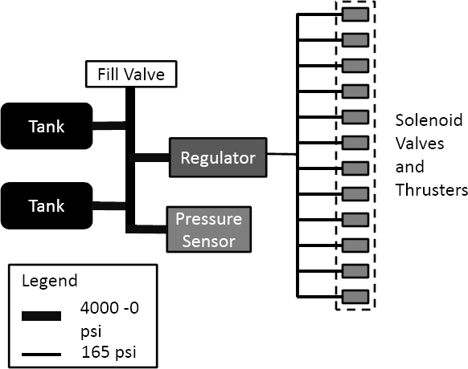
Figure 4: Attitude Stage Pneumatics

The flat disk of the AS also supports some components of the PhaseSpace System, the on-board computer, wireless receiver, and a balancing system. A diagram detailing the AS electrical system and its connections to the other systems in the testbed is provided in Figure 5. The on-board portion of the PhaseSpace system consists of a string of 6 LEDs and device called a "puck." The puck controls the power to the LEDs, which are necessary for the PhaseSpace System to determine the state of the AS. The PhaseSpace LEDs are positioned on the edges of the arms and on the middle of the upper platform. PhaseSpace cameras that are mounted around the testing area track the position of these LEDs and relay that information to the phasespace server. The phasespace server then determines the position and orientation of the attitude stage based on the LED positions and transmits this information over the ADAMUS lab network. The computer on the AS (PC104) receives this information and uses it to control the system to achieve a desired final position and orientation. The phasespace puck must be calibrated to the LEDs on the AS and must be in contact with the PhaseSpace server prior to running any closed loop experiments. See the PhaseSpace manual for more information on how to calibrate the puck and track LEDs.
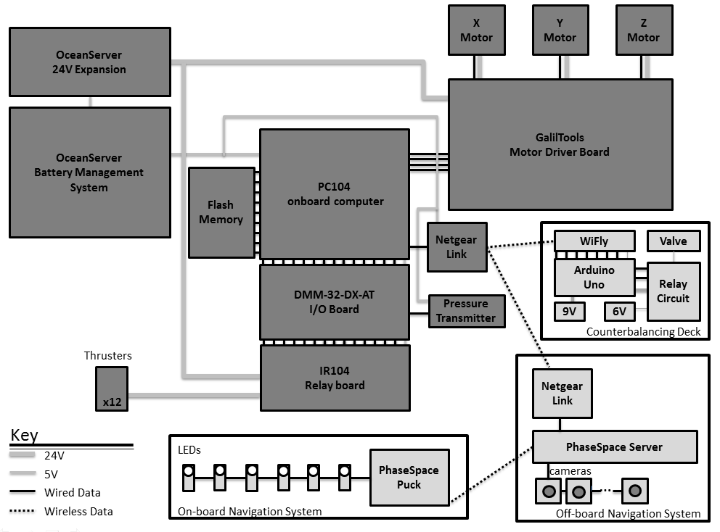
Figure 5: Attitude Stage Electrical

Central to the electrical system on the AS is an Advanced Digital Logic ADLS15PC Rev. 1.3 computer (PC104), which runs Real-Time Application Interface (RTAI) Linux. The PC104 in turn is connected to an I/O board and a relay board, which allow it to obtain pressure readings from the tanks and to control the thruster valves according to the current GNC algorithm. The PC104 is also able to control a motor driver and motor controller card, which are used in the balancing system of the AS. The PC104 is wireless connected to a Netgear wireless transceiver and is controlled remotely from an off-board desktop computer using SSH (secure shell). The same receiver is then used during experiments to communicate with both the off-board components of the PhaseSpace System and the Arduino Uno on the CD.
All of the AS electical subsystems, except the PhaseSpace puck and LEDs, rely on 2 lithium-ion batteries for power. The batteries are situated on the lower arms to help compensate for the mass of the systems above the disk. These batteries are connected to a Power Management System from Ocean Server Technology (IBPS: Intelligent Battery and Power System). The IBPS recharges the batteries when connected to the 120V grid using a safety charging circuit, and provides power to the AS subsystems at several voltages. The IBPS provides 5V power to the PC104 and 12V power to a separate 12V to 24V DC-DC converter. The IBPS also provides power to the motor driver and motor controller card. The 12V to 24V DC-DC converter outputs 24V to the thrusters through the relay board controlled by the PC104. The power system can be charged using a standard laptop charger with the correct barrel jack size (5.5 mm outer diameter). Currently, a 90 Watt universal power adapter with a 19.5 V voltage output and 5.5 mm barrel jack is being used. The system can be turned on by pressing the power button once. Press and hold the power button to turn the system off. The LED on the PC104 will be bright green if the PC104 is on and functioning.
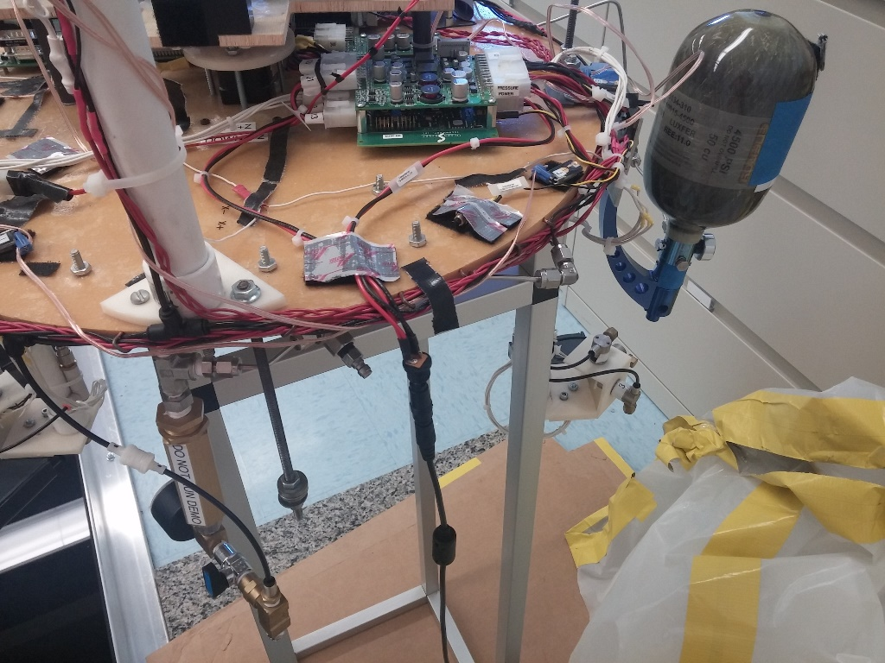
Figure 6. Charging port and power button for AS
An important consideration when dealing with rotational testbeds is that the center of mass and center of rotation must be co-located to eliminate gravitational torques. The center of rotation of the AS is located in the center of the spherical air bearing that connects it to the TS. Rough balancing is performed with static weights placed in four locations around the AS platform, as shown in Figure 3. Although the AS can be completely balanced using the static weights, the movement of small masses, such as wires and the small changes of position of parts, which are removed for charging and repairs can shift the center of mass between experiments. To deal with small misalignment in the center of mass and center of rotation, a fine active mass balancing system called the balancing platform (BP) is also present on the AS. The BP consists of three linear motors, which translate along the three body axes, shown in Figure 8(b). The motor's translation causes a shift in the center of mass of the AS. Current balancing techniques are human-in-the-loop with the motors controlled via a motor driver board with a serial connection to the onboard computer. Before each experiment, the masses are moved incrementally until the AS does not move when placed in several angled configurations. Since the balancing is done human-in-the-loop, this does not remove all disturbances from gravity torques; it serves to reduce the effects to a disturbance easily overcome by the thrusters. Controlling the alignment electronically also opens the door to alignment using adaptive methods. When implemented, automatic methods will provide a more finely and consistently balanced AS.
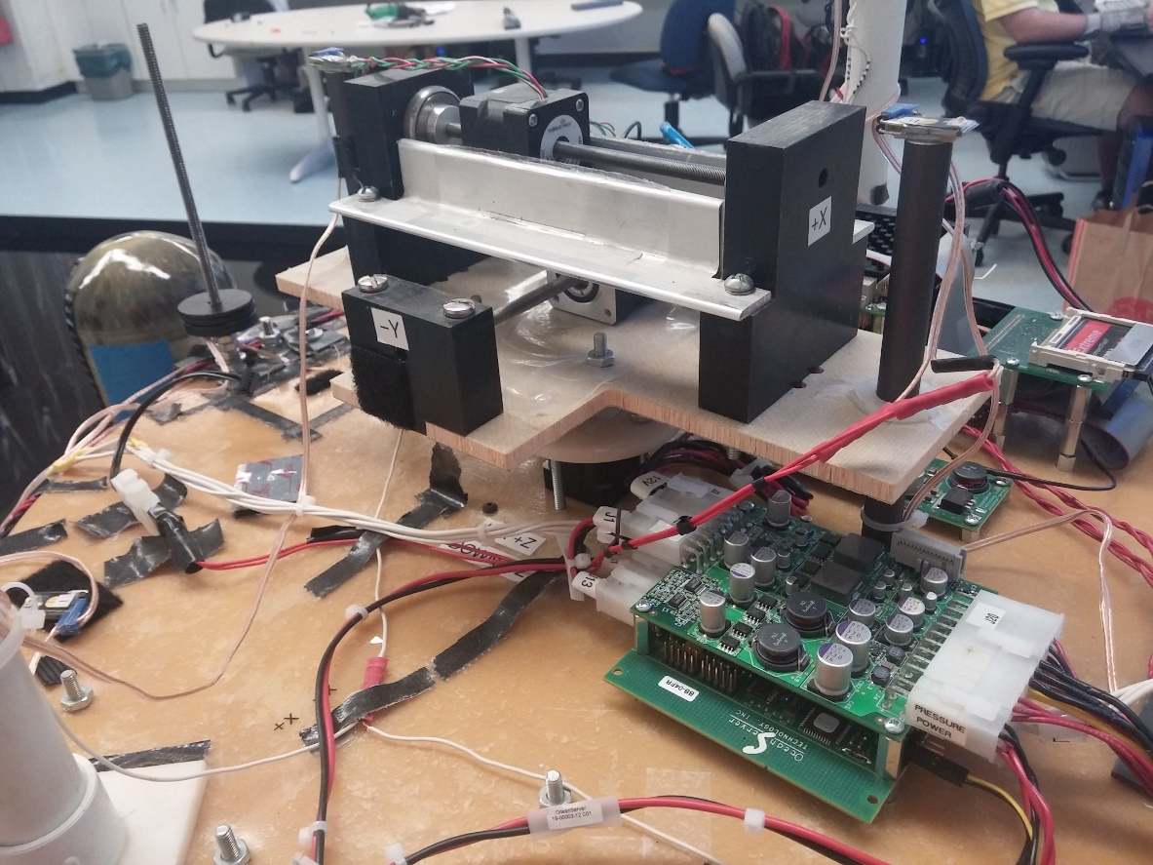
Figure 7. Balancing Platform on Attitude Stage

Translation Stage
The function of the TS, as indicated by its name, is to provide the 3 translational degrees of freedom. The two horizontal degrees of freedom are provided by linear air bearings, which create an air cushion to separate the structure from the epoxy floor, allowing for nearly friction free motion. Hanging on the structure of the TS is the counterbalancing system that provides the third translational degree of freedom. This system will be further detailed in the next section.
The main structure of the TS was custom built by Guidance Dynamics Corporation ®, according to the ADAMUS laboratory specifications. Figure 3 shows a rendering alongside the actual TS. Table 2 provides a list of the main components of the TS and their sources.
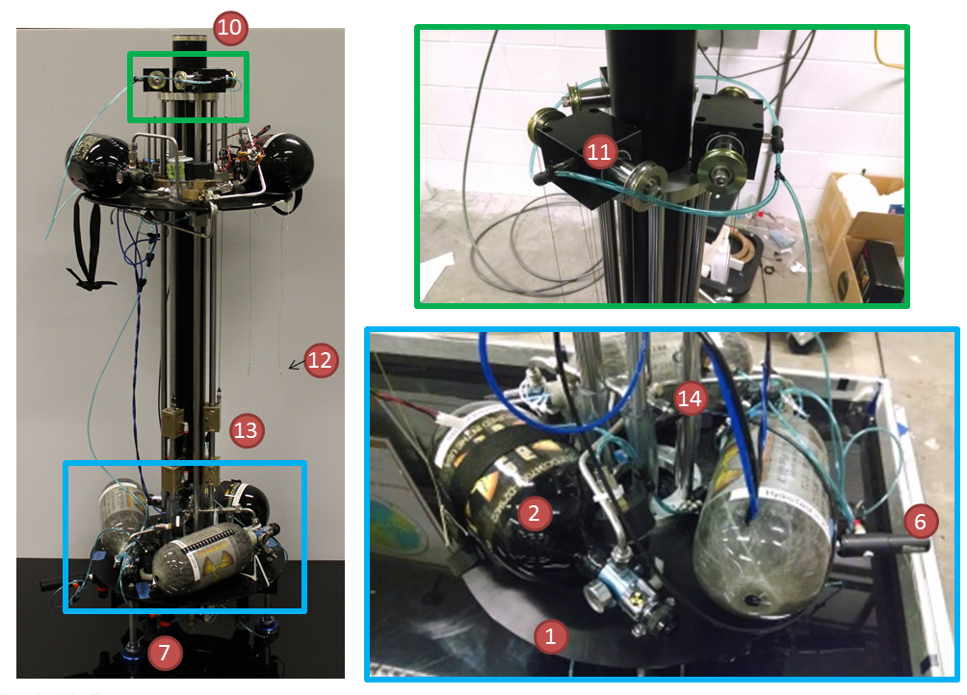
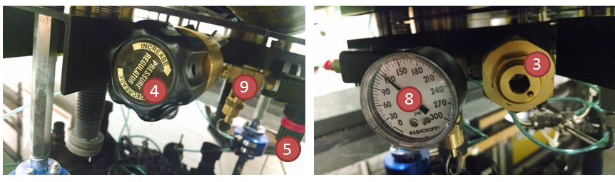
Figure 8: Translation Stage

Table 2: Translational Stage Components
# | Component Name | Part Number | Manufacturer
1 | Platform | Custom | Guidance Dynamics Corporation
2 | 4500 psi, 70cu Paintball Air Tanks | Pure Energy P11G-001 | Luxfer
3 | Regulators (x2) | 969 | Aqua Environment
4 | Replacement Regulator | 415A-400 | Aqua Environment
5 | Hand Valve (x3) | 104104-N01 | Ingersoll Rand
6 | Stabilizer | PPSP01190 | Palmers
7 | Flat Round Air Bearings (x3) | S105001 | Newway
8 | Line pressure (x3) | 20W1005PH 02B 200# | Ashcroft Instruments
9 | Safety valve | 0504 | Aqua Environment
10 | Air bearing cup | Custom | D & K
11 | Air bearing pulley block | S8019P02 | Newway
11 | Air bearing pulley bushing | S301901 | Newway
11 | Air bearing pulley shaft | S90S008-095 | Newway
11 | Air bearing pulley wheels | D 1796 | Prime-Line
12 | String for securing CD to Platform | Dyneema, 80lb | Sea Hunter
13 | Air bushing mounts | Custom | D & K
13 | Air bushings | S301201 | Newway
14 | Air bushing shafts | S90S009-915mm | Newway

The TS also carries the compressed air tanks and pneumatics that store and distribute the air used by all the air bearings and air bushings of the platform. The pneumatic system of the translational stage is shown in Figure 7.

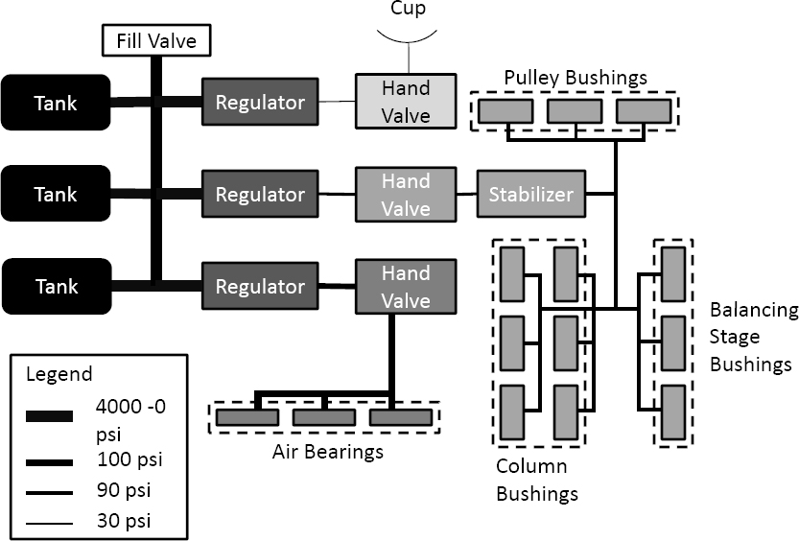
Figure 9: Translation Stage Pneumatics

In this diagram, each "Tank" is a 4500 psi paintball tank as listed in Table 2. The tanks are connected in parallel to three separate regulators that step down the tank pressures to 100 psi, 90 psi, and 30 psi. At the output of each regulator there is a valve that is controlled manually to turn the air flow on or off to each of the air bearing subsystems. One valve controls the connection of a 100 psi line that connects to the linear air bearing feet. A separate valve is used to connect a 90 psi line to a set of bushings that are involved in guiding the counterbalance system. Lastly, a third valve connects a 100 psi line to the spherical cup air bearing that supports the spherical segment ball attached to the AS. To enable translational motion in the horizontal direction, completely open the hand valve labelled “FOOT AIR”. To enable rotational first open the hand valve labelled “CUP AIR”. This will create the cushion of air for the sphereical air bearing to rest on. The air bearing will still be partially resting on the rubber stoppers at the top of the TS column at this point. AFTER “CUP AIR” is opened, open the hand valve labelled “CYLINDER/AIR BUSHING”. This will enable vertical motion of the AS and will raise the spherical air-bearing so that it is levitating on the air cushion instead of resting on the rubber stopper. Always turn of the cylinder air before turning on the cup air. This is critical because the air bearing may become scratched through contacted with the metal cylinder if the cylinder air is on without the cup air.

Counterbalancing System

The vertical degree of freedom is provided by a counterbalancing system consisting of a counterbalancing deck of the same mass as the AS and supporting column. Figure 8 contains a diagram of the counterbalancing concept with the minimum and maximum heights reached by the AS.

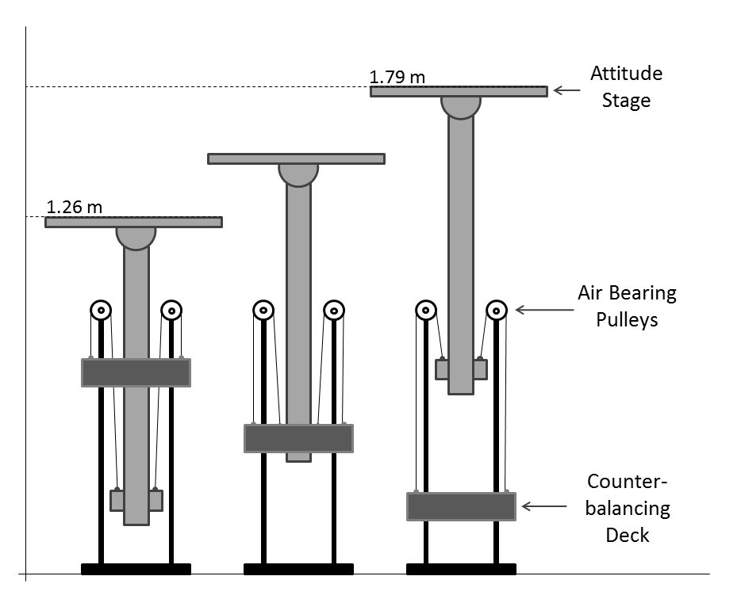
Figure 10: Counterbalancing System

The deck and central column are connected via an air bearing pulley system. The counterbalance motion is guided by two sets of vertical bars attached to the TS. One set of bars guides and stabilizes the CD, which attaches to the bars using air bushings. The other set of bars guides and supports the central column, and by extension the AS, via another set of air bushings. The guides also serve to prevent collisions between the closely moving parts. The air bushings used in the pulley system and for the guides are supplied with air from the TS tanks as illustrated in Figure 7. Flexible tubing is used to bring the air to the counterbalancing system without interfering with its motion. Table 3 contains all the major components used in the counterbalancing system and the CD is shown in Figure 9.

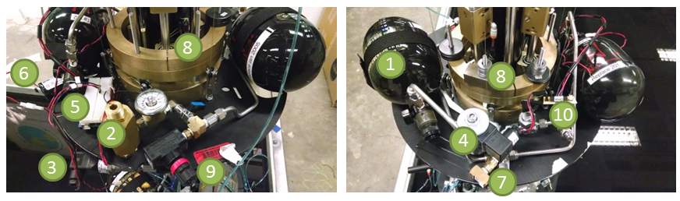
Figure 11: Counterbalancing Deck

Table 3: Counterbalancing Deck Components
# | Component Name | Part Number | Manufacturer
1 | 4500 psi, 50cu Paintball Air Tank | Carbon Fiber N2 | Ninja
2 | Regulator | 969 | Aqua Environment
3 | Pressure Sensor | A-10 | WIKA
4 | Magnetic Latching Valve | 23KK7DELM | Peter Paul Electronics
5 | Microcontroller (& bread board) | Uno | Arduino
6 | Magnetic Latching Valve Battery (x2) | UBBL20-FL | ULTRALiFE
7 | Air outlet T | 50785K322 | McMaster
8 | CD weights | Custom | D & K
9 | Hand Valve | 104104-N01 | Ingersoll Rand
10 | Relay Circuit | Custom | ADAMUS Lab
 | Arduino Battery | RLI-9600 | HiTECH

During an experiment, the mass of the CD is changed to compensate for the AS mass lost as air is released through the thrusters. In order to maintain the zero gravity effect on the AS motion it is important to maintain the balance in the counterbalance system. Although the CD and AS can be balanced using static weights before each experiment, the AS can change mass by up to 300 g as the experiment is run and the air in its tanks is depleated. To reduce this disturbance to manageable levels, the CD also releases air from its two tanks during each experiment. The associated pneumatic system is shown in Figure 10. The release of air is controlled by an Arduino Uno, which receives pressure readings from the AS tanks from the PC104 over WiFi via the WiFly expansion board. A reading is then taken from the CD tanks using a pressure transmitter and the two values are compared. If the value received from the AS is lower, the Arduino opens a magnetic latching valve, which vents air from the tanks that have been reduced in pressure to 80 psi using a regulator. The valve remains open to release air from the CD until the pressures are equalized. If value received from the AS is higher or equal, no air is released. Through this method, the pressure in the AS and CD tanks remain equal within a margin of ±50 psi, as dictated by the precision of the pressure transmitters used. Air from the CD is released from a T-joint to prevent the released air from affecting the movement of the counterbalancing system or TS in general.
The electrical system on the CD consists of a pressure transducer, Arduino Uno, WiFly expansion board, magnetic latching valve, and a diode and relay circuit that shields the Arduino and allows it to control the current supplied to the valve. The system is powered by a 9V battery with the exception of the valve, which has a seperate 6V source. The Arduino reads the pressure of the CD tanks from the pressure transducer through an A/D port and compares it to the pressure of the AS tanks, which is received wirelessly from the PC104 using the WiFly board. The Arduino controls the release of air using digital I/O ports and a relay circuit. The two states of the relay circuit which are used, control the direction of current received by the magnetic latching valve. This circuit can be seen in Figure 10. In one state, the current received is such that the valve opens, releasing air. In the other the current is reversed, so the valve closes and the release of air is stopped.

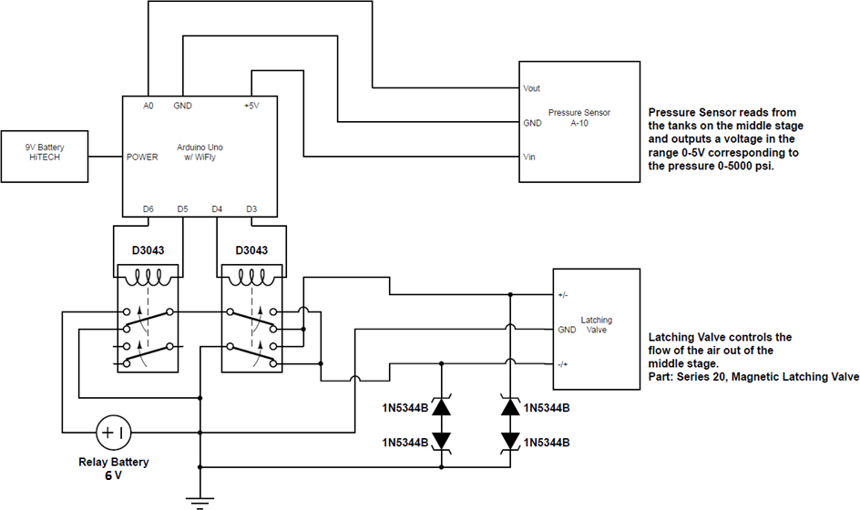
Figure 12: Counterbalancing Deck Electrical

Software Overview
Both the desktop computers and the robot’s PC/104 computers use Linux. If you are unfamiliar with Linux, you can familiarize yourself with it at http://www.linux.org/

Desktop Computers
The desktop computers are the source of all the software for the PC104. Currently (12/2015) the desktop computer “Europa” is fully operational and able to compile executables for the PC104. You can check out APPENDIX A – Setting up the desktop computer for information about duplicating the setup.

Europa Specs:
Linux Version | 2.6.28.7-rtai, Ubuntu 9.04, 32-bit
Matlab Version | 2012a, Individual License
Main Software Folder | /home/Europa/Desktop/Robot
Matlab Root Folder | /usr/local/MATLAB1/
IP Address | 192.168.0.5
Username | europa
Password | password

Callisto Specs:
Linux Version | 2.6.28.7-rtai, Ubuntu 9.04, 32-bit
Matlab Version | 2012a, Faculty License
Main Software Folder | ?
Matlab Root Folder | /usr/local/matlab2012a
IP Address | Not networked to robot network yet
Username | callisto
Password | ADAmus2.0

PC104 Computers

Currently all executables for the testbed are on the ADLS15 PC104 computer which is located on the AS. Directions for setting up the PC104 can be found in APPENDIX B – Setting up PC104. Programming and compilation should be done on the desktop computer, and the executable can be sent to the PC104 and run via SSH.

Demos
There are demo executables which exist on the PC104 already. These demos are located in the folder: /home/kissmekissme/Demos/

Before choosing a demo, make sure that the following things have already happened:
- The server is ON (lights on the front, sometimes when you “turn it on” it doesn’t actually come fully on and you have to do it again. Two beeps means it’s ok.
- The puck is on the testbed, ON (indicated by a green blinking light) , and connected to the LED’s
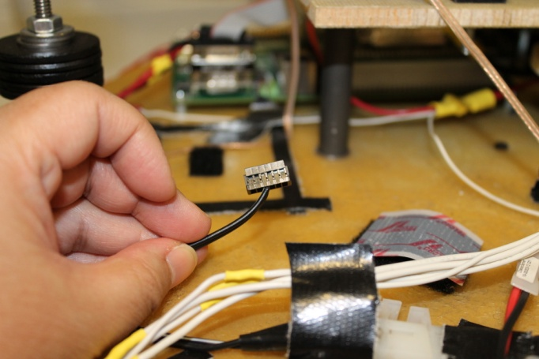
Figure 13: Puck Connector
- The tanks are full (middle tanks are only required for 6DOF)
- The floor has been recently cleaned in test area. Use the Swiffer sweeper (dry cloths only).
- PC104 is ON (green light. NOT pink!) . If the PC104 does not turn on, a connection may be loose or there may be insufficient power for the system to start. Try unplugging a non-essential device (such as the motor driver board) and then try to turn on the PC104. Also try unplugging and reconnecting the PC104 power supply.
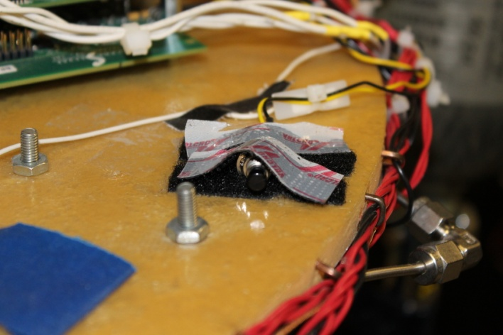
Figure 14: Electronics ON/OFF Switch
- PC104 battery has at least 2 bars (2 bars is the limit!)
- (6DOF only) Counterbalancing system has been balanced and previously tested running the same demo
Next, Pick a demo:
Name | Bearings | Description
Open Loop | Feet, Vertical Restraint | This is an open loop demo which simply shows the ability of the testbed to translate along the floor using the thrusters.
Lyapunov 3DOF Rotation | Cup, Cylinder, Vertical Restraint | This is a 3DOF test which controls only the orientation of the AS.
Lyapunov FuelLim 5DOF | Feet, Cup, Cylinder, V. Restraint | This is a 5 DOF demo which uses has some fuel limiting behavior. The testbed should start in the corner and go to the middle. After arriving at its final position, it will return to its initial condition. Vertical motion is excluded.
Lyapunov FuelLim 6DOF | All | Same as above with vertical DoF.

Open Loop
This is an open loop demo which simply shows the ability of the testbed to translate along the floor using the thrusters.
Testbed setup:
- Secure central balancing platform to bottom platform with a ziptie. This needs to prevent vertical motion. You can also remove one large weight from the central platform to further prevent motion.
- You will need to turn on the foot air
Instructions:
- ssh to the PC104 (from linux desktop)
  - To do this, enter the ssh command in the desktop followed by ssh options and the PC104 username and ip address. If the username is kissmekissme and the ip is 192.168.0.9, you would type the commands:
ssh –XY kissmekissme@192.168.0.9
  - The –XY commands is necessary to enable communication with the motor driver board
- in PC104 terminal window, move to the correct folder: cd Demos cd Open_Loop
- if the testbed is set up, run the demo: ./classdemo
- to stop the demo (it will not stop on its own): Ctrl+C

Lyapunov 3DOF Rotation
This is a 3DOF test which controls only the angle.
Testbed setup:
- Secure central balancing platform to bottom platform with a ziptie. This needs to prevent vertical motion. You can also remove one large weight from the central platform to further prevent motion.
- You will need to turn on the cup air and cylinder air. Cup air must be turned on first and turned off last.

Instructions:
- ssh to the PC104 from linux desktop as discussed for the open loop demo
- in PC104 terminal window, move to the correct folder: cd Demos cd Lyapunov_FuelLim_5DOF
- if the testbed is set up, run the demo: ./PC104_Control_Rotation3DOF
- to stop the demo (it will not stop on its own): Ctrl+C

Lyapunov FuelLim 5DOF
This is a 5 DOF demo which uses the Lyapunov controller and has some fuel limiting behavior. The testbed should start in the corner and go to the middle. After arriving at its final position, it will return to its initial condition. Vertical motion is excluded.

Testbed setup:
- Secure central balancing platform to bottom platform with a ziptie. This needs to prevent vertical motion. You can also remove one large weight from the central platform to further prevent motion.
- You will need to turn on the foot air, cup air, and cylinder air in the order listed.
- Make sure the testbed is about 1.5 ft (.5m) away from the walls as it will be returning to its initial condition and could overshoot.

Instructions:
- ssh to the PC104 (from linux desktop)
- in PC104 terminal window, move to the correct folder: cd Demos cd Lyapunov_FuelLim_5DOF
- if the testbed is set up, run the demo: ./Test_1e9
- to stop the demo (it will not stop on its own): Ctrl+C

Lyapunov FuelLim 6DOF

This is a 6 DOF demo which uses has some fuel limiting behavior. The testbed should start in the corner and go to the middle. After arriving at its final position, it will return to its initial condition.

Before running a 6DOF demo:
- Ensure that there is sufficient battery left in the PhaseSpace Puck and in the AS batteries. If the AS batteries have two or fewer bars, it is recommended that you charge them overnight.
- You will also need a charged 9V battery and two charged 6V batteries for the CD.

- Make sure there is sufficient pressure in the filling system. There should be 3000psi+. If there is less, you must run the compressor.
- Fill the tanks on the CD, then AS, then TS. The CD should be filled to a slightly higher pressure than the AS.
- Wait until the AS and CD tanks cool down. At least a couple minutes.
- Clean the floor if it appears dusty or has not been cleaned in some time.
- Make sure the PhaseSpace server and PC104 are on.
- Make sure the PhaseSpace Puck is connected to the LED string on the AS.
- Connect to the PC104 from the a linux desktop computer on the ADAMUS network. This is done using ssh or the “ssh to PC104” desktop icon (on Europa)
- Connect the 6V batteries to their plastic connectors but do no connect the power to the relay circuit.
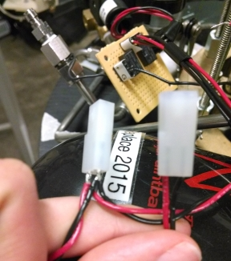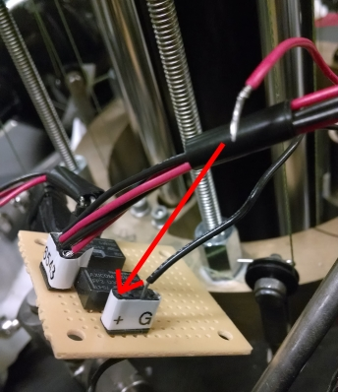
Figure 15: (Left) 6V Battery Plastic Connectors. (Right) Relay Circuit Power Shown Disconnected. Connect Red Wire in Hole Farthest from Ground Connection to Supply Power.

- Connect the 9V battery to the Arduino Uno, causing it to start up.
- If the LED is blinking orange (it generally is) click the reset button.

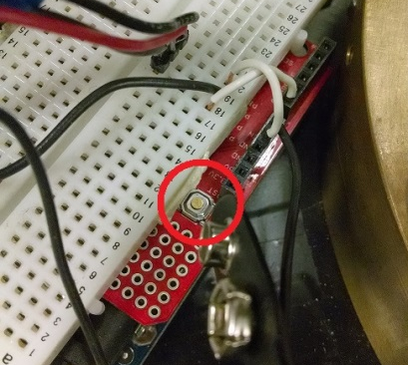
Figure 16: The Arduino Reset Button.

- Once the LED on the Arduino is slowly blinking green, return to the desktop computer where you have ssh’d to the PC104.
>> cd Balancing
>>./PressureRelease
- This will have the PC104 begin sending pressure values to the Arduino (it’s LED will blink red). Next, plug in the relay circuit on the CD so the valve is controlled by the Arduino (See Figure 1).
- Air will release from the CD until the stages are balanced based on pressure.
- When the CD stops releasing air, unplug the relay circuit and the Arduino.
- (optional) At this point you may turn on the cup and cylinder and then add weights to balance the counterbalance system.
- (optional) If you spent a lot of time balancing you may want to refill the TS tanks.

To run a 6DOF demo:
- On the desktop computer, in the ssh window
- in PC104 terminal window, move to the correct folder: cd Demos cd Lyapunov_FuelLim_6DOF
- Repeat steps 11 &12.
- Turn on the air to the air bearings, starting with the feet, then the cup, then the cylinder. The testbed should now be free floating.
- Plug in the relay circuit.
- On the desktop computer, in the ssh window, run the executable:
>> ./Test_1e9
- The executable will run and the testbed should turn on its LEDs and move towards the target position.
- When you would like the experiment to stop, click Ctrl-C on the desktop computer to stop the executable. The experiment will not stop on its own.

Shutdown Procedure

After any demo or experiment, go through the following shutdown procedure:

- Turn off cylinder air, cup air, and foot air in that order.
- Disconnect Arduino from 9V battery
- Disconnect solenoid from Ultralife batteries
- Recharge batteries
- Turn off PC/104
- Connect PC/104 charger

Common Tasks

Filling the Tanks

Precautions:
1 NEVER REFILL TANKS BY YOURSELF; MAKE SURE THERE IS AT LEAST ANOTHER PERSON IN THE LAB.

2 WEAR SAFETY GLASSES.

3 STAY ON THE SIDE OF THE CONNECTION, NOT BEHIND. THIS PREVENTS INJURY IF HOSE DISCONNECTS.

4 RULE OF THUMB IS TAKING 3 MINUTES TO COMPLETELY FILL A TANKS. ANOTHER GOOD PRACTICE IS OPENING AND CLOSING VERY LITTLE, FILLING UP IN STEPS

5 TOUCH THE TANKS FREQUENTLY. THEY NEED TO REMAIN ROOM TEMPERATURE, IF IT IS EVEN A LITTLE HOT, STOP AND WAIT UNTIL IT GETS COLD.

6 STOP IF ANY HISSING SOUND IS HEARD.

7 DO NOT OPERATE THE ROBOT’S TANKS WITH THE FILLING HOSE CONNECTED.

8 NEVER LEAVE TANKS WHILE FILLING

9 TURN OFF HEATING SYSTEM SO YOU CAN LISTEN FOR LEAKS

To Fill Tanks:

10 INSPECT THE QUICK CONNECT FOR SIGNS OF STRESS AROUND THE SMALL SPHERES.
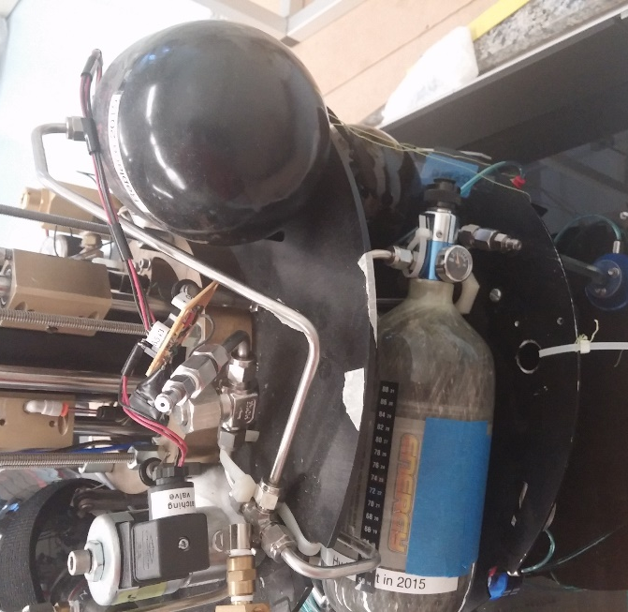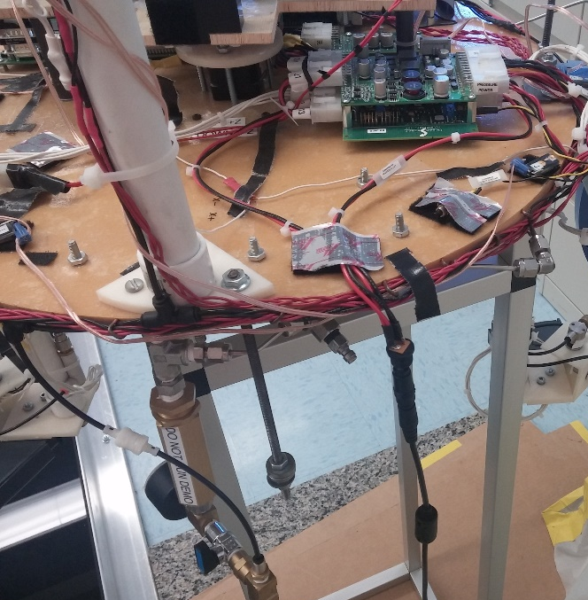
Figure 17. Air Input Ports for AS, TS, and CB

11 CONNECT HOSE TO THE AIR INPUT PORTS (Figure 15) ON THE TANKS. THE QUICK-CONNECT FITTING MUST CLICK.

12 CLOSE THE BLEEDING VALVE ON THE HOSE.

13 VERY SLOWLY OPEN THE PRESSURE KNOB IN SMALL INCREMENTS.

14 WAIT AND LISTEN FOR PRESSURE TO EQUILIBRATE AT EACH INCREMENT

15 3500-4000 psi = FULL

3 MINUTES TO COMPLETELY FILL A TANK

Once Tanks are Filled:

16 SLOWLY CLOSE THE PRESSURE KNOB

17 OPEN THE BLEEDING VALVE ON THE HOSE.

18 WAIT UNTIL ALL PRESSURE IS RELIEVED

19 DISCONNECT THE HOSE FROM THE TANKS BY RELEASING QUICK CONNECT.

20 REPLACE THE HOSE END ON ITS WALL MOUNT

Removing the Attitude Stage
Often the attitude stage will need to be removed if the robot will not be used for a long time or for maintenance purposes. The following is the procedure for this

- Two people will be needed for this
- Make sure the translational stage tanks are filled to 3000 psi.
- Turn on the cup air then the cylinder air
- While one person holds the black vertical column, the other will remove the attitude stage from the translational stage
- Gradually let the vertical column move up and the counterbalancing deck move down until they both stop
- Place the attitude stage on its stand. Make sure the pads of the stand are not on a tube. There are black circles on the bottom of the attitude stage to indicate where the pads should go.
- Turn off the cylinder air then the cup air.

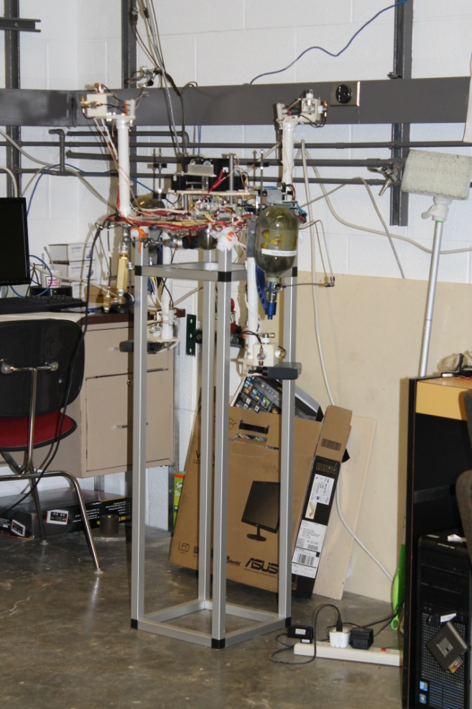
Figure 18: Attitude Stage on Stand

Placing the Attitude Stage on the Translational Stage

- Two people will be needed for this.
- Make sure the translational stage tanks are filled to 3000 psi.
- Turn on the cup air then the cylinder air
- Lift the attitude stage from its stand and place the attitude stage on the translational stage.
- Turn off the cylinder air then the cup air.

Creating and Compiling Software using Simulink and RTAI
Software is created using MATLAB Simulink.
- Open the model to be compiled in Simulink.
- Make sure there are no "Display" or "To Workspace" or "Scope" blocks in the model.
- Select from the menu bar: Simulation --> Configuration Parameters
- In the Solver tab, make sure of these settings:
- Solver options: Type: Fixed-step
- Solver options: Solver: discrete (no continuous states)
- (optional) Simulation time: Stop time: <length of simulation> (e.g. PARA.duration)
- (optional) Solver options: Fixed-step size: <sample time> (e.g TIME.SAMP)
- In the Code Generation tab, make sure of these settings:
- Target selection: System target file: rtai.tlc
- Target selection: Language: C
- Generate code only is checked.
- Select Generate Code.
Simlink then generates real time compliable code in a folder called <your_model_name>_rtai. There are two options for the final steps.

Detailed Version
7a. Open a terminal. There is a link on the desktop to do this or you can go to (top left) Applications --> Accessories --> Terminal.
8a. cd to the folder created by simulink (pick your folder):
>> cd <your_model_name_rtai/
9a. make the make file in that folder
>> sudo make -f <your_model_name>.mk
10a. If there are no errors, go back a level.( If there are errors, there are two common ones which are covered below in “.o Error” and in the troubleshooting section “Many errors similar to mxCalloc when compiling”)
>> cd ..
11a. Transfer the file to the PC104
>> scp <your_model_name> kissmekissme@192.168.0.9:/home/kissmekissme/.
Assuming the PC104 username is kissmekissme and the ip address is 192.168.0.9, a copy of the file will now be located in the /home/kissmekissme/ folder on the PC104.

.o Error!
If you receive an error complaining about a .o file (or more than one) then it is likely that you are using an sfunction which has the same name as the .o file. There are two options.
- The sfunction is in the ADAMUS library. In this case you must acquire a .o file and copy it into the _rtai folder where you are running the make file. To do this, in MATLAB go to the ADAMUS library where the <sfunction_name>.c file is located (/usr/local/MATLAB1/R2012a/toolbox/ADAMUS_library/src/c). Mex the sfunction again with the additional flag –c (e.g. >>mex sfun_example.c –c). This will create a .o file which you can copy into the _rtai folder for your model.
- The sfunction is one that is not in the library. This might be an sfunction which was downloaded or written by someone in the lab. In this case, copy and paste the .c sfunction file into the _rtai folder or your model. It doesn’t really want the .o file. It is confused.

Automatic version
7b. Open a terminal. There is a link on the desktop to do this or you can go to (top left) Applications --> Accessories --> Terminal.
8b. cd to the compiler folder
>> cd /home/kelsey/Desktop/Robot/Compiler/
9b. Open a file browser such as (top left) Places --> Desktop and browse until you reach the <your_model_name>.mdl file associated with the simulink model you just generated code for in step 6.
10b. In the terminal type ./compiler.sh but do not press ENTER
11b. Drag the <your_model_name>.mdl file to the terminal window and drop it there OR type the path to the mdl file in the terminal window.
12b. Press ENTER
13b. Most likely at this point you should select 1. Follow the directions.
14b. Repeat steps 10-12.
15b. Select 3 to transfer the file to the PC104.
16b. Select 0 to selet the executable.
The file is now on the PC104. If any of these steps fail, do the detailed version.

Move Files to and from PC104
Moving files to the PC104:
- Open a terminal window on the desktop computer
>> scp <filename and location> kissmekissme@192.168.0.9:/<desired location on PC104>.
e.g >> scp myExecutable kissmekissme@192.168.0.9:/home/kissmekissme/.
(the period at the end means to keep the name the same when you move the file)
- You will need to type the password to the PC104 (kissme)

Moving files from the PC104:
- Open a terminal window on the desktop computer
>> sudo scp kissmekissme@192.168.0.9:/home/kissmekissme/<file name and location> <desired location on desktop>/.
e.g. >> sudo scp kissmekissme@192.168.0.9:/home/kissmekissme/Kelsey/myfile.dat /home/europa/Desktop/Robot/.
(the period at the end means to keep the name the same when you move the file)
- You will need to type the password for the desktop computer and then the password for the PC104 computer (kissme)

Balancing the attitude stage
Currently balancing the attitude stage must be done by trial and error and requires two people. You can do some rough balancing by moving the washers that are suspended around the platform but I wouldn’t recommend it unless you have added some large part which needs to be compensated for. To move the little motors and balance the stage, do the following:
- Turn on the PC104 and connect to it with ssh (click the “ssh to pc104” button on the desktop). Alternatively, you can ssh manually using the command
ssh –XY kissmekissme@192.168.0.9. The –XY command is critical is it enables communication with the X-Server over ssh. The X-Server is a component of the linux OS responsible for handling graphical user interfaces and is necessary for controlling the motor driver board. Without the –XY command, you will not be able to move the motors and will spend hours trying to figure out why.
- In the PC104 terminal, move to the Balancing folder
~$ cd Balancing/
- You will want to run the file MoveMotor for a given motor and desired displacement. Turn on the cup and cylinder air and have one person determine which way the motors need to move and by how much. The other person should move the motors by running the file. For example:
Person 1: (speaks) Move positive x about an inch!
Person 2: (types) ./MoveMotor X 13120
Person 1: (speaks) Ok, move negative y a tiny bit…
Person 2: (types) ./MoveMotor Y -1000
Etc…

Running the RTAI complied code
These steps are performed after the executable has been moved to the PC104.
- Connect to the PC104:
- The PC104 must be on.
- Double click the icon on the desktop that says "ssh to pc104" OR Type in a terminal
>> ssh kissmekissme@192.168.0.9
- Run the executable:
- In the window connected to the PC104 type:
>> ./myExecutableName
- Stop the executable:
- The executable will keep running for a long time so you must stop it using Ctrl+C
- Even if you specified a run time when creating the executable (See step 4 in Creating and Compiling Software) the program will run forever. If you are logging data with the save block then it will only log for the time specified. (e.g. In the case of the PC104_Control_save model, the data will only be logged for PARA.duration but the model will keep running 'forever'. )

Running an Experiment – 5DOF
These directions assume that you already have an executable ready to run on the PC104. If you do not have your executable compiled yet then look at the instructions for compiling software on page 3.

Before running a 5DOF experiment:
- Ensure that there is sufficient battery left in the PhaseSpace Puck and in the AS batteries. If the AS batteries have two or fewer bars, it is recommended that you charge them overnight.
- Fill the tanks on the AS and TS as detailed on page 3. You do not need to fill the CD tanks.
- You may desire to hold the CD in place to prevent vertical translation. This can be done with the green threads hanging from the CD and a ziptie.
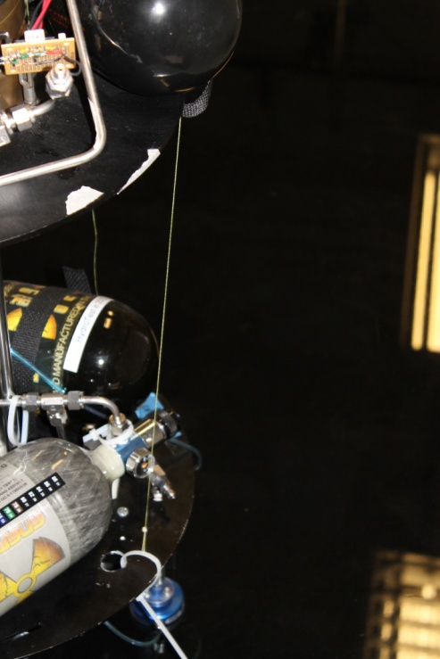
Figure 19: Counterbalancing Deck Tie Down
- Clean the floor if it appears dusty or has not been cleaned in some time.
- Make sure the PhaseSpace server and PC104 are on.

To run a 5DOF experiment (example executable file : “executableExperimentFile”:
- Connect to the PC104 from the a linux desktop computer on the ADAMUS network. This is done using ssh or the “ssh to PC104” desktop icon (on Europa)
- cd to the directory which contains the executable file.
- Make sure the PhaseSpace Puck is connected to the LED string on the AS.
- Turn on the air to the air bearings, starting with the feet, then the cup, then the cylinder. The testbed should now be free floating.
- On the desktop computer, in the ssh window, run the executable:
>> ./executableExperimentFile
- The executable will run and the testbed should turn on its LEDs and move towards the target position.
- When you would like the experiment to stop, click Ctrl-C on the desktop computer to stop the executable. The experiment will not stop on its own.

Running an Experiment – 6DOF
These directions assume that you already have an executable ready to run on the PC104. If you do not have your executable compiled yet then look at the instructions for compiling software on page 3. Note that running the vertical stage requires a lot of trial and error if the system has not yet been balanced. If a step fails while you try to complete it, go back a few steps and try again.

Before running a 6DOF experiment:
- Ensure that there is sufficient battery left in the PhaseSpace Puck and in the AS batteries. If the AS batteries have two or fewer bars, it is recommended that you charge them overnight.
- You will also need a charged 9V battery and two charged 6V batteries for the CD.

- Make sure there is sufficient pressure in the filling system. There should be 3000psi+. If there is less, you must run the compressor.
- Fill the tanks on the CD, then AS, then TS. The CD should be filled to a slightly higher pressure than the AS.
- Wait until the AS and CD tanks cool down. At least a couple minutes.
- Clean the floor if it appears dusty or has not been cleaned in some time.
- Make sure the PhaseSpace server and PC104 are on.
- Make sure the PhaseSpace Puck is connected to the LED string on the AS.
- Connect to the PC104 from the a linux desktop computer on the ADAMUS network. This is done using ssh or the “ssh to PC104” desktop icon (on Europa)
- Connect the 6V batteries to their plastic connectors but do no connect the power to the relay circuit.
Figure 20: (Left) 6V Battery Plastic Connectors. (Right) Relay Circuit Power Shown Disconnected. Connect Red Wire in Hole Farthest from Ground Connection to Supply Power.

- Connect the 9V battery to the Arduino Uno, causing it to start up.
- If the LED is blinking orange (it generally is) click the reset button.

Figure 21: The Arduino Reset Button.

- Once the LED on the Arduino is slowly blinking green, return to the desktop computer where you have ssh’d to the PC104.
>> cd Balancing
>>./PressureRelease
- This will have the PC104 begin sending pressure values to the Arduino (it’s LED will blink red). Next, plug in the relay circuit on the CD so the valve is controlled by the Arduino (See Figure 1).
- Air will release from the CD until the stages are balanced based on pressure.
- When the CD stops releasing air, unplug the relay circuit and the Arduino.
- (optional) At this point you may turn on the cup and cylinder and then add weights to balance the counterbalance system.
- (optional) If you spent a lot of time balancing you may want to refill the TS tanks.

To run a 6DOF experiment (example executable file : “executableExperimentFile”:
- On the desktop computer, in the ssh window, find the executable on the PC104 and CD to the correct folder.
- Repeat steps 11 &12.
- Turn on the air to the air bearings, starting with the feet, then the cup, then the cylinder. The testbed should now be free floating.
- Plug in the relay circuit.
- On the desktop computer, in the ssh window, run the executable:
>> ./executableExperimentFile
- The executable will run and the testbed should turn on its LEDs and move towards the target position.
- When you would like the experiment to stop, click Ctrl-C on the desktop computer to stop the executable. The experiment will not stop on its own.

Updating a Library Block

Adding a New Demo

Adding a New Library Block
These instructions are basic and may not cover all errors that can occur during this process.
- Make sure the block that you are going to put in the library has a mask, even if this mask is just a description of the block.
  - If there is no mask, right-click the block and select “Create Mask”. You can add a description in the second box in under the tab labeled “Documentation.”
- Open the ADAMUS libaray mdl file. This should exist at /usr/local/MATLAB1/R2012a/toolbox/ADAMUS_library/ADAMUS_lib.mdl
- Open up the subsystem where you would like your block to be located. (e.g. “Controllers”)
- Copy and paste the block into the subsystem window and save the model. Try to keep the color coding. This is to make it clear which blocks are library blocks.
- (s-function) If your block has an s-function associated with it then you must do the following.
  - Using whatever method you prefer for moving files, move the sfunction.c file to /usr/local/MATLAB1/R2012a/toolbox/ADAMUS_library/src/c
  - Go to that folder in MATLAB and mex the file.
  - Copy the .mexglx file to /usr/local/MATLAB1/R2012a/ADAMUS_library/src/mex
- In the main MATLAB window type
>> rehash toolboxcache
- Restart MATLAB.
- If everything worked out, you can now find your block in the Simulink library under ADAMUS Toolbox. If there are a lot of subsystems that were also added, make sure you did step 1.

PhaseSpace Alignment – ADAMUS Style
Because of the size of our experiment space, we need to align the cameras using an alignment object instead of the alignment with the wand that was provided. To do this you will need the alignment object, the PhaseSpace server computer, and ~15 minutes. This must be done whenever the cameras have been moved.
For this task you will need the Alignment Object (see Figure 19), tape, the PhaseSpace server, and a PhaseSpace puck (one from one of the other systems will work fine).
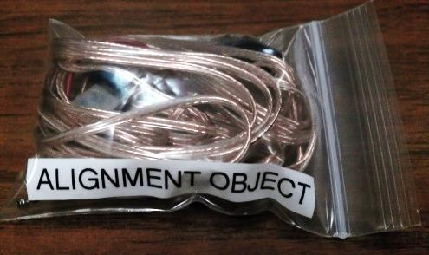
Figure 22: The Alignment Object.
- Connect monitor and keyboard to PhaseSpace server. Turn on server.

- Log into the server and start the GUI:
Impulse login: demo
Password: demo
Impulse:~$ startx

- In the open terminal, start the calibration software:
Impulse:~$ cd phasespace
Impulse:~$ ./calib

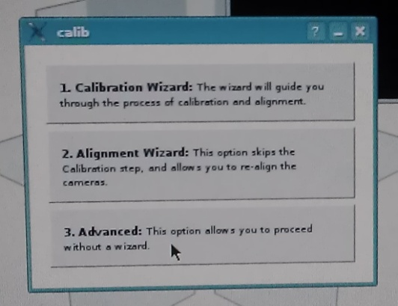
- Select Advanced

- Select Cancel
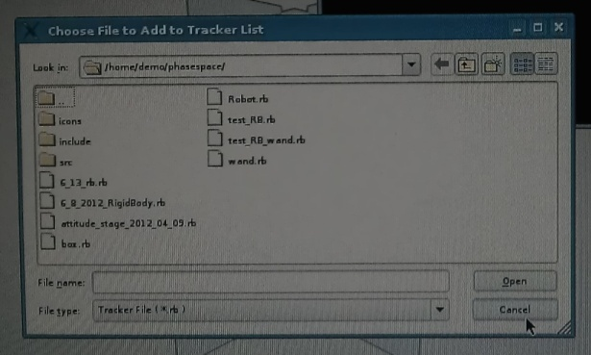
- The Calibration/Alignment tool will open. Under the Calibration menu, select Aligment.
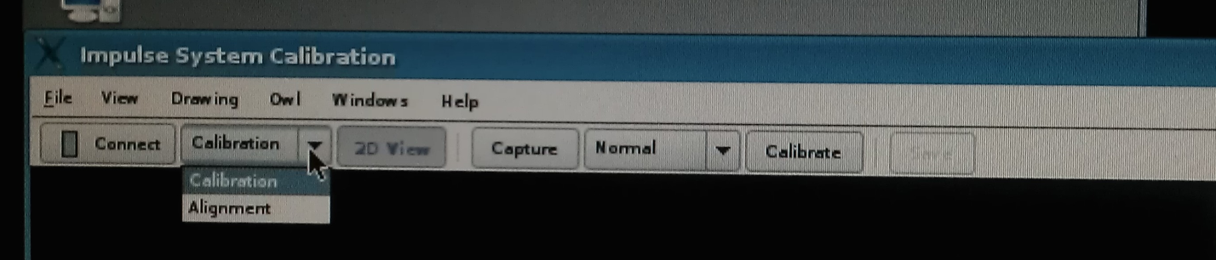
- Under the Windows menu, select Settings.
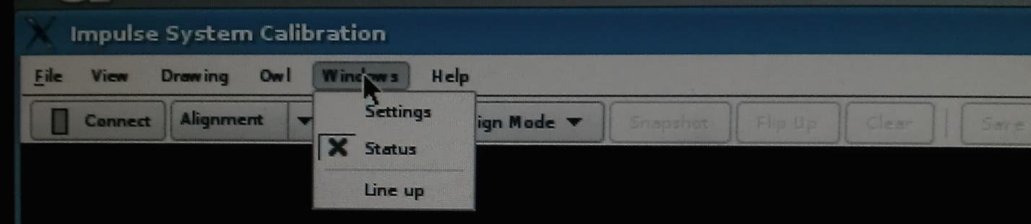
- Make sure the server address is correctly entered.
  - If it wasn’t, select Save Settings after correcting it.
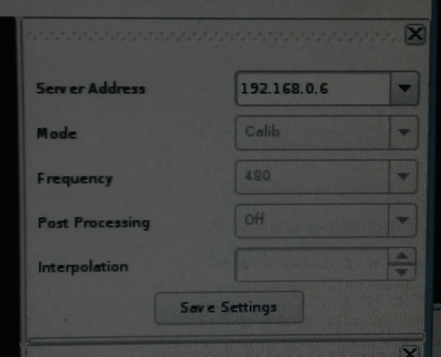
- Under the Align Mode menu, select Alignment Object.
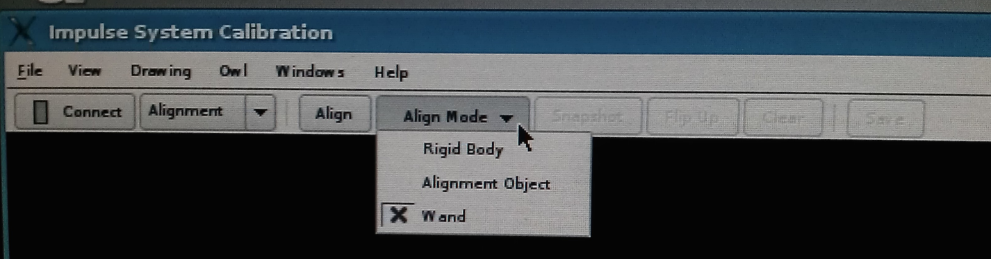
- Take the Alignment Object out of its bag and find the LED labeled A. This LED needs to mark the origin. Tape this LED to the wall of the floor in the corner (wherever you want the origin) so that the LED is as close as possible to the floor.
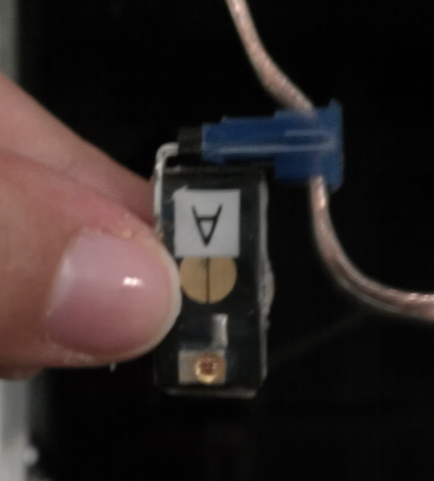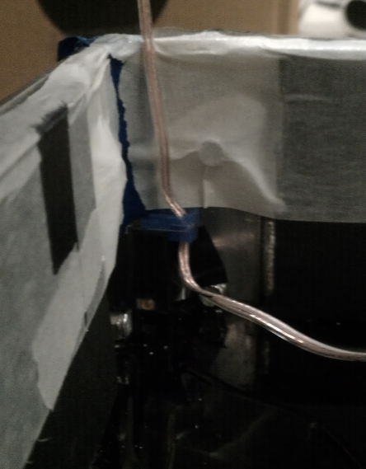
- Find the LED labeled B, this LED needs to mark the X+ direction from the origin. Find a place along the X axis and tape LED B there as close as possible to the floor.
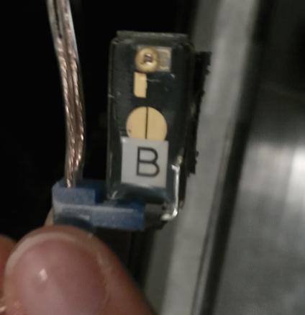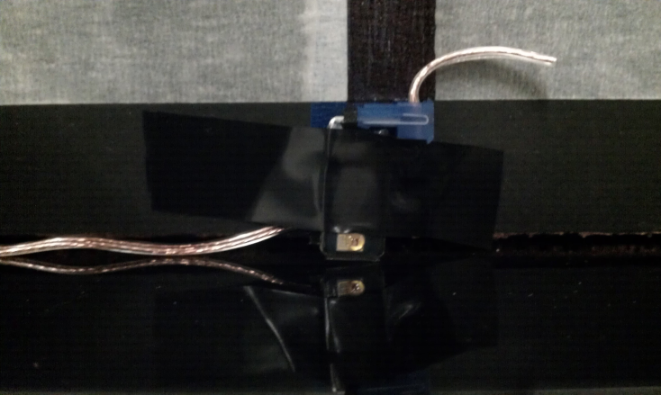
- Find LED C, this LED needs to mark the Z+ direction from the origin. Place LED C along the Z axis and as close to the floor as possible.
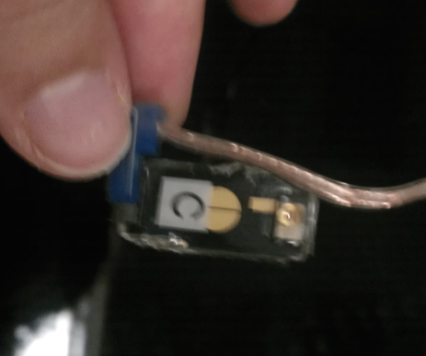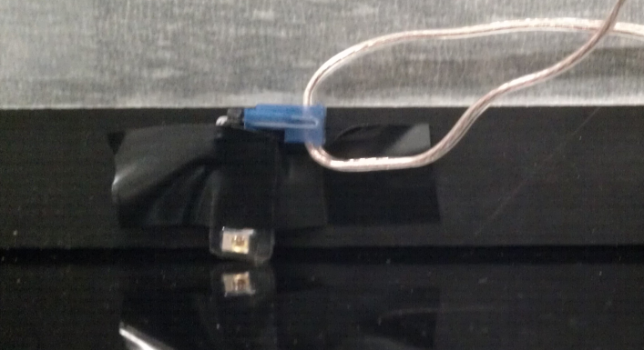
- Take a puck connector from somewhere. I took the one from the 6DOF robot.
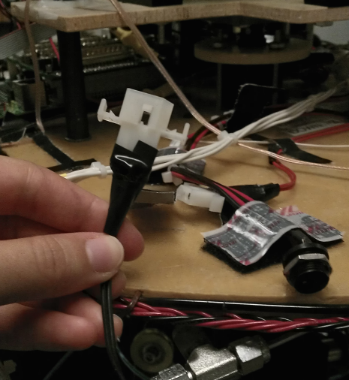
- Attach the red and black cables from the Alignment Object to the puck connector and the puck connector to the puck.
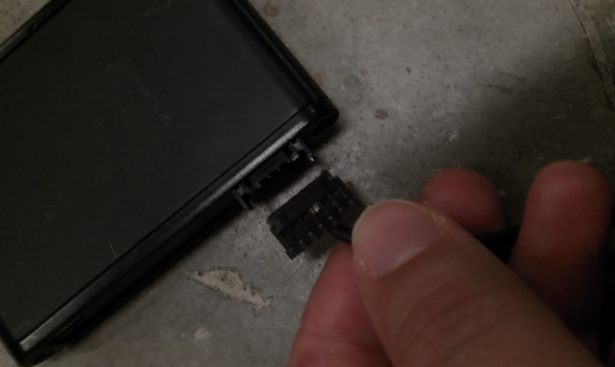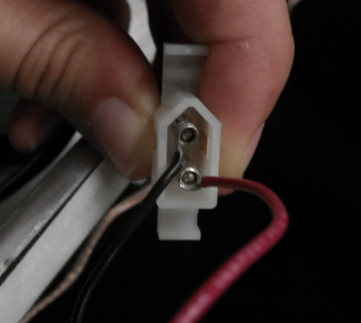
- Make sure the puck is on.
- Back in the software, click Connect. The LEDs should turn on and appear on the screen. Assure that all LEDs can be seen. If they do not appear you will need to reposition them.
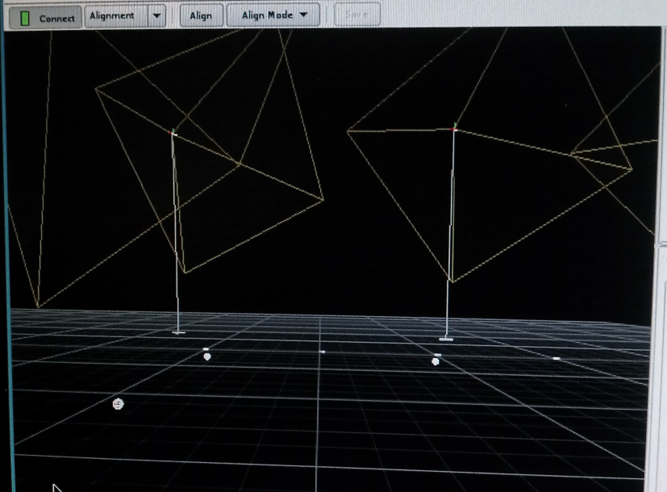
- Select Align.
- The axes you defined should appear in the software as shown on the left below. If they do not (see right) then you should disconnect and connect->align again until it works.
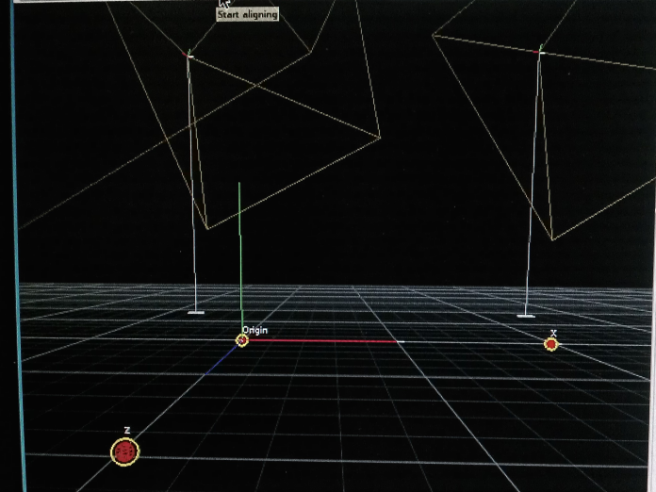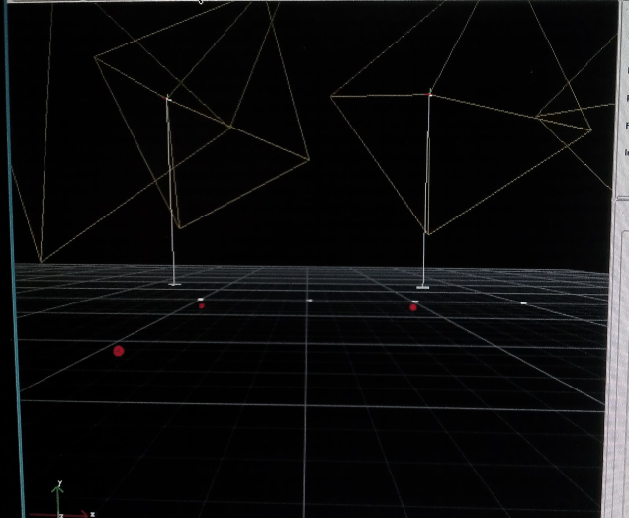
- Once the axes appear, select Save.
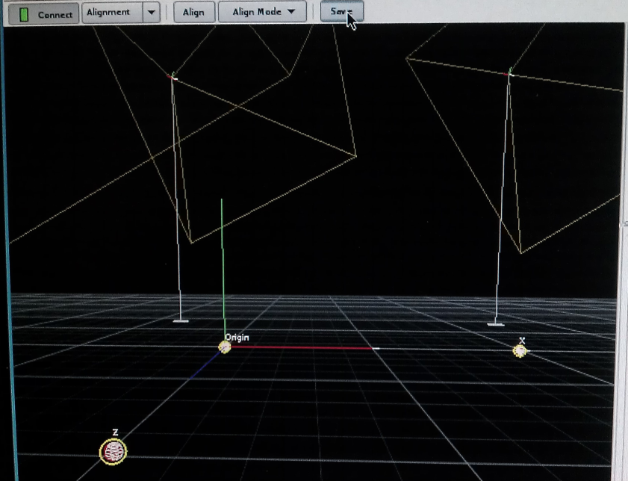
Exit the calibration software. Alignment is done!

PhaseSpace Rigid Body Capture
The rigid body capture can be done using the instuctions which come with the PhaseSpace System. Once the rigid body is captured however, the resulting coordinates must be adjusted to be in the center of the spherical air bearing and this is a time consuming process. The rigid body capture assigns the origin to LED A which is not at all what is required. To do this previously the PhaseSpace was used to output the positions of each LED individually (this is done in an sfunction called sfun_PhaseSpaceAll.c). The AS was then placed on the TS and moved around on the spherical air bearing in a gentle manner. From there, the locations of each LED can be used to triangulate the location of the center of rotation. This can be done by selecting the position of a single LED at three different times during the rotation. The center of rotation is the point in 3D space which is equi-distant from all three points. When this was done before, many different rotations and estimations were done and the result was averaged to find the center of rotation offset which was then hardcoded into the PhaseSpace function. These values may need to be adjusted if the rigid body is captured again but it is possible they will still be close enough.

Connecting to Arduino Uno
The Arduino can be connected to a laptop or desktop computer to change the software that is running on it or to check the output from the current software. To do these tasks you will need a USB A-B cable and a computer which can reach the Arduino. New software must be created using the Arduino software and output can be seen using Tera Term (http://ttssh2.sourceforge.jp/index.html.en) or the Arduino software. I find that Tera Term seems to work better in almost all cases.

Maintenance

Cleaning the feet (often)
The air bearing feet should be cleaned regularly. This task will require rubbing alcohol, a Swiffer pad or a square Berkshire pad, and two people. The AS must be removed and placed on its holding platform. One person must either lift the entire TS and hold it while the other person cleans the feet with the rubbing alcohol or the TS can be gently tilted to allow access to the bottom of each foot in turn. If the TS is lifted it must be held by the vertical guiding bars. You will find that ever other vertical bar is able to move slightly up and down. When lifting, make sure you are holding vertical bars which are secured to the testbed and unable to move.

Cleaning the pulley bushings
The pulley bushings will occasionally need to be cleaned. This will require rubbing alcohol, Swiffer pad, and some Molykote 55 O-Ring Grease (In a blue and white tube). The AS must not be attached to the TS when cleaning the pulley bushings.
- Turn on the cylinder air.
- Remove the pulley string from the air bearing pulley wheels.
- Remove the wheels from the pulley shafts and slide the shafts out of the bushings.
- Turn off the cylinder air.
- Wet a Swiffer pad with rubbing alcohol and feed it through the bushing.
- Pull the Swiffer back and forth until it no longer gathers more carbon as it goes through.
- (optional) At this time you may also want to add more lubricant to the bushings.
  - Push the bushing (cylinder) out of the casing (rectangular).
  - Use rubbing alcohol to remove the old lubricant from the bushing.
  - Add new lubricant around the o-rings.
  - Push the bushing back into its casing.
- Turn on the cylinder air.
- Put the pulley shafts back into the bushings and reattach the pulley wheels to the shafts to keep them in place.
- Loop the pulley string back over the pulley wheels.
- Assure that the pulley string is still on the wheels of the other pulleys in the system. The ones on the CD and the ones on the central column.

Cleaning the bushings
The bushings on the vertical guiding shafts must occasionally be cleaned. This is only done when the vertical motion seems to have a large amount of friction and cleaning the shafts does not seem to help. This task requires rubbing alcohol, Swiffer pads, Molykote 55 O-Ring Grease (In a blue and white tube), more pulley string, an air tubing plug (Figure 3), and two people, at least one of which must be capable of lifting the TS. The AS must not be on the TS for this to be done. This is a VERY time consuming task.

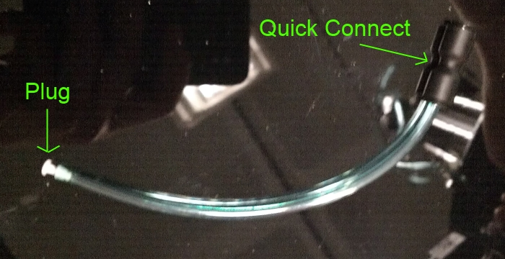
Figure 23: Air tubing plug.

- Remove the TS from the floor.
  - Detach the air tubing from the air bearing feet by pushing in the black ring and pulling out the blue tubing.
  - One person must lift the TS and hold in while the other removes unscrews the feet. When lifting, make sure you hold on the two of the three vertical bars which are well attached to the TS and not free to move.
  - After the feet are removed, the TS can be placed off the floor.
  - Keep the feet in a safe location.
- Turn on the cylinder.
- Remove the pulley string from the air bearing pulley wheels.
- Turn off the cylinder.
- Cut the string and remove it from the system. Keep it for measurement later.
- Uncrew the top ring which holds the air bearing pulley system on the vertical guides.
- Detach the blue air tube which goes to the pulleys from the TS tanks. Plug the end attached to the TS with an air tubing plug. This should allow the cylinder system to be used without the air bearing pulleys attached.
- Lift the pulley circle off of the vertical guides and set it aside.
- Use some tape to mark how the CD is aligned with the TS bottom platform so it can be reassembled in the same orientation.

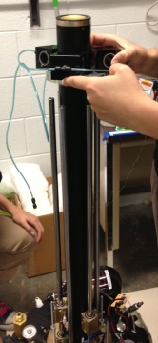
Figure 24: Pulley circle, with its air system detached, being lifted off the vertical gudes.

- Turn on the cylinder.
- The central column and CD must both be removed from the guiding shafts at the same time. This is because the cylinder must remain on while the two pieces are removed. Have one person lift the central column and the other lift the CD (See Figure 4). If there is a third person available you can have them steady the vertical shafts. NOTE: Three of the vertical shafts are not attached at the bottom and may try to fall over or go flying when you are doing this step! Try not to let them fall.

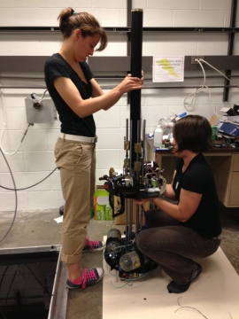
Figure 25: Lifting the central column and CD off of the vertical guides.

- Lay the vertical column and CD on the ground near the TS and turn off the cylinder.
- The bushings are located on the central column (6) and the CD (3).
- The bushings can be cleaned by wetting a Swiffer pad with rubbing alcohol and feeding it through the bushing. The pad can be pulled back and forth until it no more carbon is deposited on it.
- (optional but recommended) Since you are cleaning the bushings and have gone through the trouble of taking apart the testbed, it is a good idea to also replace the lubricant in the bushings.
  - Push each bushing out of its casing. To get the bushings out of the CD, wrap a vertical shaft in a Swiffer and push it in to the bushing hold from the top. This should push the bushing out of the bottom. See Figure 5 and Figure 6.

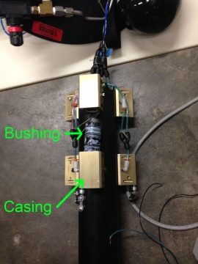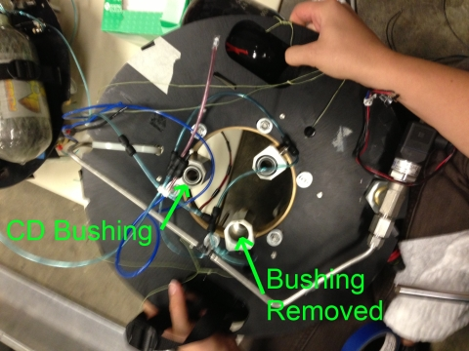
Figure 26: Removing bushings from their casings. (Left) Removing bushings from central column. (Right) removing bushings from CD.
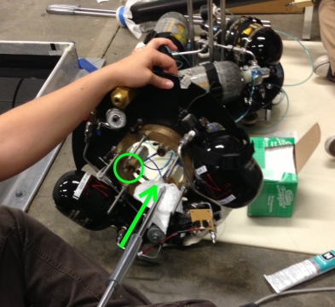
Figure 27: Using a vertical guiding shaft and Swiffer pad to remove the CD bushings.

  - Clean off the old lubricant with rubbing alcohol.
  - Apply rubbing alcohol to the o-rings.
  - Push the bushing back into its casing.
- Put the CD and central column back onto the vertical bars. This will require the cylinder air to be on. The three vertical bars which were not connected must be held in place while the two pieces are reattached. The CD should go on the three stable vertical guides and the central column should go on the three unstable vertical guides.
- Allow the CD and central column to rest on the TS and turn off the cylinder air.
- Reattach the pulley ring.
- (optional) cut a new pulley string slightly longer than the old one. If you do not do this step, just use the old string.
- Thread the pulley string though the CD and central column pulleys. The string should go through a central column pulley, then through two CD pulleys, then through the next central column pulley, etc.
- Tie the two ends of the string together. Make sure the knot will not slip! This is important! Use a perfection loop for one end and an improved clinch knot to secure the other end to the loop.
- Remove the air tubing plug from the TS and reattach the pulley circle to the pneumatic system.
- Turn on the cylinder air and loop the pulley string back over the air bearing pulleys.
- Turn off the cylinder air.
- The air bearing feet can then be reattached while one person holds up the TS, then the TS can be placed back on the epoxy floor.

Cleaning the vertical guides (often)
When the vertical motion becomes “sticky” or seems inexplicitly to have more friction, you may need to clean the vertical bars. To do this you will need rubbing alcohol and a Swiffer or a square Berkshire pad. Simply wet the pad with rubbing alcohol and rub in on the vertical bars were they are visible. Do this until no more carbon comes off of the bars. Turn on the cylinder air (and cup air if the AS is attached) and move the CD to a new location. Turn off the air and clean the visible parts of the vertical bars. You can also clean the air bearing pulley shafts using the same technique.

Replacing the tanks
The paintball tanks must be removed and sent back to Ninja every 5 years to be tested. The year that this should happen during should be marked on each tank. The black Ninja tanks will occasionally acquire cracks in the hard surface coat. This is a defect which is covered under warranty. If any more of these cracks appear, send the tank back to Ninja with this form: http://97.74.153.121/NinjaWarrantyTankReturns/warranty.php

Suspending the testbed
If any work needs to be done underneath the testbed, it is a good idea to suspend the testbed from the ceiling. Hanging the balancing stage and translation stage requires two people. Placing the stages on the floor should be done by hand, with the tanks full and pressure supplied to the feet.
- Connect steel cables to mounting points on translation stage
- Make sure carabiners are tight
- Make sure the felt cap is on the translation stage(see Figure 21)
- Put a zip tie around the cables near the top of the translation stage (see Figure 21)
- Hook the other end of the cable to the loop on the ceiling
- One person should lift the stages by the vertical metal bars while the hooks the cable. Only the posts with air bearings are structural-the others should not be used.
- Reverse these steps to put the stages down
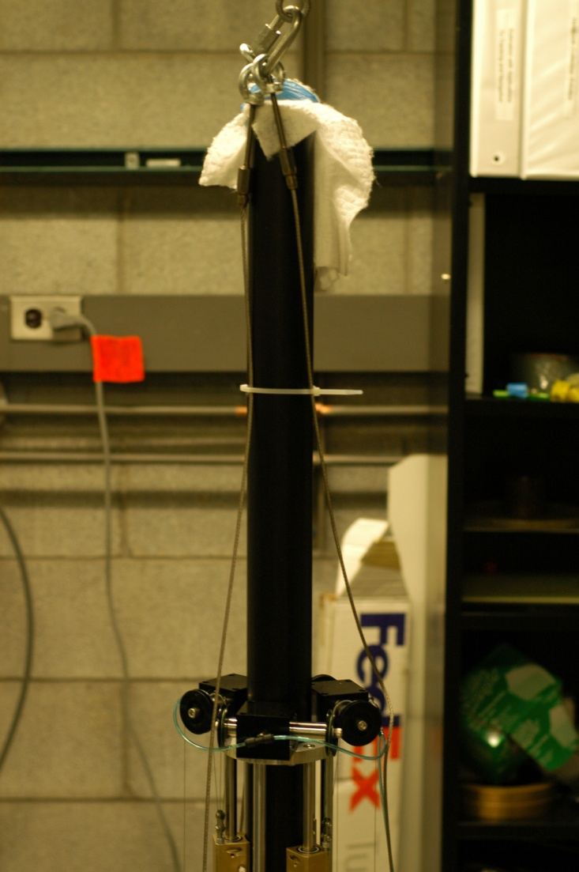
Figure 28: Location of Zip Tie for Hanging Stages

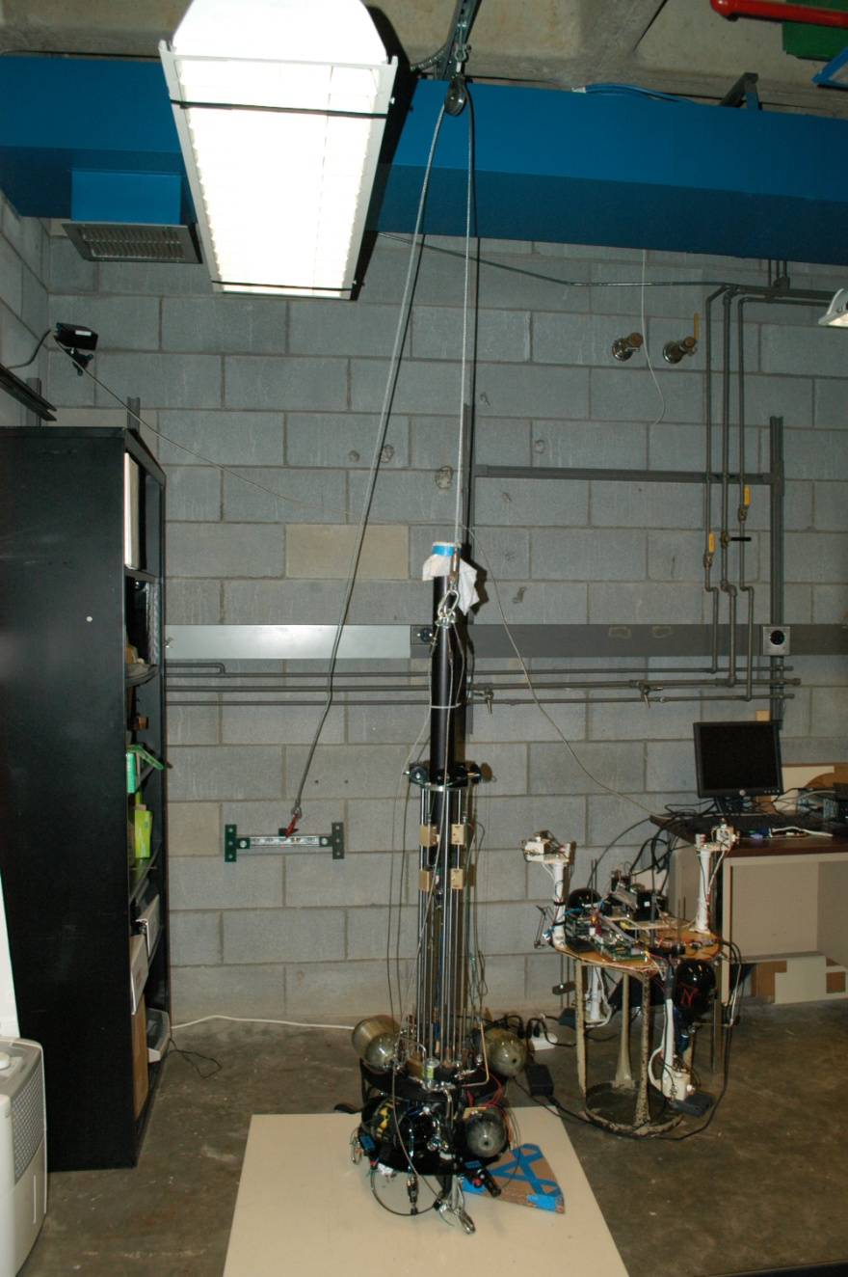
Figure 29: Counterbalancing and Translation Stages Docking System

Replacing the filling hardware
The filling quick connect hardware occasionally needs to be replaced.

Knicks in the epoxy floor
Knicks or bumps on the epoxy floor can be sanded down using the high grade steel wool or krocus paper. Keep in mind that only damage which bumps up over the surface of the floor can be fixed. If the damage goes down into the floor then there is nothing that can be done about it.
- Using blue painters tape, tape the section of the floor around the damaged spot.
- Rub the steel wool gently over the damaged spot to sand down the bump.
- Remove the tape and use it to pick up any steel wool remains that are left on the floor.

The ADAMUS Simulink Toolbox

Actuators

Motion Control System
Overview: Legacy

Inputs

Outputs

Mask

Relay Board
This block is used to control the IR-104 Relay Board from Diamond Systems which is attached to the PC104 on the AS. This relay board controls the thrusters. Note: There is an error in the wiring so that thrusters 8 and 9 are swapped and so are thrusters 11 and 12. This block uses the S-function sfun_ir104pbf.c. Thrusters 3 and 6 are also not operational, and thruster 4 is exhibiting lag before actuating.

Inputs
Input (xN) | The number of inputs is set in the mask using the Channel Vector field. Each input expects 1 or 0 indicating the corresponding relay should be ON or OFF.

There can be any number of inputs but they should all be either 1 for opening the relay or 0 for closing it.

Outputs
None.

Mask
Channel Vector | An array indicating the number of inputs as well as which relays they should go to. | E.g. [1 3 2 4] would give the block 4 inputs corresponding to relays 1, 3, 2, and 4 respectively.
Reset Vector | I’m not sure exactly what this one does, it can be set to an array of zeroes equal in size to the number of inputs | E.g. [0 0 0 0]
Initial Value Vector | An array of values (1:ON or 0:OFF) to be used as initial values for each of the relays mentioned in the channel vector | E.g. [0 0 0 0]
Sample Time
Base Address | The hardware address of the PC104 that the IR-104 Relay Board is on. For the 6DoF testbed this has been 0x240. | E.g. 0x240

Controllers

LQRY Solution
Overview: Legacy.

Lyapunov Controller
A controller using the Lyapunov control method outlined in Kelsey Saulnier, David Perez, Grace Tilton, Daniele Gallardo, Chris Shake, Rosemary Huang, Riccardo Bevilacqua, "Operational Capabilities of a Six Degrees of Freedom Spacecraft Simulator", AIAA GNC Conference 2013, Boston, MA. (AIAA 2013-5253).

Inputs
x_current | The current state of the controlled testbed. [position, rotation (quaterion 0123), velocity, angular velocity]
x_desired | Desired final state of the testbed. (this can be changed over time) [position, rotation (quaterion 0123), velocity, angular velocity]
other | An array containing [K1, K1, K1, K2, K2, K2, K3, K3, K3, K4, K4, K4, Position threshold, Angle threshold (deg), error mask (12x1), delta]
(t) | (goto) This block expects there is a goto block somewhere which has the time and is called “t”
(enabled) | (goto) This block expects there is a goto block somewhere which tells it when it is enabled. There is such a goto in the State Estimator block so if that block is being used you do not have to worry about this.

Outputs
U | A (12x1) vector of 1s and 0s indicating the state the relays should be in to implement the control. (this output can be fed into the Relay Board block with the 8&9 and 11&12 values switched.
output | Value of the Lyapunov function. Often this is used for debugging output.
error | Current error as seen by the controller. This error is output after the thresholds are applied.
(A_read) | (from) Outputs A matrix of the Linear Reference Model as it is created from the “other” input K values.
(thres_read) | (from) Outputs the threshold values being used.
(delt_read) | (from) Outputs the actuation frequency being used. (ACTUATION FREQUENCY HAS NOT BEEN TESTED IN THIS CONTROLLER)

Mask
mass | The mass of the entire testbed in kg. | E.g. 41.2
H Matrix (thruster map) | The matrix which describes the thruster layout on the AS.
(Inertia Matrix)^-1 | The inertia matrix of the AS.
Sample Time
Read Other Parameters From File | Should always be checked. If you feel like digging through the code it can be removed.

Non-Linear Quaternion Feedback
Overview: Legacy.

FileIO
File I/O is weird with RTAI since you do not want to interrupt the process that you are running in RTAI so it will not be interrupted. That would be silly. So these are some blocks which were created to try to prevent interruption.

Read Vector From File
This can only read numbers so far! Note that there is a very specific file format that is required for this to work. It is shown in the mask. It looks something like this:
Label1, value1
Label2, value2

Etc… The array that is output will contain [value1, value2]. The label1 and label2 are there for convenience when editing the file and can be any string which does not include any spaces.

Inputs
None.

Outputs
An array of all the values that were read from the file.

Mask
FileName | The file name that you want to read from. I do not know why but it will not let you exit the dialogue unless that file exists in the current directory (it can be empty) | E.g inputData.txt
Sample Time
Number of Elements | Number of values that you are expecting to read from the file. | E.g. 33

ToFile
This is a RTAI friendly save function. As the model runs, it collects data in RAM which is later stored in a specified .dat file. Occasionally when this is used in a model you can receive no output. I do not know what causes this to happen but I find that removing parts of the model can resolve this. Especially if you accidentally have “to workspace” or “scope” blocks in the model. This block has not been tested with multiples of the same block in one model.

Inputs
A vector of data to save each time step

Outputs
The output of this block is a file whose name is specified in the mask.

Mask
Number of Channels | Basically the number of elements the input vector should expect to hold. | E.g. 5
Input Type | What type of data does the input vector hold? This block does not support mixed data types. | E.g. Double
Fprintf Output String | This has to do with the format of the output. If it is a number and you don’t know what to put, just keep the default. | E.g. ‘%f’
[StartTime StopTime] | Along with Sampling Time, this defines the size of the output. | E.g. [1.1 10]
Sampling Time

Image Processing
Overview: Legacy.

Firewire Frame Grabber
Overview: Legacy.

Image Processor
Overview: Legacy.
Overview: Legacy.

Observers

State Estimator
This is the Kalman/Extended Kalman filter duo which has been designed to create velocity data from the PhaseSpace output. A Kalman filter is used to smooth the position data and estimate the velocity and the Extended Kalman filter (EKF) is used to smooth the attitude data. A derivative and low pass filter is used to create the angular velocities. This is done instead of using the EKF because the EKF was either too slow or too noisy with no middle ground.
If this block must be edited, note that the quaternions are handled in a peculiar manner. All blocks used in the 6DoF control models (Linux_Control.mdl, PC104_Control_new.mdl) used to use the quaternion convention ([123]4) but have since been changed to (0[123]). This change proved difficult when dealing with the filter. For this reason (and perhaps laziness) the filter takes the quaternions as (0[123]), changes them to ([123]4), does its filtering, then changes them back to (0[123]) to be output.

Inputs
x_meas | This should be a vector like so: [position (mm), quaternion (0[123]), zerosx6].
avail_meas | This should be the flag output which says whether there is a new measurement or not. This can be the flag output of the PhaseSpace block.
runstate | This is 1: Using PhaseSpace or 0: Running a Simulation. The Sensor Package has an output which works for this.

Outputs
Initial Condition | The full state when the estimator first comes online. This output is duplicated in the (initCond) goto output. This is used in trajectories when it is desirable to return to the starting point.
Enabled | 1: Estimator has started outputting good values, 0: Estimator has not yet started output good values. This is duplicated in the (enabled) goto output.
x_est | A state vector of estimated values: [x(mm),y,z,q0,q1,q2,q3,vx(mm/s),vy,vz,w1(rad/s),w2,w3]
(initCond) | Duplicated for convenience of using a goto instead of a wire.
(enabled) | This is used by the Lyapunov Controller block and possibly other controller blocks so that they know when they can trust the current state.

Mask
These values are all defined in the file InitializeDynamics.m for the 6DoF testbed. If there are doubts on what the values should be, check in that file. The example inputs are defined there.
State transition matrix |  | E.g. F
B |  | E.g. B
Process noise covariance matrix |  | E.g. QK
Position mask | A 3x6 matrix [eye(3), zeros(3)] | E.g. HK
Observation noise covariance |  | E.g. R
Initial covariance matrix |  | E.g. P0
Sample Time
Process noise covariance - omega |  | E.g. sigOm
Process noise covariance - Quaternion |  | E.g. sigQ
Observation noise covariance |  | E.g. R_att
Angle mask | A 4x7 matrix [eye(4), zeros(4,3)] | E.g. H_att
Inertia: J11 |  | E.g. PARA.JZ(1,1)
Inertia: J22 |  | E.g. PARA.JZ(2,2)
Inertia: J33 |  | E.g. PARA.JZ(3,3)
Initial covariance matrix |  | E.g. P0_att

Sensors

DAQ
Overview: Legacy.

KVH DSP-300 FOG
Overview: Legacy.

KVH DSP-300 FOG 1
Overview: Legacy.

Metris iGPS Position Measurement
Overview: Legacy.

Ocean Server Battery Controller
Overview: Legacy.

PNI Micro-Mag 3-axis Magnetometer
Overview: Legacy.

PhaseSpace
This block collects data from the PhaseSpace server about the position and attitude of the testbed

Inputs
There are no true inputs to this system. However, you need to input the rigid body definition manually in the sfunction sfun_PhaseSpaceC.c which is located in the /usr/local/MATLAB1/R2012a/toolbox/ADAMUS_library/src/c folder.

Outputs
Position & Attitude | [[x,y,z](mm), [q0,q1,q2,q3]. This output can flip randomly. See PreventJumps for one solution)
Condition | This is supposed to be about how confident the PhaseSpace server is about its measurements. They are very unclear about what this output means.  The very first member of this array however is an error code from the sfunction. If the first output is not zero that means there was an error in communicating with PhaseSpace. This is often used to stop the model. (See implementation of Sensor Package for an example)
Flag | 1: Output trustworthy, 0: Output not trustworthy.

Mask
Server Name: | The IP address of the PhaseSpace server | E.g. 192.168.0.9
Sampling Time:

Simulators

6-DoF Rigid Body Satellite Dynamics
This is an old block. It must be tested for accuracy before it is used again. The dynamics are currently output from the Sensor Package block when the dynamics are simulated.

Linear Reference Model
This is an old block and must be updated before it is used. It should contain the linear reference model which is used when creating the Lyapunov Controller and is intended to be used as a reference for tracking in the future.

Orbital Perturbations
Overview: Legacy.

Sensor Package
This package requires the Simulink Aerospace Blockset

Inputs
(U) | (from)Control vector for the current time step

Outputs
X_meas | The measured values for position and orientation [position(mm), quaternion [0(1,2,3)], zeros(1,6)]
Avail_meas | 1 or 0 at each time step indicating whether the output value is new and can be trusted.
Runstate | 1: Real, 0: Simuated

Mask
Use PhaseSpace measurements | Checked: Real dynamics from PhaseSpace used. Unchecked: Simulated dynamics used.
Sample Time
Generate noise | Checked: Simulated dynamics add noise similar to the noise found in PhaseSpace measurements.
H matrix | The thruster map: [Forces,Moments]’ = H*U | E.g. H
Control amplitude | Of each thruster in newtons. This is a single value as heterogeneous thrusters are not yet supported. | E.g. CONTROL.AMP
Initial position in inertial axes | In meters
Initial velocity in body axes | In meters/second
Initial Euler orientation | [roll, pitch, yaw]
Initial body rotation rates
Initial mass | Just the mass in kg… | 42.1
Inertia | Matrix | E.g. PARA.JZ

Transformations

PreventJumps
This block is used to prevent the quaternion from jumping back and forth between its two forms (positive and negative). If it detects a jump across zero of a certain size it begins inverting all the quaternions until another jump is detected.

Inputs
qJumps | A quaternion (0[123]) which may jump around between its positive and negative forms randomly.
availData | Availability data such as that output from the PhaseSpace block.

Ouputs
qNoJumps | The same quaternion that was input, this time without any jumps.

Mask
None.

reorderQ_0to4, reorderQ_4to0
In earlier versions of the GNC model there was a lot of need to switch between the two quaternion representations. 0to4 goes from the scalar first form to the scalar last form and 4to0 does the opposite.

quaternion to modified Rodrigues parameters
This block switches quaternions to modified Rodrigues parameters. This operation is no longer used in any of the models.

UDP Comms

Byte Pack, Byte Unpack

Linux & Win32 UDP Receive Binary, Linux & Win 32 UDP Send Binary

clock signal
If a clock is needed in an RTAI compiled model then this is the clock that should be used. For some reason the other clock does not work in RTAI compiled form!

The ADAMUS Code Library

Scripts
The scripts in the Kelsey-ControlTest file should all have descriptive headers about their purpose and use.

stateTransitionGen.m
This is a script which is used to calculate the symbolic representations of the matrices needed to write the extended Kalman filter in the State Estimator block.

headerTemplate.m
To standardize the comment format of the scripts and functions written in matlab, there is a format to follow in this file. It is highly recommended to use this format for good coding practice. Please try to keep up with commenting!

InitializeControl.m
This function is used by Linux_Control.mdl and PC104_Control_new.mdl to initialize the Lyapunov parameters which are necessary to run the models.

InitializeDynamics.m
This function is used by Linux_Control.mdl and PC104_Control_new.mdl to initialize the information needed by the simulated Sensor Package and the State Estimator Kalman filter information.

Functions

plotData
This is the main function used for plotting data from PhaseSpace control experiments. Often the wrapper function plotDataFrom is used to automate the process though since there are a lot of inputs to keep track of in this function.

Inputs
simTime | Time vector for the x-axis of the plots
availl | Availability of new data (‘Flag’ output from PhaseSpace)
pos_est | Vector of estimated positions (red solid line)
pos_mes | Vector of measured positions (black dots)
vel_est | Vector of estimated velocities (red solid line)
vel_mes | Vector of measured velocities (black dots)
quater_est | Vector of estimated quaternions (red solid line)
quarter_mes | Vector of measured quaternions (black dots)
omega_est | Vector of estimated angular velocities (red solid line)
omega_mes | Vector of measured angular velocities (black dots)
control | Vector of control output (1,0) for 12 thrusters
plotDegrees | 1: Angle plots in Degrees, 0:Angle plots in radians
plotQuaterDiff | 1: Quaternion derivative is plotted
plotEuler | 1: Plot euler angles (YXZ)
subplot | 1: Group plots into subplots, 0: All plots separate
plotAvail | 1: Make a bar graph of the availability, 0: Don’t.
closeAll | 1: Close all currently open plot windows before making any new ones.

Output

plotDataFrom
This function used to plot data output from the PC104 and Linux control models.

Inputs
type | ‘PC104’ – Old (pre 10/2013) data from experiment  ‘PC104_New’ – Data from PC104_Control_new.mdl  ‘Linux’ – Data from Linux_Control.mdl
saveData | 1: Save data in Autosave folder, 0: Don’t save data.

Outputs
Some graphs. If saveData was 1, you will be prompted to enter a filename to save as. You can cancel the save in that dialogue.

plotRobot3D
Plotting function for the 3D cube plot and videos. Some aspects of this function are not complete.

Inputs
x_est | A vector of position measurements (mm)
x_est_att | A vector of quaternion measurements (0[123])
timeOut | A vector of time
timeStep | Amount of time between cubes
(markOrigin) | Internal: 1: Place a * on the origin, 0: Don’t.
(greyscale) | Internal: 1: Make graphs black and white, 0: Color!
(centerOfMass) | Internal: 1: Mark the center of mass projected on each plane, 0: don’t mark the center of mass.
(movementArrow) | Internal (not implemented):
(showmovie) | Internal: 1: Show and make a movie of the cube moving instead of a plot. 0: Make a plot of the cube moving.
(showGoal) | Internal: (not implemented)
(movieName) | Internal: ‘movAVI.avi’, the name of the file to store the movie as when it is created.

Outputs
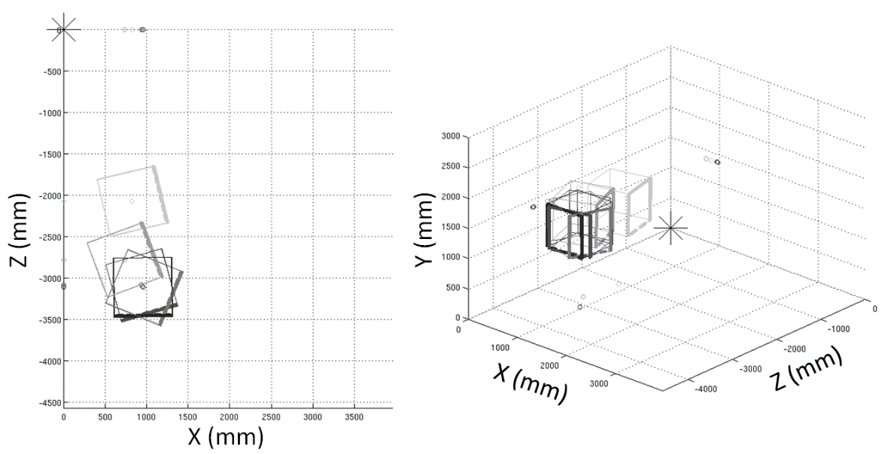
Figure 30: plotRobot3D outputs 3D cube graphs of the robot experiment. They can be rotated to also give 2D views.

Models

Linux_Control.mdl

PC104_Control_new.mdl

PC104_Control_paper.mdl
A cleaned up version of PC104_Control_new.mdl which is used to represent the code in papers.

Unlinked_PhaseSpace.mdl
This is an old version of the model which has been disconnected from all required libraries and is therefore independent.

S-functions (non-library)

sfun_PhaseSpaceAll.c
This sfunction was created to output the locations of each LED separately. This is used when you need to do a new PhaseSpace Rigid Body Capture to help with finding the location of the center of rotation.

sfun_readAnalogPin.c
This is used to read the inputs to the I/O board attached to the PC/104.

Troubleshooting
Problems we have encountered before and their solutions

ssh to pc104 does not work
Occasionally the desktop computer becomes unable to connect to the PC104. This can happen for a number of reasons. The most common way to fix this problem is to turn off the desktop computer and PC104. While they are off, unplug the ADAMUS router, wait 10 seconds, then plug it back in. After the router has restarted, restart the PC104 and desktop computer. In the past it has occasionally taken more than one iteration of this process to regain the ability to connect.
The desktop computer running ubuntu has two Ethernet connections. The network settings in Ubuntu may be such that it is not properly prioritizing Ethernet adaptors when trying to connect to the PC 104 of a robot. Removing the hardline Ethernet connection to the computer, and then rebooting the Ubuntu Terminal, seems to fix the issue, and once again, it is possible to SSH into the PC104.

Desktop computer cannot connect to the ADAMUS server
If you click the desktop icon labeled “server” and receive an error about the server being unable to be reached. This is could mean the server is off or disconnected but more often it is an error on the side of the desktop computer. Before worrying if the server is working, restart the desktop computer and try again.

PC104 will not turn on/show a magenta LED
This has happened occasionally and I do not know why. When this happens:
- Check that the PC104 has sufficient battery. The battery should have more than two bars remaining to be certain there is sufficient power.
- Remove the power connection to the PC104 and reconnect it. See Figure 28.
- 5/27/14 – KT – It does come to pass that the PC 104 will just flash pink, then nothing happens. Removing and reseating the power connector identified in Figure 28 does seem to fix the problem. It is possible that there is something loose with this connection. It may also be the case that there is insufficient power from the batteries for the system to turn on. You can also try unplugging a nonessential piece of equipment (such as the motor driver board) and then turning on the PC104. Reconnect whatever you unplugged after the PC104 turns on.
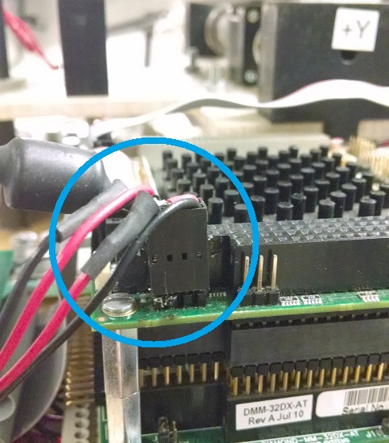
Figure 31: Power connection to the PC104.

The puck has a solid green light – won’t transmit data
If the puck is turned to the on position, and the light is solid green, it has entered a state whereby it is acting as if it is charging, but it is not connected to a usb charging source. To clear this state, allow the puck to lose all of its charge. Once the puck is fully discharged, which will probably take at least 24 hours, then reencode the puck for the appropriate number of LED’s. This will clear the issue.

Many errors similar to mxCalloc when compiling
When compiling code generated by Simulink you will occasionally get many errors which say things like “mxCalloc.” This will most often occur after you add files to the automatically generated folder. The most common culprits are:
- You must add a .c file to the auto-generated folder (the one ending in _rtai) which corresponds to a custom made or ADAMUS library block.
- The .o file from a custom made or ADAMUS library block is included in the auto-generated folder and must be deleted.

Connecting the PC104 to a monitor and keyboard

The handle fell off of the fill nozzle! D:
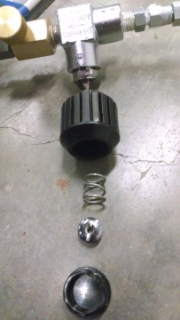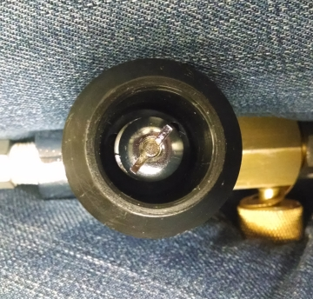
Figure 32: Broken fill handle. The picture shows the order the parts need to go back together.

Yup, this happens. To fix it you will need a screwdriver, all the pieces from inside the handle, and a lot of patience. Place the handle back on the fill nozzle and put the spring inside. Next use the screwdriver to compress the spring and screw in the nut to hold it in place.

Sfunction using shared library mex’s but gives linker errors when compiling
If Matlab cannot find the shared library (e.g. libowlsock.so) that you would like to use even though you have added it to /usr/local/lib and it can be used with mex just fine (mex thing.c –lLibrary returns no errors) but then it gives a linker error when run.
Run in a terminal window:
>> ldconfig

The quaternion data is corrupted – Sign flipping Issue
The quaternion data provided by phase space will occasionally flip sign. Now, in principle, flipping every sign on a quaternion would actually render the same euler angles if converted to those values. However, when the data is passed through a Kalman Filter, there will be a spike and noise for ‘a few’ of the cycles after the sign flip. To correct this, is is necessary to ‘pre process’ the data after collected from the phase space but prior to going into an extended kalman filter, such that if all 4 quaternions flip sign, they are flipped back until it happens again.

Program Aborted prematurely in Labview
New data collection programs were written in labview in June, 2014, and moving forward. A command is sent to the robot through a command line interpreter on a pc. If the program faults, it may be necessary to reboot the robot, reboot the primary pc, and reboot the phase space machine.

Known Issues

Reading pdfs from Firefox can crash the desktop computer
I have no idea… I just restart when this happens.

Only one battery of the two on the AS actually works
This is likely an issue with the IBPS system where the batteries connect to the board. There are 4 choices of where to plug in the batteries and we are using two of them. It is possible that using a different two would work but to do this the other two outputs must be turned on which appears require a serial connection to a desktop computer.
Failed attempts at fixing:
- Replaced white cables which connect directly to the batteries. Cables replacement did not help.
- Swapped batteries to opposite cables. The connection problem occurred from the same cable no matter which battery it was attached to.
Update: As of Dec 2015, it appears as though both batteries are working

Vertical guides are warped
One or two of the vertical guides are bent due to the configuration of the high pressure piping on the bottom platform. You will see that the vertical guides are pressed up against the high pressure pipes. There are new vertical guides which can be used to replace the warped ones but two things need to happen first:
- The vertical guides need to be machined to have threads in the top of some of them and pegs on the bottom to fit into the bottom ring.
- Holes have to be drilled in the bottom platform so the ring can be turned slightly from its current position. This will allow the vertical guides to no longer be in contact with the high pressure piping. It is also possible to move all the piping out of the way but it seems that the drilling would likely be easier.

Thrusters 8 & 9, 11 & 12 are swapped
Due to an error during assembly, the wire that should go to thruster 8 goes to thruster 9 and vice versa. Also the wire which should go to thruster 11 goes to thruster 12 and vice versa. This is handled in the software generally by swapping the commands before they go into the Relay Board block.

Thrusters 3, 4 and 6 are not working
Thrusters 3, 4 and 6 are not consistently responding to commands. May have been damaged in transit from RPI to UF. The thrusters activate when struck with a wrench or when nearby thrusters are on. The issue is thus most likely the solenoid valve within the thruster not creating enough magnetic force. The solenoid valves will be changed soon.

Notes for the Future
This section is just to record any notes for future versions of the testbed if they are ever built.
- Currently the length of experiment is limited by the tanks which fuel the air bearings. These should be larger or there should be more of them.
- The central column is metal and very heavy. This could probably be made of plastic.
- The hold between the CD and the vertical guides is tiny and tends to grab the plastic piping. Maybe this hole should be larger.
- An arduino could be used instead of the PC104 to control things. This would make life way easier and would make it easier to add sensors and actuators. MATLAB/Simulink programs could be developed on Windows instead of Linux Computers. Simulink coder could still be used to convert Simulink programs into Arduino code.
- It would be nice to have the vertical DOF air bearings separate from the rotational air bearings to prevent the need to restrain the vertical motion when running experiments which use less than the full DOF.

Contacts and Support
IT Support
PhaseSpace | Kan Anant | P: (510)798-4497  E: kan@phasespace.com
PC104 | Mike Shultz | P:  E: mike@ald-usa.com

APPENDIX A – Setting up the desktop computer

- Updated: 2/15/2011 – Kelsey Saulnier (Added Wireless setup and Compatible PC104 Setup parts)

1. After installing Ubuntu 9.04, in terminal with root access (to get root access, open a terminal and type "sudo su" (no quotes). It will ask for your password.):
>> apt-get update
>> apt-get install cvs subversion build-essential
>> apt-get install kernel-package linux-source libncurses5-dev
>> apt-get install libtool automake
>> apt-get install bison flex
>> apt-get install libboost-dev libboost-program-options-dev libgs10-dev
>> apt-get install gfortran sablotron tcl8.5-dev tk8.5-dev xaw3dg-dev libpvm-dev libgtkhtml2-dev libzvf-dev libvte-dev
>> apt-get install make
2. Get Kernel 2.6.28-7
>> cd /usr/src
Either cisit http://www.kernel.org/pub/linux/kernel/v2.6/ and download 2.6.28-7 manually or >> wget http://www.kernel.org/pub/linux/kernel/v2.6/linux-2.6-28.7.tar.bz2
>> bunzip2 /home/(username)/Desktop/linux-2.6.28.7.tar.bz2
>> cp /home/(username)/Desktop/linux-2.6.28.7.tar .
>> tar -xvf linux-2.6.28.7.tar
>> mv linux-2.6.28.7 linux-2.6.28.7-rtai
>> ln -s linux-2.6.28.7-rtai linux
3. Get RTAI 3.7
>> cd /usr/src
Either visit http://www.rtai.org/RTAI/ and download rtai-3.7 manually or >> wget -no-check-certificate https://www.rtai.org/RTAI-rtai-3.7.tar.bz2
>> bunzip2 home/(username)/Desktop/rtai-3.7.tar.bz2
>> cp /home/(username)/Desktop/rtai-3.7.tar .
>> tar -xvf rtai-3.7.tar
>> ln -s rtai-3.7 rtai
4. MesaLib 7.5
Visit http://www.mesa3d.org and download MesaLib-7.5.tar.bz2
>> cd /usr/local/src
>> bunzip2 /home/(username)/Desktop/MesaLib-7.5.tar.bz2
>> cp /home/(username)/Desktop/MesaLib-7.5.tar .
>> tar -xvf MesaLib-7.5.tar
>> cd Mesa-7.5
>> make realclean
>> make linux-x86
>> make install
5. EFLTK
>> cd /usr/local/src
>> apt-get install gettext
>> svn co https://ede.svn.sourceforge.net/svnroot/ede/trunk/efltk
>> cd efltk
>> autoconf
>> ./configure --disable-mysql --disable-unixODBC
>> ./emake
>> ./emake install
>> pico -w /etc/ld.so.conf
Add /usr/local/lib to the end of the file and save it. ( To save press: ctrl-X, Y, Enter )
>> /sbin/ldconfig
>> cp efltk-config bin/
6. Comedilib
>> cd /usr/local/src
Visit http://www.comedi.org/download and download comedilib-0.8.1.tar.gz
>> gunzip /home/(username)/Desktop/comedilib-0.8.1.tar.gz
>> cp /home/(username)/Desktop/comedilib.-0.8.1.tar .
>> tar -xvf comedilib-0.8.1.tar
>> cd comedilib-0.8.1
>> sh autogen.sh
>> ./configure --sysconfdir=/etc/
>> make
>> make install
>> make dev
7. Patching Linux Kernel
>> cd /usr/src/linux
>> patch -p1 < /usr/src/rtai/base/arch/x86/patches/hal-linux-2.6.28.7-x86-2.2.06.patch
>> wget http://hart.sourceforge.net/files/config-2.6.28-rtai_i386
>> cp config-2.6.28-rtai_i386 .config
>> make oldconfig
>> make menuconfig
Make sure there is a * next to ext3 under filesystem.
8. Compiling and Installing Kernel
>> cd /usr/src/linux
>> make-kpkg clean
>> make-kpkg --initrd kernel_image kernel_headers kernel_source
>> dpkg -I linux-headers-2.6.28.7-rtai_2.6.28.7-rtai-10.00.Custom_i386.deb
>> dpkg -I linux-image-2.6.28.7-rtai_2.6.28.7-rtai-10.00.Custom_i386.deb
>> cd
>> update-grub
>> reboot
9. RTAI 1st Pass
>> uname -a && cat /etc/*release
Output should show that the rtai linux is running. If not, reboot again and make sure to choose the correct linux in the bootloader.
>> cd /usr/src/rtai
>> make menuconfig
Menu General: Verify defaut directories:
- *installataion directory /usr/realtime
- *kernel source directory /usr/src/linux

Menu Machine (x86):
- Adjust number of CPUs to the number available on the machine. (e.g. 2 for dualcore)

>> make
>> make install
>> nano /etc/environment
Add :/usr/realtime/bin to the end of the PATH= line before the last "
>> reboot
10. Install Comedi
>> cd /usr/local/src
Visit http://www.comedi.org/download/ and download comedi-0.7.75.tar.gz
>> gunzip /home/(username)/Desktop/comedi-0.7.75.tar.gz
>> cp /home/(username)/Desktop/comedi-0.7.75.tar .
>> tar -xvf comedi-0.7.75.tar
>> cd comedi-0.7.75
>> sh autogen.sh
>> ./configure --with-linuxdir=/usr/src/linux --with-rtaidir=/usr/realtime
>> make
>> make install
>> depmod -a
>> make dev
>> cp include/linux/comedi.h include/linux/comedilib.h /usr/include
>> cp include/linux/comedi.h include/linux/comedilib.h /usr/local/include
>> ln -s /usr/include/comedi.h /usr/include/linux/comedi.h
>> ln -s /usr/include/comedilib.h /usr/include/linux/comedilib.h
>> cd /usr/src/rtai
>> make menuconfig
Menu Add-Ons:
- Select RealTime COMEDI support in user space.
Change path to be "/usr/local/src/comedi-0.7.75"

Menu RTAI Lab:
- Select RTAI Lan.
Change path to be "/usr/local/src/efltk"

>> make
>> make install
>> make dev
>> insmod /usr/realtime/modules/rtai_hal.ko
>> insmod /usr/realtime/modules/rtai_up.ko
>> insmod /usr/realtime/modules/rtai_fifos.ko
11. RTAI tests
>> cd /usr/realtime/testsuite/kern/latency
>> ./run
Press Ctrl+C to stop the test after some data has been output. Do this for the following tests as well.
>> cd ../preempt
>> ./run
>> cd ../switches
>> ./run
If results of any of the tests are bad or if they do not work, do >> make dev under >>cd /usr/src/rtai and then try again.
12. Modifying startup file
>> pico -w /etc/rc2.d/S99rc.local
Add the following to the file after the section that looks like: do_start(){
// Stuff
}

sync
insmod /usr/realtime/modules/rtai_hal.ko
insmod /usr/realtime/modules/rtai_up.ko
insmod /usr/realtime/modules/rtai_fifos.ko
insmod /usr/realtime/modules/rtai_sem.ko
insmod /usr/realtime/modules/rtai_mbx.ko
insmod /usr/realtime/modules/rtai_msg.ko
insmod /usr/realtime/modules/rtai_netrpc.ko ThisNode="127.0.0.1"
sync

>> cd /usr/src/rtai
>> make dev
>> reboot
13. Retry three RTAI tests and also type
>> /usr/realtime/bin/xrtailab &
See if the GUI pops up (it should!)
If any of the tests do not work, do >> make dev under >> cd /usr/src/rtai and then try again. If they still do not work it is likely that the 'insmod /usr/realtime/modules/rtai' lines were added in a bad place. To check, try adding "> /home/(username)/out.log" (no quotes) attached to one of the insmod lines (e.g. insmod /usr/realtime/modules/rtai_sem.ko > /home/(username)/out.log). Reboot the computer and see if a file named out.log has appeared in /home/(username)/. If not, move the lines elsewhere in the file and try again. If so, any errors generated by the line will be written there to help with debugging.
14. Install Matlab
Get a matlab licence and install it.
>> cd /MATLABROOT/
>> mkdir rtw/c/rtai
>> cp -r /usr/src/rtai/rtai-lab/matlab/* /MATLABROOT/rtw/c/rtai
Start Matlab
>> change working directory to /MATLABROOT/rtw/c/rtai
Type “setup” into matlab, run it.
Move to devices folder
Mex all files in the folder (e.g. Mex sfun_comedi_data_read.c)
Go up a level in folders
Double-click on rtai.tmf
Do a search on ANSI. Delete $(ANSI_OPTS) when found (there is only one)
Do a search on RTAIDIR. Delete everything after = and replace with /usr/realtime
Go to /MATLABROOT/bin in Matlab
Double-click on mexopts.sh
Do a search on ANSI and delete -ansi when found (four different places)
15. First test of Simulink, compiled and executed under RTAI.
Open Matlab and go to /usr/local/matlab/rtw/c/rtai/examples
Copy the test.mdl
Go to /usr/local/src
Create new folder named tests
Paste the test.mdl in this folder
Open test.mdl
Real-Time Workshop: go to Simulation->Configurations Parameters in the scrolling down menu. Select Real-Time Workshop tab.
- Select rtai.tlc as target
- Check generate code only.
Click generate.

Go back to root terminal
>> cd /usr/local/src/tests/test_rtai
>> make -ftest.mk (generates executable)
>> cd ..
>> ./test -v -f 5 (runs for 5 seconds)
Note for compiling code: if the make -f nameofthemodel.mk complains that it does not find nameofthemodel.o file, copy the nameofthemodel.c file where you are launching the make -f nameofthemodel.mk, or, in Matlab, remember to include the folder containing nameofthemodel.c file in Matlab path before generating code from Real-Time Workshop
16. Ad Hoc Wireless infrastructure installation (with Belkin Wireless G USB Network Adapter)
Connect the Belkin Wireless G USB Network Adapter to a USB port.
Download RT_73 driver. These directions are for 2008_0506_RT73_Linux_STA_Drv1.1.0.1.tar.gz
>> lsusb
Record the device ID from the line that looks like:
Bus 008 Device 002: ID 050d:705a Belkin Components F5D7050A Wireless Adapter
NOTE: The following directions closely follow the directions in (WiFiDocsBelkin_F5D7050_ver_3000_(Ralink_rt73_driver), 2008)
>> gksudo gedit /etc/modprobe.d/blacklist
Add the following to the end of the file:
# Added when rt73 module was installed:
blacklist rt73usb
blacklist rt2570

Save, exit, and reboot.

Open a terminal.

>> sudo apt-get install linux-headers-‘uname –r’
>> sudo ln –s /usr/src/linux-headers-‘uname –r’ /lib/modules/’uname –r’/build
>> sudo apt-get install tofrodos
>> tar xvzf _0506_RT73_Linux_STA_Drv1.1.0.1.tar.gz
>> cd 2008_0506_RT73_Linux_STA_Drv1.1.0.1/Module
>> chmod –R 775 *
>> fromdos *
>> cp Makefile.6 Makefile
>> gedit rtmp_def.h
Add a line in the section labled #define RT73_USB_DEVICES that describes your Belkin device:
{USB_DEVICE(0x050d,0x705a)}, /* Belkin F5D7050 ver 3000 */
Save file and exit.
>> make clean
>> make
>> sudo gedit rtmp_main.c

Search for and comment out all kill_proc lines. kill_proc is depreciated and will cause errors.

Save and exit.

>> sudo gedit rtmp_info.c

Change line 997 to read (bold should be only change):
current_val = iwe_stream_add_value(info, <leave other parameters the same)

Change line 870 and 842 to read:
current_val = iwe_stream_add_point(info,<leave other parameters the same>)

Change line 855, 830, and 813 to read:
current_val = iwe_stream_add_event (info, <leave other parameters the same)

Save and exit.

>> sudo iiptables –A INPUT –p tcp –dport ssh –j ACCEPT
>> sudo bash –c “iptables-save > /etc/iptables.rules”
Choose adhoc and and IP in the same family of the robots' once.
At this point the Ethernet port of the PC104 must be set up as static IP and the IP has to be the one we want to assign to the robot:
>> pico -w /etc/network/interfaces

This file should read similar to this:
auto eth0
iface eth0 inet dhcp
auto lo
iface lo inet loopback
auto rausb2
iface rausb2 inet static
pre-up ifconfig rausb2 up
wireless-essid adamus-jec1034
address <desired IP: e.g. 192.168.0.8>
netmask 255.255.255.0
network <network IP: e.g. 192.168.0.0>
broadcast <e.g. 192.168.0.255>
gateway <e.g.192.168.0.1>
pre-up iptables-restore < /etc/iptables.rules
up route del -net 169.254.0.0 netmask 255.255.0.0
up sudo route add -net 169.254.0.0 netmask 255.255.0.0 dev eth0

Save and exit.

APPENDIX B – Setting up PC104

(by Chris Shake, January 2011)

- Updated: 2/15/2011 – Kelsey Saulnier (Added final touches section)

Notes/Disclaimer:
This manual was written for using rtai-linux on an ADLS15PC PC-104 system from Advanced Digital Logic (http://www.adl-usa.com/products/cpu/datapage.php?pid=ADLS15PC) and describes the steps taken in December 2010 to make it functional. Due to the changing nature of the linux kernel and the frequency with which it is updated, the instructions provided may need to be updated with newer version numbers if this is to be replicated later. The basic instructions are taken from rtai installation notes provided with the HART project on sourceforge (http://hart.sourceforge.net/rtai_installation_10_04.html), which may contain updated version numbers or tricks for newer kernel and/or other software versions.
These directions require the following:
- ADLS15PC PC-104 system base
CompactFlash card used as the main hard drive (16GB in our case)
Ubuntu 10.04 LTS 32-bit desktop edition installation CD
Working internet connection
A USB CompactFlash card reader for a desktop PC and a virtual machine emulator – these instructions assume Oracle VM VirtualBox (internet connection only required on desktop PC)
1. Preparation (Common):
- Download an Ubuntu installation CD from [http://www.ubuntu.com/desktop/get-ubuntu/alternative-download], specifically the 10.04 desktop i386 version.
2. Create a virtual machine (VM)
NOTE: If no CD drive is available or the system cannot be connected to the internet during setup, it is possible to install Ubuntu on a virtual machine and transfer the installed system to the CF card. This can be done on any Windows or Linux computer (referred to as the host PC), the only requirement is a CF card reader for it.
Visit [http://www.virtualbox.org/] and download Virtual Box.
Run VirtualBox.
Select Machine->New… and follow the wizard.
On the VM Name and OS Type page:
- Select Linux from the Operating System dropdown.
Select Ubuntu from the Version dropdown.

On the Memory page:
- Set the amount to what you have available on the PC104.

On the Virtual Hard Disk page:
- Create a hard disk the same size of your compact flash.

3. Configure VM
Connect your CF card and reader to the host machine
Open the Settings menu for the newly created VM.
On the USB tab:
- Enable the USB (and 2.0) controller
Click the "Add Filter From Device" button to the right of the empty table (which looks like a USB plug with a green + on it.)
  - Select the card reader to enable direct access by the VM.

On the Storage tab (still in the Settings menu):
- Remove all the components in the Storage Tree area.
Add an IDE Controller (default type PIIX4).
Add a new Hard Disk and CD/DVD Device.
Make sure the HD device is in the IDE Primary Master slot
Make sure the HD device has the virtual HD selected in the Hard Disk dropdown
Make sure the CD device is the IDE Primary Slave
Make sure the CD device has the Ubuntu installation .iso selected as the device.
NOTE: Selecting the .iso may require clicking the Virtual Media Manager icon next to the device dropdown and then adding the image to the menu from that manager.

Save the changes
Start the new VM. ( It should boot to the Ubuntu installer)
Follow the steps on the screen to install the system, using defaults.
Once it has finished, it will tell you to reboot and remove the CD, which can be done by clicking the CD icon on the bottom right of the VM window and unmounting the image.
4. RTAI installation.
NOTE: This section is a subset of the HART instructions as mentioned in the Notes/Disclaimer section, check the website for newer versions if any of these commands fail.
Boot into the newly install Ubuntu system.
Open a console window and install the following packages:
>> sudo apt-get install cvs subversion build-essential
>> sudo apt-get install libtool automake libncurses5-dev
>> echo deb http://www.linuxcnc.org/lucid lucid base emc2.4 > /tmp/linuxcnc.list
>> echo deb-src http://www.linuxcnc.org/lucid lucid base emc2.4 >> /tmp/linuxcnc.list
>> sudo mv /tmp/linuxcnc.list /etc/apt/sources.list.d/
>> gpg --keyserver pgpkeys.mit.edu --recv-key 8F374FEF
>> gpg -a --export 8F374FEF | sudo apt-key add -
>> sudo apt-get update
>> sudo apt-get install linux-headers-2.6.32-122-rtai linux-image-2.6.32-122-rtai
Configure the boot manager to display the kernel options with a delay instead of silently booting:
>> gedit /etc/default/grub

Comment out the GRUB_HIDDEN_TIMEOUT= and GRUB_HIDDEN_TIMEOUT_QUIET= lines by adding a hash (#) at the start of the line.
Save and exit gedit.
>> sudo update-grub
Reboot into the rtai kernel.
NOTE: If the rtai version is not selected by default, make a note of which position it is in. Open /etc/default/grub again and change the GRUB_DEFAULT= line to point to the correct option, remembering that the list is zero-indexed, and run "sudo update-grub" again. Repeat until the default option is the rtai kernel so the system will boot to that once the keyboard and screen are disconnected.
Download the rtai package itself:
>> cd /usr/src
>> sudo wget --no-check-certificate https://www.rtai.org/RTAI/rtai-3.8.1.tar.bz2
>> sudo tar xjvf rtai-3.8.1.tar.bz2
>> sudo ln -s rtai-3.8.1 rtai
Configure rtai:
>> cd /usr/src/rtai
>> sudo make menuconfig
In the config menu, check the following options:
- Installation: /usr/realtime
- Linux source tree: /usr/src/linux-headers-2.6.32-122-rtai
- Under Machine, choose number of CPUs as 1

Install the configured rtai:
>> sudo make
>> sudo make install
>> sudo sed -i 's/\(PATH=\"\)/\1\/usr\/realtime\/bin:/' /etc/environment

>> sudo gedit usr/local/bin/start_rtai
Copy the following lines there:
/sbin/insmod /usr/realtime/modules/rtai_smi.ko
/sbin/insmod /usr/realtime/modules/rtai_hal.ko
/sbin/insmod /usr/realtime/modules/rtai_lxrt.ko
/sbin/insmod /usr/realtime/modules/rtai_fifos.ko
/sbin/insmod /usr/realtime/modules/rtai_sem.ko
/sbin/insmod /usr/realtime/modules/rtai_mbx.ko
/sbin/insmod /usr/realtime/modules/rtai_msg.ko
/sbin/insmod /usr/realtime/modules/rtai_netrpc.ko
/sbin/insmod /usr/realtime/modules/rtai_shm.ko
Save and exit.
>> sudo chmod a+x /usr/local/bin/start_rtai
NOTE: The rtai modules can be auto-loaded by calling /usr/local/bin/start_rtai from /etc/rc.local, but make sure they load without error when run as root (i.e. by actually switching to root user and running instead of just sudo).
5. Transfer the system from VM to the CF card.
Make sure that the CF card can be mounted directly within the VM as described in step 2.
Open System->Administration->Disk Utility and format CF card.
Create partitions that are the same or larger than the virtual HD in the VM.
Disconnect the reader from the host machine.
Boot the VM into the LiveCD image instead of the installed system.
Connect the CF card and open System->Administration->Disk Utility again.
In the tab on the left there will be all the devices connected to the system, which should include the VBox HD that Ubuntu is installed on, the LiveCD, and the CF card.
Click on the VBox HD and make note of a few things:
- the "Device:" label on the top right, which should be /dev/sda,
Click on each of the partitions in the "Volumes" display in the middle of the screen, checking their "device" label as well, writing down what each one is (i.e. the system is installed on /dev/sda1 and the swap is /dev/sda2).
Do the same for the CF card, which may be /dev/sdd or similar, hopefully with the same numbers for partitions as the VM HD.

Open a terminal window.
For each of these partitions on the CF card and VM HD:
>> sudo blkid –p /dev/sda1 (replacing /dev/sda1 with all the partitions in turn)
Record the "UUID=" value for each. If there are multiple non-swap partitions in use, such as a separate /boot partition, modify the following commands to mount/copy/dismount them one by one, there is no need to mount them all in their correct places just for the copying step.
Copy the system (assuming the VM HD is /dev/sda and the CF is /dev/sdd):
>> sudo mkdir /mnt/old
>> sudo mkdir /mnt/new
>> sudo mount /dev/sda1 /mnt/old
>> sudo mount /dev/sdd1 /mnt/new
>> sudo cp –a /mnt/old/* /mnt/new/
>> sudo umount /mnt/old
>> sudo umount /mnt/new
6. Set up file system.
>> sudo mount /dev/sdd1 /mnt/new
NOTE: If you are using separate partitions for /boot, /home, etc, mount them now under the /mnt/new/ root. This guide assumes that anyone using an advanced HD partitioning scheme will know how to use it, and only provides the basic steps for a single-partition system.
>> sudo gedit /etc/fstab
There will be UUIDs for the drives and their mount points, which will correspond to the numbers on the VM HD. Look at the UUIDs you recorded for the CF card partitions, and substitute in to the corresponding lines without changing anything else.
Save and close the file.
>> sudo gedit /boot/grub/grub.cfg
Search for all instances of the old UUIDs, replacing them with corresponding UUIDs for the CF card partitions, leaving everything else the same
Save and close file.
7. Install Bootloader.
(substitute /dev/sdd for the correct device for the CF card as always)
>> sudo mount --bind /dev /mnt/new/dev
>> sudo mount --bind /dev/pts /mnt/new/dev/pts
>> sudo mount --bind /proc /mnt/new/proc
>> sudo mount --bind /sys /mnt/new/sys
>> sudo chroot /mnt/new
>> sudo grub-install /dev/sdd
>> sudo grub-install --recheck /dev/sdd
Press CTRL-D on the keyboard.
>> sudo umount /mnt/new/dev/pts
>> sudo umount /mnt/new/dev
>> sudo umount /mnt/new/proc
>> sudo umount /mnt/new/sys
>> sudo umount /mnt/new/usr
>> sudo umount /mnt/new
At this point the card can be removed, VM shut down, CF card attached to the PC-104, and it should boot correctly into the rtai environment.
8. Final touches.
Install openssh-server to communicate with deskop:
>> sudo apt-get install openssh-server
Clock battery was not working causing an error that required the ‘f’ key be pressed during bootup every 24hours. This is to fix (ignore) this error (Anonymous, 2009).
>> sudo gedit /etc/initramfs-tools/hooks/hook_script
Paste in the following contents (file should be empty)
#!/bin/sh
# Initramfs-tools hook script
# Copyright 2006 Tim Dijstra <tim@famdijkstra.org>
# Released under GPLv2
PREREQ=""
prereqs()
{
echo "$PREREQ"
}
case $1 in
prereqs)
prereqs
exit 0
;;
esac
. /usr/share/initramfs-tools/hook-functions
[ -f /etc/e2fsck.conf ] && mkdir -p ${DESTDIR}/etc && cp /etc/e2fsck.conf ${DESTDIR}/etc/e2fsck.conf
Save and quit.
>> sudo gedit /etc/e2fsck.conf
Paste in the following contents.
[problems]
# Superblock last mount time is in the future (PR_0_FUTURE_SB_LAST_MOUNT).
0x000031 = {
preen_ok = true
preen_nomessage = true
}
# Superblock last write time is in the future (PR_0_FUTURE_SB_LAST_WRITE).
0x000032 = {
preen_ok = true
preen_nomessage = true
}
Save and quit. Reboot.
Works Cited:
Anonymous. (2009, October). General Questions. Retrieved January 2011, from Debian User Forums: http://forums.debian.net/viewtopic.php?f=10&t=45797
Bevilacqua, R., Hall, J. S., Horning, J., & Romano, M. (2009). Ad Hoc Wireless Networking and Shared Computation for Autonomous Multirobot Systems. Journal of Aerospace Computing, Information, and Communication , 6, 25-17.
Nahrstaedt, H. (2010). Installation RTAI. Retrieved January 2011, from Hart Toolbox: http://hart.sourceforge.net/rtai_installation_10_04.html
WiFiDocsBelkin_F5D7050_ver_3000_(Ralink_rt73_driver). (2008, August 24). Retrieved January 2011, from Community Ubuntu Documentation: https://help.ubuntu.com/community/WifiDocs/Device/Belkin_F5D7050_ver_3000_%28Ralink_rt73_driver%29

APPENDIX C – Setting up Arduino Uno

