IAC-18,A6,5,4,x42719

Hardware and GNC Solutions for Controlled Spacecraft Re-Entry using Aerodynamic Drag

Sanny R. Omarª*, Riccardo Bevilacqua^{b}

ª Department of Mechanical and Aerospace Engineering, University of Florida, 939 Sweetwater Dr., Gainesville, FL, USA 32611 sanny.omar@gmail.com
^{b} Department of Mechanical and Aerospace Engineering, University of Florida, 939 Sweetwater Dr., Gainesville, FL, USA 32611 bevilr@ufl.edu
* Corresponding Author

Abstract

Traditionally, controlled spacecraft re-entries have been conducted using propulsive de-orbit burns which are risky, expensive, and may not be possible for all vehicles. Recently, the miniaturization of technology has ushered in a new class of small satellites (such as CubeSats) that are too small to host thrusters but may require a controlled de-orbit if they contain materials capable of surviving re-entry. For all space vehicles requiring a controlled re-entry, the ability to harness the naturally occurring aerodynamic drag force for orbit control provides a cheaper and more reliable alternative to chemical propulsion.
This paper discusses a comprehensive method for drag-controlled re-entry that is applicable to any vehicle capable of modulating its ballistic coefficient. First, a novel guidance generation algorithm efficient enough to run onboard a CubeSat outputs a desired ballistic coefficient profile and corresponding numerically propagated trajectory that if followed, will lead the spacecraft to a desired de-orbit location. This guidance generation algorithm is based on an analytical solution that provides convergence guarantees, ensures rapid performance, and facilitates a controllability analysis. Next, the guidance tracking algorithm utilizes an extended Kalman filter and GPS measurements to estimate the position and velocity of the satellite relative to the guidance. A full state feedback linear-quadratic-regulator (LQR) control strategy is then used to drive the relative position and velocity to zero using solely aerodynamic drag. This paper also discusses a novel retractable drag de-orbit device (D3) that can be attached to existing CubeSat structures and can easily be scaled up for larger satellites. The D3 provides passive three-axis attitude stabilization using aerodynamic and gravity gradient forces and can be repeatedly modulated to perform aerodynamically-based orbital maneuvering and controlled re-entry. The design of the planned 2U CubeSat to test the D3 and control algorithms in flight is also discussed.
The re-entry point targeting algorithms were validated through extensive Monte Carlo simulations which included realistic GPS measurement errors and drag force uncertainties. The algorithms were able to guide the satellite to a desired de-orbit location with an average error below 25 km and in all cases, the targeting error was low enough for debris mitigation purposes. The accuracy and reliability of these algorithms coupled with the D3 device that has successfully undergone thermal vacuum, vibration, and fatigue testing provide a cheap, reliable, and comprehensive attitude, orbit, and de-orbit control solution that can be used on large and small space vehicles, possibly replacing conventional propulsion and attitude control systems and making space more accessible to everyone.
Keywords: Controlled Re-Entry, CubeSat, Guidance Generation, Feedback Control, Aerodynamic Drag

Nomenclature
$a$ $=$ semi major axis
$e$ $=$ eccentricity
$i$ $=$ inclination
$u$ $=$ argument of latitude
$Ω$ $=$ right ascension of ascending node
$J_{2}$ $=$ gravitational perturbation due to Earth’s oblateness
$t$ $=$ time
$R_{e}$ $=$ Earth’s equatorial radius
$I$ $=$ identity matrix

Acronyms/Abbreviations
Global Positioning System (GPS)
International Space Station (ISS)
Extended Kalman Filter (EKF)
Linear Quadratic Regulator (LQR)
Low Earth Orbit (LEO)
Drag De-Orbit Device (D3)
Local Vertical Local Horizontal (LVLH)
Poly-Picosatellite Orbital Deployer (PPOD)
Root-Mean-Square Acceleration (GRMS)

Introduction
The increasing number of space vehicles launched has led to an increasing concern with orbital debris mitigation [1]. NASA requirements [2] state that low Earth orbit (LEO) spacecraft must de-orbit within 25 years and that the probability of human casualty from re-entering debris must be less than 1 in 10,000. Aerodynamic drag presents itself as a convenient and efficient way to expedite de-orbit and control the re-entry location of a LEO spacecraft without using thrusters. While several teams have developed drag devices and tested them in orbit [3,4,5], the majority of these devices have been single-use drag sails that cannot be retracted. These devices had been developed with the sole purpose of expediting the de-orbit of a host satellite. The PADDLES retractable drag sail was developed previously by the University of Florida ADAMUS lab to facilitate orbital maneuvering [6], but has not yet flown. The ExoBrake drag device [7,8] developed by NASA Ames deploys in a parachute shape and can be partially retracted, but is limited by how far it can retract and how many deploy-retract cycles it can perform. The ExoBrake is thus far the only drag device launched that can be utilized to perform orbital maneuvering [8], but successful maneuvering with the ExoBrake has not been demonstrated so far and the controlled re-entry algorithms developed by that team involve uplinking a pre-computed set of desired ballistic coefficients to the satellite and applying these open loop [9]. In addition, while the ExoBrake provides passive aerodynamic stability if it is deployed while in the correct orientation, the ExoBrake is incapable of constraining rotation about the roll axis [8]. While multiple algorithms for orbital maneuvering using aerodynamic drag exist [10,11,12,13] and Planet Labs has a CubeSat constellation with separation controlled by differential drag [14], to date there has not been a successful controlled de-orbit of a spacecraft using entirely aerodynamic drag.
The University of Florida ADAMUS lab, with funding from the NASA Launch Services Program (LSP) and Florida Space Research Initiative (SRI), has developed a new retractable drag de-orbit device (D3) capable of modulating the drag area of a host CubeSat while maintaining passive 3-axis attitude stabilization using aerodynamic and gravity gradient torques [15]. The D3 can be utilized for orbital maneuvering, reduction of orbit lifetime, collision avoidance, and targeted re-entry. The ultimate goal of the D3 is to provide an affordable yet reliable and easy to integrate device that will enable LEO CubeSats to meet or exceed NASA debris mitigation requirements and will facilitate advanced CubeSat missions through enhanced attitude and orbit control. As a part of the project, a targeted re-entry algorithm has been developed that determines how the D3 should modulate its deployment level to re-enter the spacecraft in a desired location [16]. This algorithm offers improvements in robustness and reliability over the state of the art and is efficient enough to run onboard a CubeSat with a high performance processor such as a BeagleBone Black or Xiphos Q7. Feedback Control techniques are employed to ensure that the spacecraft follows a desired trajectory to the de-orbit point [16]. While the re-entry point targeting algorithm was developed with the D3 in mind, the algorithm can be utilized on any spacecraft capable of modifying its ballistic coefficient and precisely measuring its position and velocity. Once the technique is validated, large vehicles such as rocket upper stages can achieve drag modulation through attitude changes or the use of a drag device and utilize the targeting algorithm to control their re-entry locations and minimize the risk associated with re-entry debris. Presently, upper stages use residual propellant to perform a controlled de-orbit burn, so the ability to harness the naturally occurring aerodynamic drag for this purpose would eliminate the need for a propulsive de-orbit burn, saving fuel and ultimately enabling the launch vehicle to carry a larger payload. The enhanced payload capacity could easily translate to millions of dollars of savings. The targeting algorithm could also be utilized to facilitate the landings of probes on other planets with atmospheres without the need for thrusters.
This paper first gives an overview of the D3 device in Section 2. Next, the targeted re-entry algorithms and their expected performances are discussed in Section 3. Section 4 details the planned spacecraft components, Section 5 discusses ground operations, and Section 6 presents power, link, thermal, and vibration analyses. Finally, Section 7 discusses the software development plan and Section 8 discusses the mission concept of operations and the mission success criteria.

Drag De-Orbit Device (D3) Overview
The drag de-orbit device (or D3) consists of four retractable tape-spring booms inclined at 20 degrees relative to the face of the satellite to which the D3 is attached (x-y plane) as shown in Fig. 1. A zoomed in view of the D3 device and an expanded view of one of the D3 deployers are shown in Fig. 2 and Fig. 3. The complete design of the D3 and the simulations utilized to inform this design are detailed by Guglielmo et al [15]. In summary, the “dart” configuration of the D3 booms allows the host satellite to aerodynamically stabilize such that the satellite z-axis (Fig. 1) is aligned with the velocity vector. Because the booms are 3.7 m long and about 4 cm wide, significant aerodynamic torques are created, facilitating aerodynamic stability up to an altitude of 700 km. The length of the booms and the ability to actuate each boom independently also allows two booms opposite each other to be partially retracted to create a clear minimum moment of inertia axis along the two deployed booms.
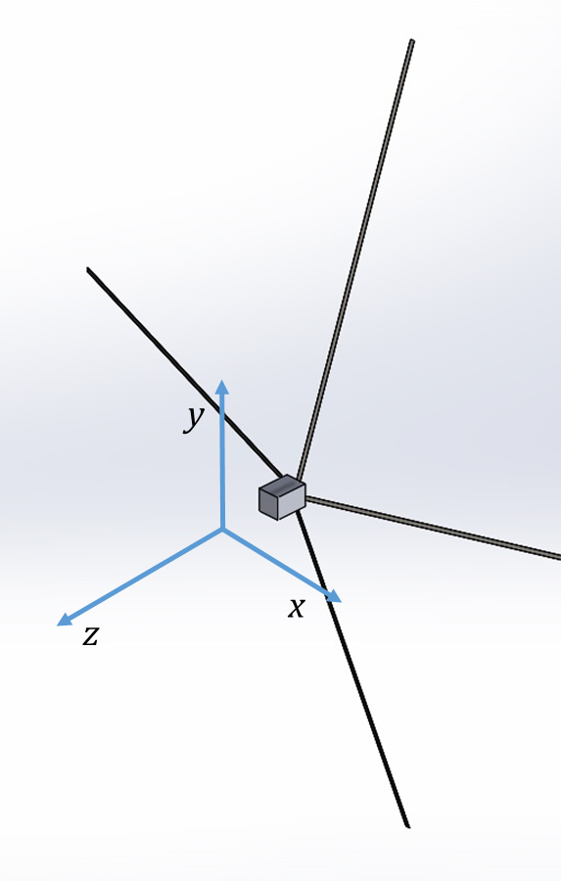
Fig. 1. D3 Device Attached to a CubeSat with Body Axes

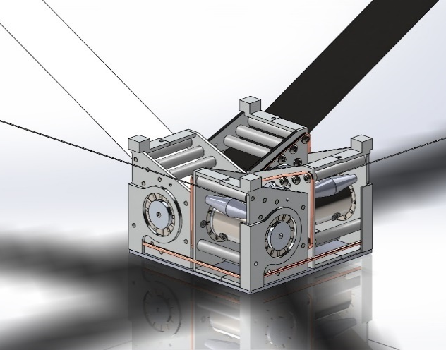
Fig. 2. Zoomed in view of D3 device
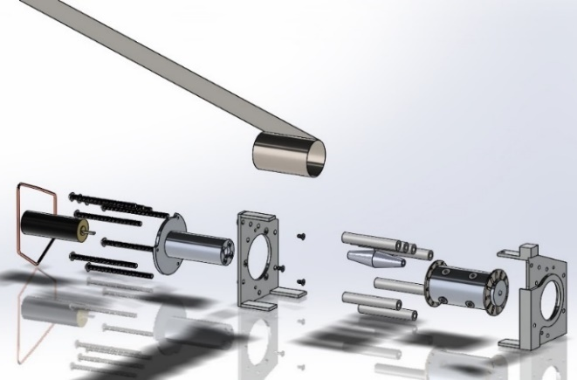
Fig. 3. D3 Device Deployer Expanded View
Gravity gradient torques will work to passively align this minimum moment of inertia axis with the nadir vector. The combined effects of gravity gradient and aerodynamic torques enable the D3 to provide passive 3-axis attitude stabilization. To increase the attitude stability, three orthogonal magnetorquers are integrated into the D3 and serve to damp any attitude oscillations when set to run the B-Dot de-tumble algorithm discussed by Guglielmo et al [15]. In the previous design, four stepper motors located inside the deployers were utilized to deploy and retract the booms. Unfortunately, there was not a reliable mapping between motor rotation and boom deployment. The booms would often wind up internally as the motor spun before deploying in spurts and jumps. To facilitate accurate boom deployment, the stepper motors were replaced with brushed DC motors (Faulhaber 1516-006SR with 262:1 spur gearbox) and a rotary encoder (Pololu 12CPR) was integrated into each deployer. As each boom deploys, it drives a silicon wheel on a steel shaft that is attached to the encoder. In this manner, the encoder provides an accurate measurement of the movement of the boom itself. A spring roller is also included to push against the boom and ensure that it remains in contact with the silicon wheel. Prototype (Fig. 4) testing showed that with this new design, the boom would consistently deploy or retract to within about two centimetres of the commanded amount.
Fig. 4. Prototype of D3 Deployer
When fully extended, the D3 increases the cross-wind surface area of the host satellite by .5 m² enabling a 12U, 15 kg CubeSat to de-orbit from a 700 km circular orbit in 25 years under standard atmospheric conditions. Unlike most other drag devices that can only be deployed once to increase the drag area, the D3 can be repeatedly retracted, facilitating orbital maneuvering, collision avoidance, and re-entry point targeting using aerodynamic drag. A prototype of a D3 deployer has also been fatigue tested and functioned nominally after 500 full deploy retract cycles (more than would be required on an average mission) and continued to operate properly after thermal vacuum testing conducted to simulate the space environment. Vibration testing of a D3 deployer to 9.6 GRMS was also conducted. In this test, the D3 deployer was integrated into a 2U-sized CubeSat structure and the entire assembly was integrated into a PPOD CubeSat deployer prior to vibration to most accurately simulate a launch environment. Functional testing showed all D3 components to be operational and non-damaged after vibration testing.

Re-entry Point Targeting Algorithm
The purpose of the D3 CubeSat mission is to test the ability of re-enter the atmosphere in a desired location by varying the spacecraft’s aerodynamic drag through a modulation of the D3 booms. The drag modulation scheme necessary to de-orbit in the desired location was developed by Omar and Bevilacqua [16] and offers significant improvements over the state of the art [9,17]. The first step in the drag based re-entry scheme is the guidance generation algorithm. This technique calculates the drag profile that a spacecraft must maintain to de-orbit in a desired location. The calculation is done using the highest fidelity orbit propagator available and ensures that if the orbit propagator were a completely accurate reflection of reality, the spacecraft would de-orbit in the desired location if the prescribed boom deployment profile were applied. Unfortunately, even the best models are not perfect and there is significant uncertainty in the drag force prediction. For this reason, a guidance tracking algorithm [16] is utilized that varies the spacecraft’s ballistic coefficient using an LQR-based full state feedback control methodology based on the linearized motion of the spacecraft relative to the guidance. An Extended Kalman Filter is utilized to remove sensor noise from the GPS derived relative position and velocity estimates. The details of these algorithms and the means by which they were tested are described below.

Guidance Generation Algorithm
The guidance generation algorithm utilizes an analytical solution to estimate the drag profile required to de-orbit in a desired location. This drag profile is simulated using numerical orbit propagation techniques and is continuously refined using analytical techniques and re-simulated based on the discrepancy between the actual and desired de-orbit location. Ultimately, a numerically propagated trajectory and corresponding drag profile are obtained that if followed, will lead the satellite to the desired de-orbit location. The fundamental theory and development of the guidance generation algorithm are discussed in [16] and [18], but significant upgrades have been made since those publications. This section will provide an overview of the algorithm but will focus most heavily on the recent upgrades.
Define the spacecraft ballistic coefficient as
$$C_{b}=\frac{C_{d}A}{2m}$$ | (1)
Where $C_{d}$ is the drag coefficient, $A$ is a reference area, and $m$ is the spacecraft mass. The aerodynamic drag acceleration ($a_{d}$) acting on the spacecraft is
$$a_{d}=-C_{b}ρv_{∞}^{2}$$ | (2)
Where $ρ$ is the ambient atmospheric density and $v_{∞}$ is the spacecraft velocity relative to the free stream. It is shown in [16] that given the ability to vary an initial $C_{b1}$, a second ballistic coefficient $C_{b2}$, and the time $t_{swap}$ at which the ballistic coefficient is changed from $C_{b1}$ to $C_{b2}$, it is possible to target any point on the Earth with latitude below the orbit inclination if maneuvering is initiated early enough. We will define $\left(C_{b1}, C_{b2}, t_{swap}\right)$ as the control parameters. Note that $C_{b2}$ is maintained until some terminal semi-major axis at which point some pre-set $C_{b_{term}}$ is maintained until de-orbit.
The basis of the analytical solution for determining the control parameters needed for proper targeting is the ability to calculate the effect that a perturbation in the control parameters will have on a given trajectory. While a satellite in an unperturbed two-body orbit (spherical Earth) will experience a constant semi-major axis, a satellite in a two-body orbit with drag will experience a monotonically decreasing semi major axis over time. It can be shown [16] that in a circular orbit around a spherical Earth, if a constant, invariant density is assumed at each altitude, then the time and argument of latitude (true anomaly plus argument of perigee) required for a spacecraft to decay from an initial to final semi major axis due to aerodynamic drag increase linearly with decreasing ballistic coefficient. Assuming a satellite with ballistic coefficient $C_{b1}$ takes time $t_{1}$ to achieve some change in semi major axis $Δa$ and undergoes argument of latitude change $Δu_{1}$ during this drop, the time and argument of latitude change a satellite with the same initial conditions and some different $C_{b2}$ will undergo to achieve the same $Δa$ is given by
$$Δt_{2}=\frac{C_{b1}Δt_{1}}{C_{b2}}$$ | (3)
$$Δu_{2}=\frac{C_{b1}Δu_{1}}{C_{b2}}$$ | (4)
Since the average rate of change of right ascension (${\dot{Ω}}_{avg}$) is independent of $C_{b}$, the change in $Ω$ experienced during the orbital decay can be calculated by
$$ΔΩ={\dot{Ω}}_{avg}Δt$$ | (5)
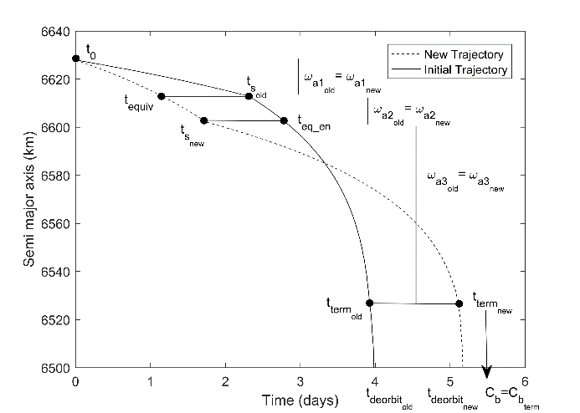
Fig. 5. Characterizing Behavior of New Trajectory Based on Old Trajectory
As shown in Fig. 5, if the trajectory of a satellite with some initial set of control parameters has been numerically propagated, the de-orbit location of a new trajectory corresponding to the same initial conditions but a different set of control parameters can be analytically estimated by dividing the trajectories into regions of semi major axes where the $C_{b}$ is not changing in either trajectory. In the last region (below the terminal point) both trajectories have the same $C_{b}$ so they can be assumed to experience the same change in orbital elements between the terminal point and the de-orbit point. For the three phases before the terminal point, Eqs. (3-5) can be utilized to calculate the changes in time and orbital elements experienced in each phase of the new trajectory. All changes in time and orbital elements can be added to calculate the final time and orbital elements, and hence the latitude and longitude, at the de-orbit point.
Additionally, a closed form analytical solution is derived in [15] to compute the control parameters ($C_{b1}, C_{b2},$ and $t_{swap}$) needed to achieve a desired total time ($Δt_{t}$) and total change in argument of latitude ($Δu_{t}$) to the terminal point based on $C_{b10}, C_{b20}, {Δt}_{10}, Δt_{20}, Δu_{10},$ and $Δu_{20}$ from an original numerically propagated trajectory. These relations are
$$C_{b2}=\frac{C_{b20}\left(Δt_{20}Δu_{10}-Δt_{10}Δu_{20}\right)}{Δt_{t}Δu_{10}-Δt_{10}Δu_{t}}$$ | (6)
$$C_{b1}=\frac{Δu_{10}C_{b10}C_{b2}}{Δu_{t}C_{b2}-Δu_{20}C_{b20}}$$ | (7)
$$t_{s_{new}}=\frac{t_{s_{old}}C_{b10}}{C_{b1}}$$ | (8)
Note that $C_{b10}, Δt_{10},$ and $Δu_{10}$ are the ballistic coefficient, time change, and argument of latitude change between the initial time and the swap point and $C_{b20}, Δt_{20},$ and $Δu_{20}$ apply between the swap point and the terminal point. Given a numerically propagated trajectory with some final impact longitude and latitude, the total argument of latitude and orbit lifetime required to de-orbit in the desired location can be calculated [16] as
$$Δu_{t}=\sin^{-1}\left(\sin{\frac{\left(lat\right)}{\sin\left(i\right)}}\right)$$ | (9)
$$Δt_{t}=Δt_{t0}+\frac{λ_{imp}-λ_{des}}{ω_{e}}$$ | (10)
Where $λ$ is longitude and $ω_{e}$ is the rotation rate of the Earth. The $Δt_{t}$ value can be adjusted using the method in [16] to ensure that the minimum targeting error is achieved within the range of feasible satellite ballistic coefficients. Note that with this method, the desired $Δu_{t}$ will always be achieved, and $Δt_{t}$ as close as possible to the desired one will be achieved.
A key recent update to the guidance generation algorithm is the drag-work-enforcement method that is merged into the shrinking horizon guidance generation approach. Due to the assumptions of a spherical Earth and constant density vs. altitude profile used in the analytical solution, there are often discrepancies between the numerical and analytical trajectory solutions, especially if the trajectories extend far into the future. To ensure sufficient controllability to target any point with latitude below the orbit inclination, maneuvering must begin almost two weeks in advance of the expected de-orbit. When this trajectory is simulated, the long propagation time causes the analytical and numerical solutions to diverge because small errors due to the analytical solution assumptions grow over time. Conversely, if maneuvering is initiated very close to the de-orbit time (2-3 days), the analytical and numerical solutions will agree very well, but there may not be sufficient controllability to target any point on the Earth’s surface. In the shrinking horizon approach (Fig. 6), when the trajectory is propagated to the de-orbit point with the ballistic coefficient profile dictated by the analytical solution, the first $t_{g}$ seconds of this trajectory are stored as a part of the guidance and the trajectory after $t_{g}$ is utilized to compute another analytical ballistic coefficient profile that will be numerically propagated and will be approximately $t_{g}$ seconds shorter than the previously propagated trajectory. This process continues until a certain error threshold is reached or a trajectory is propagated that has less than a certain amount of orbit lifetime remaining. In the drag-work enforcement method, the work done by aerodynamic drag is recorded during the trajectory propagation, and the ballistic coefficient of the satellite during the first $t_{g}$ seconds of propagation is varied so that the total work done by drag at $t_{g}$is equal to the work that should have been done by this time according to the analytical solution. In the trajectory propagation, the power or rate of change of work done by drag per unit mass can be calculated as
$$P={\dot{W}}_{d}=-C_{b}ρv_{∞}(v_{∞}∙v)$$ | (11)
This expression is equivalent to the drag force (per unit mass) multiplied by the distance over which the drag is acting, divided by the time over which that distance is acted through which is the definition of power. Work done by drag is considered as a seventh state variable (in addition to the ECI position and velocity vectors) and is numerically integrated along with the position and velocity by computing ${\dot{W}}_{d}$ using Eq. (11) at each time step. Given a numerically propagated trajectory with come $C_{b}$ and $W_{d}$ available at each time step, the work that should be done by drag for a trajectory with the same initial conditions but a different $C_{b}$ can be calculated at some time $t$ as follows.
1. Eq. (1) is used to calculate the time ($t_{eq}$) at which the old trajectory has the same orbital energy (same semi-major axis) as the new trajectory at time $t$. If the ballistic coefficient is unchanging in both trajectories, this is computed by
$$t_{eq}=\frac{C_{b_{new}}t}{C_{b0}}$$ | (12)
2. The new trajectory should have the same $W_{d}$ at $t$ as the old, numerically propagated trajectory did at $t_{eq}$.
By scaling the $C_{b}$ during each propagation phase to force the actual $W_{d}$ to equal the analytically expected $W_{d}$, the numerically propagated trajectory is made to behave more like the analytically predicted trajectory, and thus the errors between the analytical and numerical trajectories are reduced.
Another factor that was instrumental in the reduction of guidance errors was the use of density values that were continuous in time. The NRLMSISE-00 model that was used in the orbit simulation requires current, past, and predicted F10.7 and Ap solar and geomagnetic index data. This data is reported at discrete 3-hour intervals, but using such discrete, discontinuous index values leads to a density profile that is discontinuous in time. Instead, by using a cubic spline to interpolate between the F10.7 and Ap values, a set of indices, and hence a set of densities, that are continuous in time can be obtained. Because the analytical solution assumes a continuous density model, numerically propagating trajectories with a continuous density over time reduces the discrepancy between the analytical and numerical solutions and improves algorithm performance.
Ultimately, the drag-work enforcement method coupled with a continuous-time density model and the shrinking horizon guidance generation procedure causes targeting simulations run using the high fidelity NRLMSISE-00 model to experience the same high convergence rates as simulations run using the 1976 standard atmosphere.
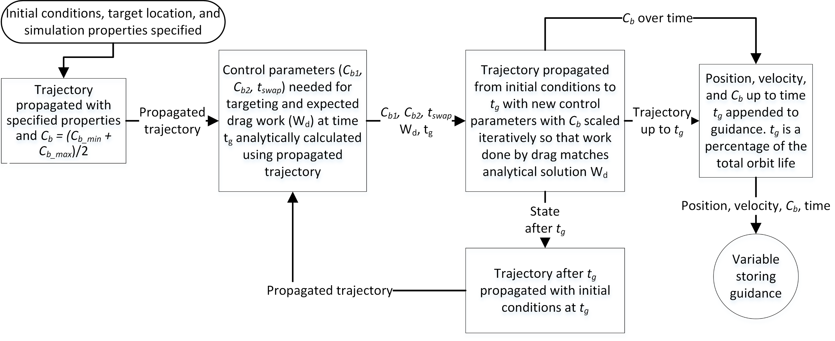
Fig. 6. Guidance Generation Algorithm Flowchart

  - Guidance Tracking Algorithm
The guidance tracking algorithm is detailed in [16] and a brief description is given here. The tracking algorithm involves first computing the position and velocity of the satellite relative to the guidance in the Local-Vertical-Local-Horizontal (LVLH) frame. The LVLH frame is a non-inertial reference frame defined with x-axis aligned with the zenith vector, z-axis aligned with the orbit angular momentum vector, and y-axis completing a right-handed coordinate system as show in Fig. 7.
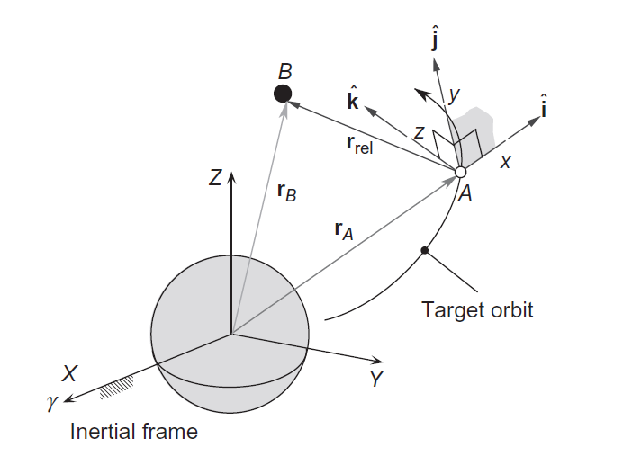
Fig. 7. LVLH Reference frame
Let the position of the spacecraft relative to the guidance be denoted by
$$r_{rel}=r_{sc}-r_{guid}=\left[\begin{matrix}δx \\ δy \\ δz\end{matrix}\right]$$ | (13)
The Schweighart Sedwick (SS) dynamics [19] given by Eq. (14) provide a linearized model describing the evolution of the in-plane position and velocity of the satellite relative to the guidance in the LVLH frame based on the difference in ballistic coefficient between the guidance and the actual satellite.
$$\left[\begin{matrix}δ\dot{x} \\ δ\dot{y} \\ \begin{matrix}δ\ddot{x} \\ δ\ddot{y}\end{matrix}\end{matrix}\right]=\left[\begin{matrix}0 & 0 & \begin{matrix}1 & 0\end{matrix} \\ 0 & 0 & \begin{matrix}0 & 1\end{matrix} \\ \begin{matrix}b \\ 0\end{matrix} & \begin{matrix}0 \\ 0\end{matrix} & \begin{matrix}\begin{matrix}0 \\ -d\end{matrix} & \begin{matrix}d \\ 0\end{matrix}\end{matrix}\end{matrix}\right]\left[\begin{matrix}δx \\ δy \\ \begin{matrix}δ\dot{x} \\ δ\dot{y}\end{matrix}\end{matrix}\right]+\left[\begin{matrix}0 \\ 0 \\ \begin{matrix}0 \\ -ρv^{2}\end{matrix}\end{matrix}\right]\left(C_{b_{sc}}-C_{b_{guid}}\right)$$  $$d=2nc, b=\left(5c^{2}-2\right)n^{2},$$  $$c=\sqrt{1+\frac{3J_{2}R_{e}^{2}}{8a^{2}}\left[1+3cos⁡(2i)\right]}, n=\sqrt{\frac{μ}{a^{3}}}$$ | (14)
Treating $ΔC_{b}=\left(C_{b_{sc}}-C_{b_{guid}}\right)$ as a control parameter, the linear-quadratic-regulator (LQR) [20] control approach can be utilized to compute a feedback control gain ($K$) that when made negative and multiplied by the relative in-plane state vector ($x={\left[δx δy δ\dot{x} δ\dot{y}\right]}^{T}$), results in a $ΔC_{b}$ that the satellite should command to drive the relative state error to zero and return to the guidance. The commanded spacecraft ballistic coefficient is thus given by
$$C_{b_{sc}}=C_{b_{guid}}-Kx$$ | (15)
The LQR gain is computed by the MATLAB command $K=lqr(A,B,Q,R,0)$ where $A$ and $B$ are the state space dynamics matrices given in Eq. (14) and $Q$ and $R$ are weighting matrices on penalizing state errors and control effort respectively. $Q$ is set to $Q=\left[\begin{matrix}0 & 0 & \begin{matrix}0 & 0\end{matrix} \\ 0 & 1 & \begin{matrix}0 & 0\end{matrix} \\ \begin{matrix}0 \\ 0\end{matrix} & \begin{matrix}0 \\ 0\end{matrix} & \begin{matrix}\begin{matrix}0 \\ 0\end{matrix} & \begin{matrix}0 \\ 0\end{matrix}\end{matrix}\end{matrix}\right]$ to emphasise only along-track control, and $R$ will be a scalar the will increase if the user wants the control system to be less aggressive and use less actuator effort.

  - Kalman Filtering Navigation Algorithm
The details of the Kalman filtering algorithm are also given in [16], but a brief summary will be presented here. Because the LQR controller needs an estimate of the relative, not absolute, position and velocity, the position and velocity relative to the guidance can be computed at each GPS measurement and treated as the “measurement” for the purpose of the Kalman filter. A standard Extended Kalman Filter (EKF) [21] formulation is used to remove noise from this measurement. First, an initial relative state estimate ($x_{i-1}^{+}$) is converted to the ECI frame, propagated to the time of the next available measurement and converted back to a relative position and velocity ($x_{i}^{-}$). Let this numerical propagation process be denoted by $x_{i}^{-}=f(t_{i},t_{i-1},x_{i-1}^{+})$. The estimation error covariance ($P$) is then updated using the state transition matrix ($Φ$) derived from the SS dynamics as
$$Φ_{i}=e^{\left(A-BK\right)\left(t_{i}-t_{i-1}\right)}$$ |  | (16)
Such that
${ x}_{i}≈Φ_{i}x_{i-1}$ | (17)
This is the predict phase and can be described mathematically as
$$x_{i}^{-}=f(t_{i},t_{i-1},x_{i-1}^{+})$$  $$P_{i}^{-}=Φ_{i}P_{i-1}^{+}Φ_{i}^{T}+Q$$ | (18)
Where $Q$ is a user-defined process noise covariance matrix. The actual (noisy) GPS measurement is converted to a relative in-plane position and velocity ($z$) and is finally used to update the state and error covariance matrices as shown in Eq. (19).

$$S=GP_{i}^{-}G^{T}+W$$  $$K_{i}=P_{i}G^{T}{\left(S\right)}^{-1}$$  $$x_{i}^{+}=x_{i}^{-}+K_{i}\left(z_{i}-Gx_{i}^{-}\right)$$  $$P_{i}^{+}=\left(I-K_{i}G\right)P_{i}Λ$$ | (19)
Where $G=I_{4x4}$ is the mapping from the state that is being estimated to the measurement $\left(z_{i}=Gx_{i}\right)$, $W$ is a user defined measurement noise covariance matrix, $K_{i}$ is the Kalman gain, and $S$ is an intermediate term used in the calculations. $Λ$ is an “anti-smugness” term set slightly greater than 1 to ensure that the process noise covariance ($P$) does not become too small and lead to a lack of responsiveness of the filter to new inputs.
  - Testing method
The targeting algorithm was tested using a Monte Carlo simulation approach with randomized initial condition and realistic models of drag uncertainty [22] and GPS sensor noise [23]. One thousand Monte Carlo simulations were conducted and in all cases, a guidance was generated that was trackable in a realistic environment. The average guidance error was 12.5 km with a standard deviation of 7.5 km and the average tracking error was 1.1 km down to a geodetic altitude of 120 km. 997 of the 1,000 Monte Carlo guidance simulations had a final error under 25 km which is the point where the algorithm stops seeking an improved solution. All guidance errors were below 106 km and all final tracking errors were below 5 km. Fig. 8 and Fig. 9 show the results of the Monte Carlo guidance and tracking simulations and Fig. 10 shows the ballistic coefficient profile associated with one of the simulation runs. This simulation included sinusoidally varying density errors with periods of 26 days, 1 day, and 5400 seconds. As Fig. 10 shows, the tracker was able to effectively compensate for these errors. The D3 actuator was required to run for an average of 4.1% of the orbit lifetime based on the Monte Carlo simulations.
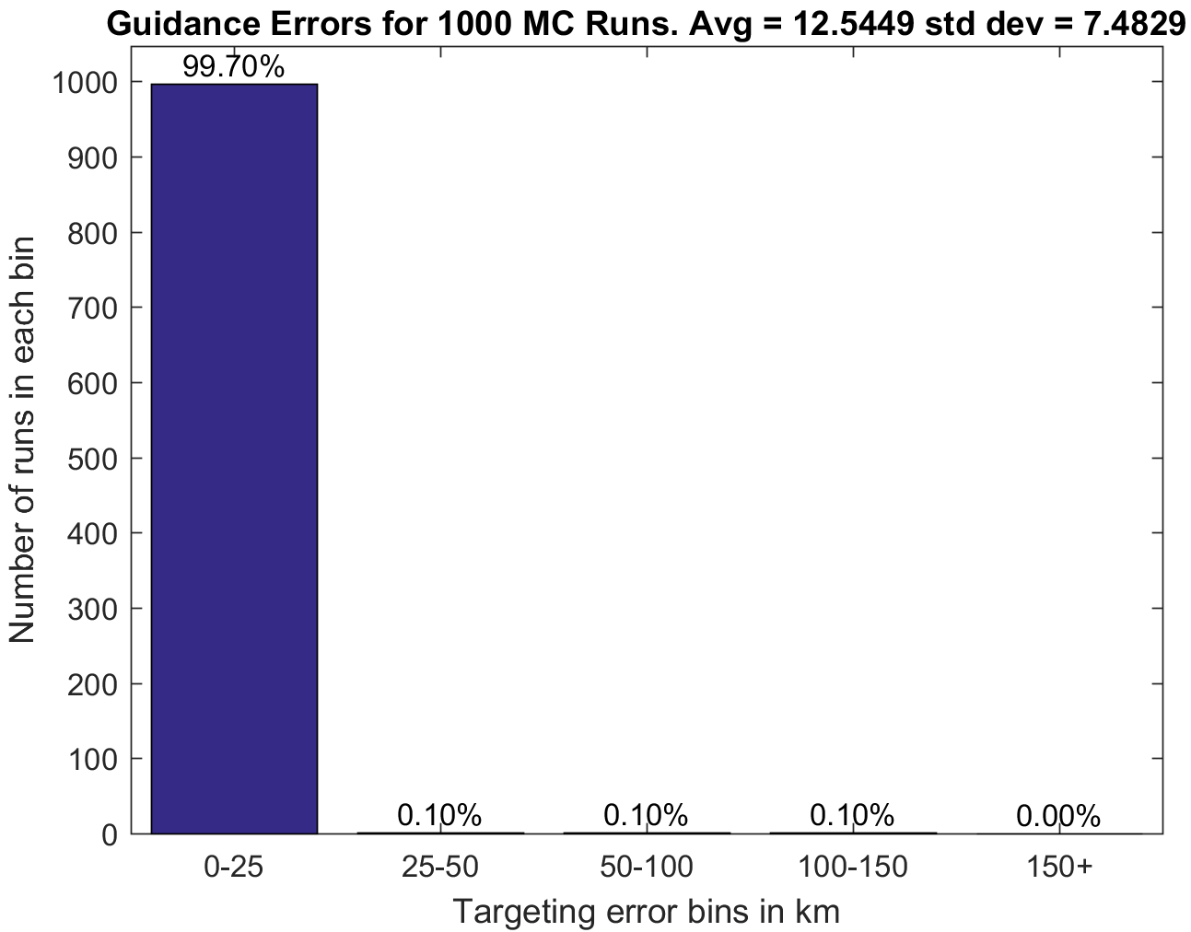
Fig. 8. Monte Carlo Guidance Errors
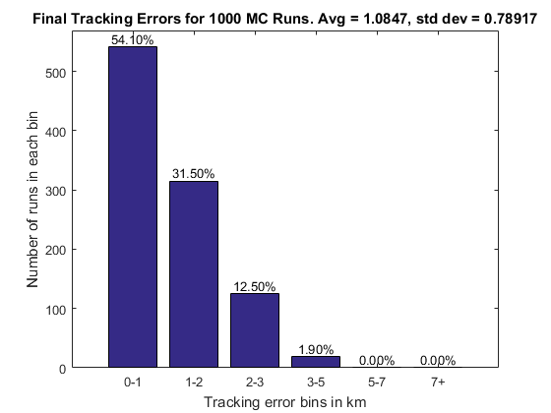
Fig. 9. Monte Carlo Tracking Errors
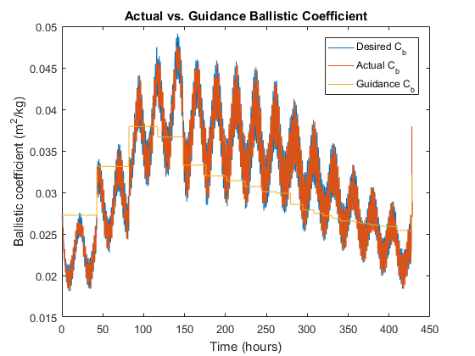
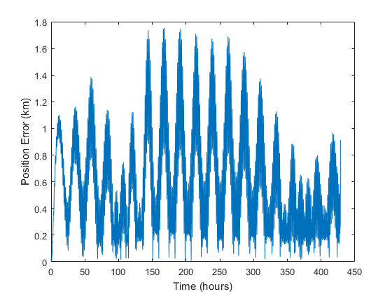
Fig. 10. Position Error and Ballistic Coefficient over Time for Simulation with Density Uncertainty

CubeSat Design
The D3 satellite is designed to test the D3 device and de-orbit point targeting algorithm. Secondary objectives will include the tests of other orbital maneuvering algorithms and collision avoidance algorithms. As such, to maximize the change of mission success, the 2U CubeSat will be built using TRL 9 parts (those with space legacy) whenever possible.

D3 Mechanical Interface
The D3 device was designed to interface easily with existing CubeSat structures. Using four M2.5 screws, an adapter stage connected to the D3 device is attached to existing holes in a standard ClydeSpace 1U structure. This serves to integrate the D3 into the structure and expand the satellite to fit the 2U form factor.

D3 Electrical Interface
The D3 board (Fig. 18) is the sole electrical interface between the D3 device and the rest of the CubeSat. The D3 board is interfaced with the top of the PC104 stack using standard PC104 pin headers as shown in Fig. 16. The D3 board pinout is shown in Fig. 17. The D3 device is connected to the D3 board via a 24 pin ribbon connector after both the D3 device and board are mechanically integrated.

CubeSat Structure, Deployables, and Solar Panels
To maximize the chance of mission success, the CubeSat will be built around a standard 1U structure with significant space legacy designed and manufactured by Clyde Space. This 1U structure (Fig. 11) is designed with upper mounting holes which the manufacturer sometimes uses to convert it to a 1.5U structure. A custom-made adapter stage shown in Fig. 12 will be attached to these mounting holes and the D3 device will attach to the top of the adapter stage.
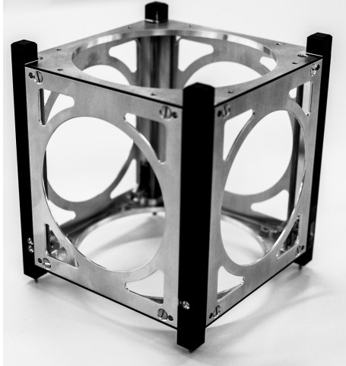
Fig. 11. Clyde Space Standard 1U Structure
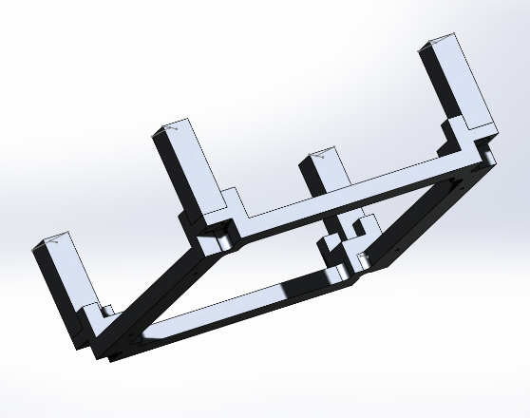
Fig. 12. D3 Adapter CAD Model
All satellite avionics will be contained in the 1U structure. The adapter stage is manufacturable using the machines at the University of Florida ADAMUS lab and in addition to connecting the D3 to the standard 1U structure, ensures that the entire CubeSat is 225 mm long as required by the design standard [24]. The adapter vertical posts are manufactured separately from the bottom plate that attaches to the 1U structure. A manufactured prototype of the adapter stage is shown in Fig. 13. Prior to attachment to the 1U structure, four screws are utilized to connect the adapter base, through the adapter posts, to the D3 baseplate. The placement of the adapter over the 1U structure prevents these screws from falling out of place. The complete satellite assembly when the 1U structure, adapter stage, and D3 are connected is shown in Fig. 14 and Fig. 15. A SkyFox piPATCH-L1 GPS antenna is located on top of the D3 deployer assembly which is designed to support this device. The 2U faces of the satellite will contain solar panels custom made by DHV technologies to provide room for the D3 booms to deploy. One of the panels will have holes for the remove-before-flight pin and USB charging and data cables. These panels will be fastened via screws to the standard solar panel mounting holes built into the 1U structure. The solar panels and their locations on the D3 CubeSat are shown in Fig. 14.
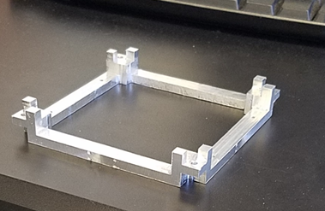
Fig. 13. Hardware Prototype of D3 Adapter Stage
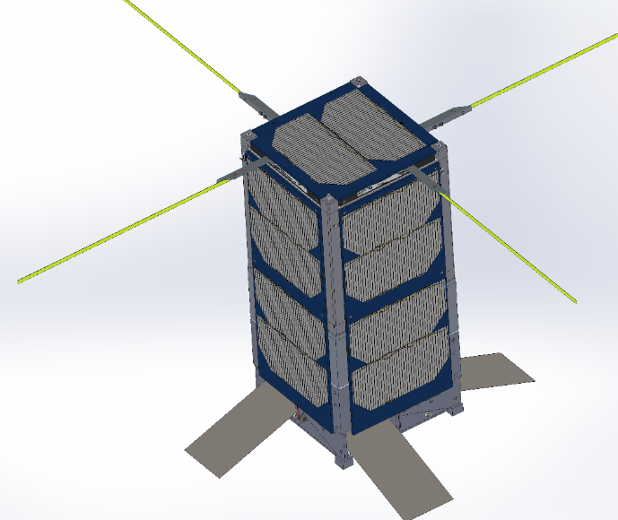
Fig. 14. D3 CubeSat with Solar Panels
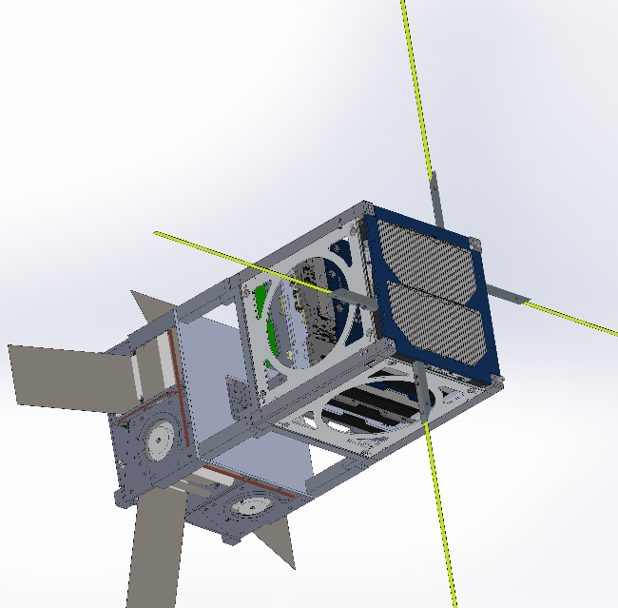
Fig. 15. D3 CubeSat without Side Solar Panels
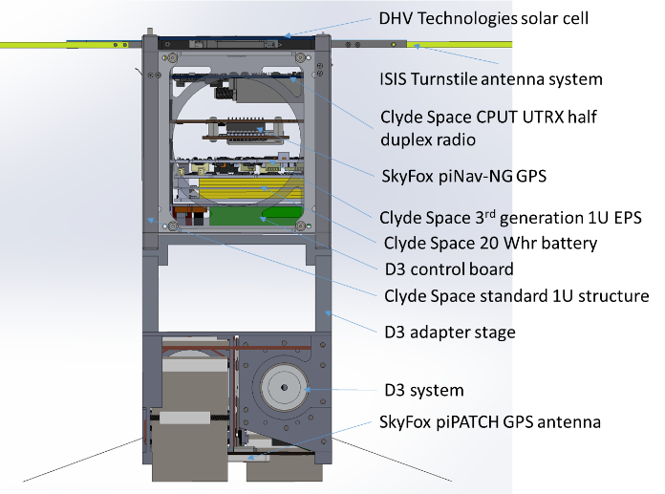
Fig. 16. Complete CubeSat Structure with Integrated Avionics (no side solar panels)

Avionics
Commercially available TRL 9 avionics are used in this satellite with the exception of the D3 control board that is custom-made. All avionics are integrated into the 1U structure which is manufactured with support for standard PC104 sized CubeSat boards.
The D3 avionics are shown in Fig. 16 and the COTS (commercial off the shelf) avionics include the CPUT UTRX UHF half duplex radio board sold by Clyde Space, the piNAV-NG GPS receiver made by SkyFox labs, and 20 Whr Battery and Electrical Power System boards from Clyde Space. The masses, costs, and expected power consumptions of these boards are shown in Table 1. With a maximum power output of 24 W, the EPS will be capable of running the D3 device, all avionics, and the radio simultaneously. The piNAV-NG is the lowest power commercially available CubeSat GPS, and based on the Monte Carlo simulations discussed previously, will provide sufficient accuracy for the targeting algorithms. Note that all simulations were conducted with simulated measurement noise corresponding to the manufacturer specified values for the piNAV-L1. The CPUT UTRX radio provides half duplex communication at 9600 bit/s on the 435 Mhz UHF band. The half duplex mode requires a single antenna on the ground and on the satellite for both reception and transmission. By connecting the UTRX to the ISIS turnstile antenna, an omnidirectional radiation pattern will be achieved whereby the satellite will be able to maintain contact with the ground regardless of its attitude.
The D3 system will be controlled by a single board which will host a high-performance BeagleBone Black Industrial processor that will also serve as the primary flight computer for the satellite. The BeagleBone will be more than capable of performing autonomous, onboard guidance generation and tracking and will connect to a PC104 sized PCB via pin headers. This PCB will also contain two TI SN754410 quad half h-bridge chips to control the D3 deployer motors and three TI DRV8837 Dual Low-Voltage H-Bridge chips to control the magnetorquers. A 24 conductor ribbon cable will be connected to the D3 board to rout signals from the D3 board to the motors and magnetorquers. Two cables will be required for each motor, two for each encoder, and two for each magnetorquer. A D3 power and ground cable will also be required. A TDK ICM-20948 9-axis IMU will also be included on the board. This chip uses only 2.4 mW and provides acceleration, angular velocity, and magnetic field measurements. These can be utilized along with the magnetometers located on the solar panels for the B-Dot de-tumble algorithm. The D3 board will interface with the battery, EPS, GPS, and radio using the PC104 headers. Fig. 17 shows the header pin configuration for the D3 board based on the interfacing requirements specified by the manufacturers of the other avionics. Fig. 18 shows a simplified CAD model of the D3 board containing its various components.
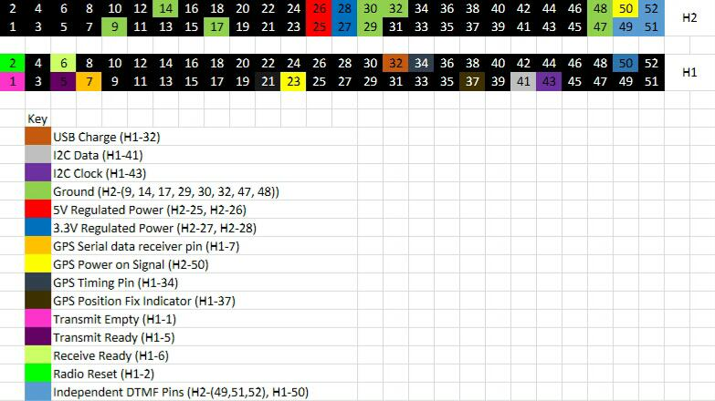
Fig. 17. D3 Board PC104 Pin Header Configuration
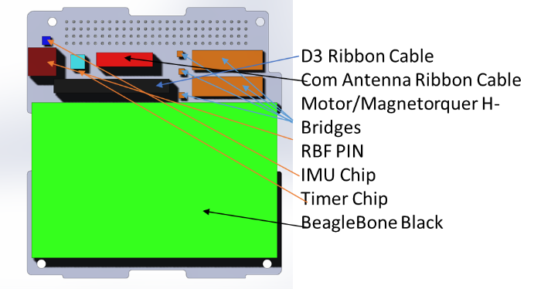
Fig. 18. D3 Board CAD Model

Mass, Power, and Financial Budgets
Table 1 shows the mass, power, and cost of each of the aforementioned spacecraft components. These values are given by the manufacturer for COTS components and are estimated based on the current stage of the design process for custom-made parts.
Table 1. Table of CubeSat Components with Masses and Power Usages
Component | Mass (g) | Avg Power User (mW) | Cost (USD)
Clyde Space 3rd Generation EPS | 86 | 160 | 4900
Clyde Space 20 WHr Battery | 256 | 0 | 2700
Clyde Space CPUT UTRX Half Duplex Radio | 90 | 250 RX, 4000TX, 333 avg with 30 min daily TX | 8850
ISISpace Turnstile Antenna System | 30 | 0 | 6891
D3 Deployers | 1100 | 200 avg, 15000 peak | 2000
D3 Magnetorquers | 101 | Variable, max 1000 during de-tumble | 100
Beaglebone Black Master CubeSat and D3 Micro-controller | 24 | 1000 | 100
DHV Technologies Custom Solar Panels (four 2U side panels, one 1U top panel) | 400 total | 4240 max gen. for 2U panels and 2120 max. gen. for 1U panel | 21150
1U Clyde Space Structure | 200 | 0 | 3550
D3 Adapter Stage | 200 | 0 | 200
SkyFox piNav-NG GPS Unit | 100 | 139 | 9624
SkyFox piPATCH GPS Antenna | 25 | 100 | 2238
Totals | 2612 | 1932 average continuous use | 62303

Ground Station
The UHF/VHF ground station operated by the Space Systems Group at the University of Florida will be utilized for this mission. The satellite will operate in the UHF frequency in a half duplex mode and will transmit data at 9600 bits/second. By the time the D3 mission launches, the ground station will be operational and will have been used for the SwampSat II and CHOMPTT missions. This will reduce risk and ensure that the ground station is working properly for the D3 mission. The ground station will need to be capable of sending several basic commands to the satellite including:
- Reset microcontroller
- Update software
- Update F10.7 and AP solar and geomagnetic indices for density forecasting
- Target desired de-orbit location
- Change operation mode (normal, debug, bare-bones)
- Manual boom deployment profile
- Request telemetry
In addition to sending down acknowledgments and status indicators in response to all received ground station commands, the satellite will need to collect and send telemetry to the ground station upon request. This telemetry will include the following information at multiple points in time
- Battery voltage
- Solar panel voltages
- Boom deployment levels
- GPS position and velocity estimates
- Magnetometer readings
- Motor and magnetorquer usage history
- Any relevant error codes
- Current guidance trajectory

Design analysis and simulations

Power Analysis
AGI’s System’s Toolkit (STK) was utilized to determine the angle of the sun with respect to each face of the satellite at each point in time. For each solar panel, the produced power was calculated in terms of the maximum achievable power and the angle $θ$ between the solar panel surface normal vector and the sun vector.
$$P=P_{max}cos⁡(θ)$$
A power analysis is included for a space-station orbit (400 km circular at 51.9 degrees inclination) where the orbit angular momentum vector is perpendicular to the sun vector as shown in Fig. 19. This orbit represents a worst case scenario for power generation because it results in the maximum exposure of the 1U CubeSat faces to the sun and the minimum exposure of the 2U faces. This results in the lowest power generation because only one of the 1U faces has a solar panel and that panel generates only half the power of the 2U panels. Note that for the 2U side panels, $P_{max} = 4.24W$ and for the 1U top panel, $P_{max}=2.12W$. The average power generation and total energy generated by each solar panel over the course of an orbit (5554 s) is shown in Table 2 and the power generation over time profile of each panel is shown in Fig. 20. Each solar panel is defined based on the spacecraft body axis (see Fig. 1) that the normal vector of that panel aligns with. For example, the -x panel normal vector is aligned opposite the spacecraft body frame x-axis. Recall that this analysis represents a worst-case scenario for power generation. When the same power analysis was conducted for a scenario where the orbit angular momentum vector was as close as possible to parallel with the sun vector (right ascension shifted by 90 degrees), the average power generation was 3.83 W. Ideally, the deployment level of the drag device will be planned such that when it is time to begin the orbital maneuvering algorithm (about 2 weeks before de-orbit), the satellite will be in a maximum power orbit. Even if this is not possible, however, Table 1 shows that the expected orbit-averaged power consumption will remain under 2 W. Fig. 20 shows that the satellite will never be without power generation for more than an hour at any given time, so the 20 WHr battery should be sufficient for this mission and will not drain as long as the average power consumption is less than the average power generation. As a precaution however, logic will be built into the EPS and master micro-controller to reduce the electrical load in the event that battery charge drops below 50%.
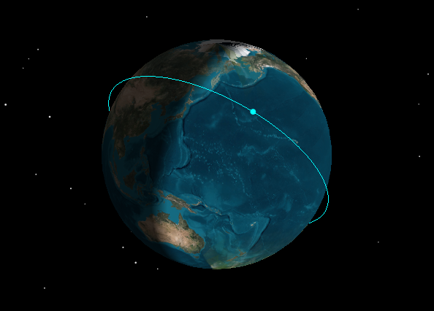
Fig. 19. Orbit with Lowest Power Generation
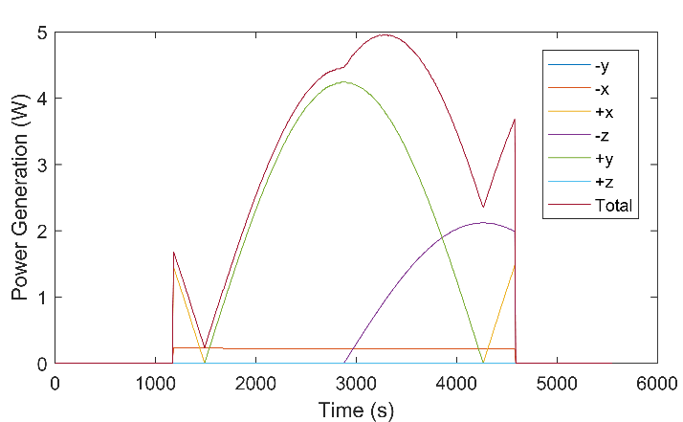
Fig. 20. Power Generation by Each Panel over Time
Table 2. Worst Case Power and Energy Generation Per Orbit for Each Solar Panel
Panel | +x | +y | +z | -x | -y | -z | Total
Orbit-Averaged Power Generation (W) | .09 | 1.35 | 0.46 | .13 | 0.00 | .00 | 2.02
Energy Generated per Orbit (J) | 476 | 7484 | 2532 | 745 | 0 | 0 | 11237

Link Analysis
AGI’s Systems Toolkit (STK) was utilized to assess the ability to communicate with the satellite from the ground station. For the purpose of a worst case analysis, an isotropic ground antenna and the worst case antenna gain of -1dBi were considered. Atmospheric refraction and light travel time effects were also taken into account in the STK calculation. In this scenario, even when the spacecraft was located at an elevation of 5 degrees from the ground station in a 600 km circular orbit (absolute worst case communication scenario), the signal to noise ratio was 10.8dB with 1 Watt of RF output power (3 Watt power draw) and the bit error rate was $1x{10}^{-6}$ using a 9600 bits/s downlink with GMSK modulation. With 2 W RF output power (5 W power draw), the signal to noise ratio was 12 dB and the bit error rate was $2.2x{10}^{-12}$. With such a high link margin even in the worst case scenario, the team can be reasonably sure that it will be possible to reliably communicate with the satellite at any point where the satellite is physically in view of the ground station.

Thermal Analysis
The largest thermal concern in this mission is associated with the D3 device, specifically with the deployed booms. If untreated, the booms will have a solar absorptivity of 0.39 and emissivity of 0.11, resulting in maximum temperatures over 180 ˚C. This would be unacceptably hot and may cause thermal warping of the booms or overheating of the boom deployment electronics. To remedy this, the booms will be treated with Insta-Blak SS-370 to get an absorptivity to emissivity (A/E) ratio of 1 which will result in boom temperatures between -94 and 68 ˚C which is acceptable [15]. Several boom samples made of Austenitic 316 stainless steel were treated with various concentrations of Insta-Blak (Fig. 21) and are ready for optical testing to verify the A/E ratio. Exposed aluminum elements of the D3 device will be anodized to achieve an A/E ratio of 0.8, which yields acceptable temperatures. A plot of the expected temperatures over time (after treatment) of the D3 booms and aluminum D3 shells is shown in Fig. 22.
all CubeSat avionics except the D3 board are COTS components with spaceflight legacy. Though the D3 board is made in house, the BeagleBone Black microcontroller has space flight legacy, so no significant thermal issues are expected. Future work will include more detailed thermal modeling and analysis of the entire spacecraft with all components included.
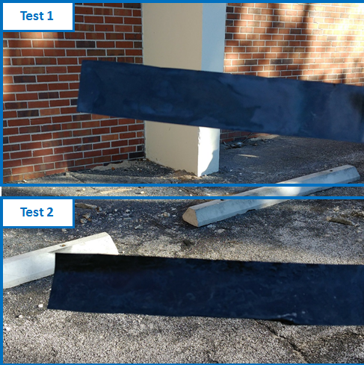
Fig. 21. Austenitic 316 Stainless Steel with Insta-Blak SS-370
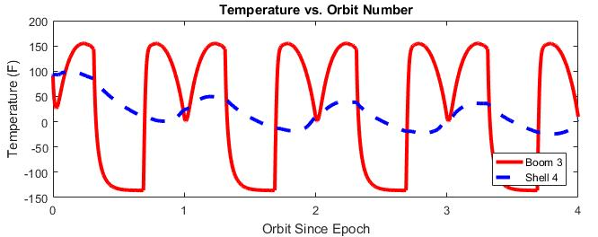
Fig. 22. D3 Component Temperatures over Time

Launch and Structural Analysis
Currently, the team plans to deploy the D3 CubeSat from the International Space Station via NanoRacks. NanoRacks payloads are stored in the pressurized sections of ISS resupply vehicles, many of which are designed to carry astronauts. This means that the launch vibrational loads are quite low compared to other rideshare opportunities. However, in order to maximize the possibility of obtaining a launch, the CubeSat was designed to handle the most rigorous launch vibrational load of any vehicle currently offering CubeSat deployment. The CubeSat structure with a D3 deployer has been vibration tested to 9.6 GMRS in a PPOD CubeSat deployer and passed the post-vibration functional testing with no observed damage or issues.

Software Development Plan
The 2U spacecraft will host the high performance (1 GHz) BeagleBone Black processor which runs a Debian Linux operating system. Because Linux is a multi-tasking operating system, all software processes necessary to operate the spacecraft can run simultaneously without the need for multiple microcontrollers. As such, the flight software will consist of the following modules running independently on the Beaglebone using the Robot Operating System (ROS) framework:
- Command and data handling module to communicate with and route signals between all other modules
- Guidance generation module to compute trajectory that must be followed to de-orbit in desired location
- Guidance tracking module to compute D3 deployment variations necessary to track the guidance
- Attitude control module to read magnetometer data and command magnetorquers for de-tumble
- Communication module to send and receive signals from communication radio
- D3 deployer control module to actuate D3 to get desired boom deployment levels
A diagram of all relevant software modules, the connections between them, and the hardware that they interface with is shown in Fig. 23.
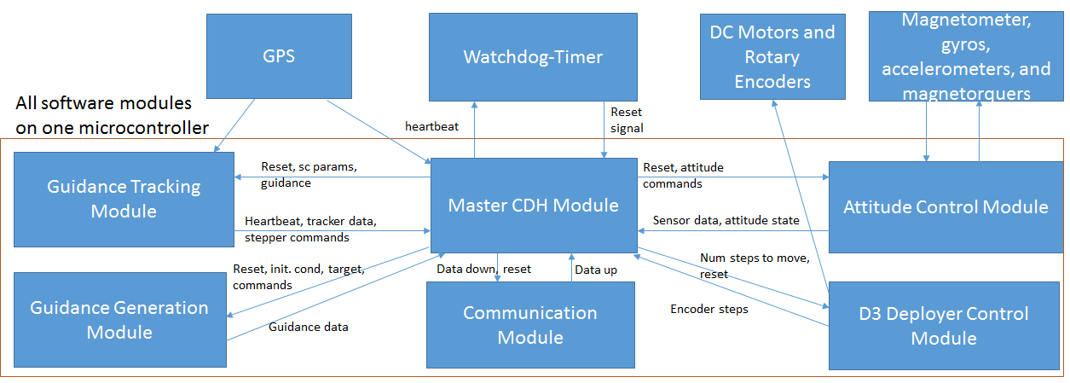
Fig. 23. Software Block Diagram
To ensure reliability and clarity of the code, all software modules will be written in object-oriented Python 3, with computationally intensive modules such as the guidance generation module written in C++. Test drivers will be written to verify the integrity of all module functions.
Even in low Earth orbit, high energy protons and electrons can cause single event upsets such as bit flips which can cause a micro-controller to operate incorrectly. Often, these upsets can be corrected by resetting the microcontroller. To perform this reset when necessary, the master command and data handling module will periodically send a pulse to one of the BeagleBone’s GPIO pins that is connected to a watchdog timer. If the watchdog timer does not receive a pulse after a certain period of time, it will send a signal to reset the BeagleBone. This ensures that the BeagleBone can be reliably reset even if the processor completely locks up.

Mission operations and Evaluation
This section discusses the operations the satellite will undergo during the mission and the methods for assessing the success level of the mission.

Mission Operations Concept
The mission phases and the conditions to go from one phase to the next are outlined in Fig. 24. The spacecraft will have on-orbit software update capabilities, so if any issues arise, ground operators can diagnose them and upload software patches. The current plan is to deploy the CubeSat from the International Space Station via NanoRacks [24], so the CubeSat is designed to conform to the NanoRacks payload specifications. The team is planning to apply to the CubeSat Launch Initiative (CSLI) to secure funding for a launch and deployment through NanoRacks. Because the CubeSat will be deployed from the space station, the orbit will naturally decay within a few months, even if the booms do not deploy. At the end of its life, the CubeSat will re-enter the atmosphere, and all components will burn-on re-entry, preventing the CubeSat from being a hazard to ground or space assets.
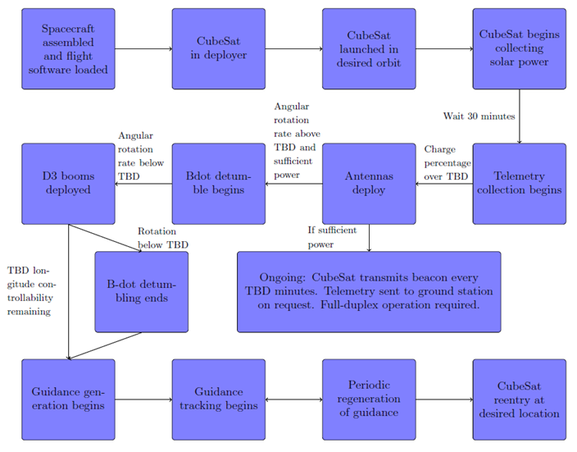
Fig. 24. D3 Mission Concept of Operations

Mission Success Criteria
The goal of the mission is to demonstrate targeted re-entry using aerodynamic drag. However, even if this objective is not successful, other useful technology demonstrations may still be completed including demonstrations of drag device deployment and operation in space, passive attitude stabilization, and orbital maneuvering using aerodynamic drag. Fig. 25 shows the contribution to overall mission success of the partial or total fulfilment of each of these objectives.
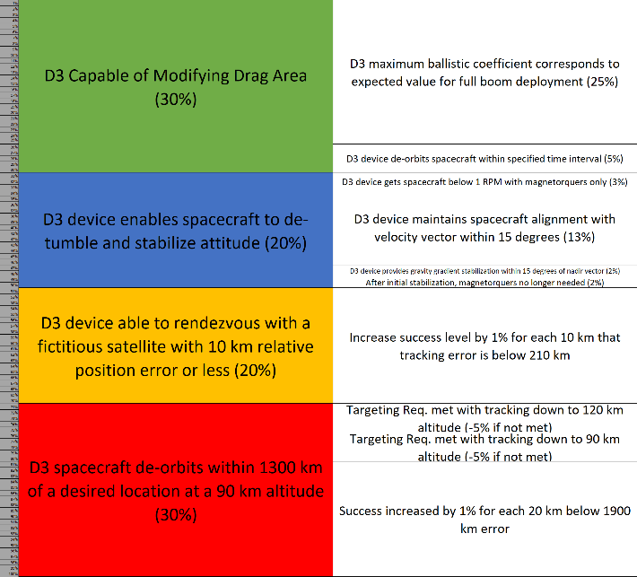
Fig. 25. D3 Mission Success Criteria

Conclusions
This paper presents a set of re-entry point targeting algorithms that enable a spacecraft to re-enter in a desired location solely by modulating its ballistic coefficient. Also discussed is the design of the retractable Drag De-Orbit Device (D3) and the D3 CubeSat mission which will involve a 2U, D3-equiped CubeSat that will actively modulate the D3 to autonomously control its re-entry location. The CubeSat will use commercially available TRL 9 components for the avionics, antennas, and structure with only the D3 device, structural interface adapter, and D3 control board built in-house. The D3 board, though custom-made, will use a high performance BeagleBone Black processor that has space legacy and is a TRL9 component. The use of space-tested components will increase the reliability of the satellite and the chance of mission success. After launch, the spacecraft will demonstrate the operation of the drag device, orbital maneuvering using aerodynamic drag, passive attitude stabilization using aerodynamic and gravity gradient torques, and finally, controlled re-entry using aerodynamic drag. After a successful mission, the D3 device and control algorithms will hopefully become standard tools for spacecraft attitude, orbit, and de-orbit control.

Acknowledgements
The authors wish to thank a.i. solutions for sponsoring this investigation under a NASA Kennedy Space Center subcontract (project LSP 15-025: A Drag Device for Controlled De-Orbiting of LEO Spacecraft). This work was also supported by a NASA Space Technology Research Fellowship and funding from the Florida Space Research Initiative.

References
- W. H. Ailor and R. P. Patera, “Spacecraft re-entry strategies: Meeting debris mitigation and ground safety requirements,” Proceedings of the Institution of Mechanical Engineers, Part G: Journal of Aerospace Engineering, Vol. 221, June 2007, pp. 947–953, 10.1243/09544100JAERO199.
- NASA, “Process for Limiting Orbital Debris,” Tech. Rep. NASA-STD-8719.14A, May 2012.
- B. Cotton, “On-Orbit Results from CanX-7 Drag Sail De-Orbit Mission,” Proceedings of the 31st Annual AIAA/USU Conference on Small Satellites, Logan, Utah, Aug. 2017.
- P. Harkness, M. McRobb, P. L¨utzkendorf, R. Milligan, A. Feeney, and C. Clark, “Development Status of AEOLDOS – A Deorbit Module for Small Satellites,” Advances in Space Research, Vol. 54, July 2014, pp. 82–91, 10.1016/j.asr.2014.03.022.
- “Re-Entry: FREEDOM Drag Sail CubeSat – Spaceflight101,”
- D. Guglielmo and R. Bevilacqua, “Propellant-less Atmospheric Differential Drag LEo Spacecraft (PADDLES) Mission,” in Proceedings of the 27th Annual AIAA/USU Conference on Small Satellites, Logan, UT, 2014.
- M. S. Murbach, P. Papadopoulos, C. Glass, A. Dwyer-Cianciolo, R.W. Powell, S. Dutta, A. Guarneros-Luna, F. A. Tanner, and A. Dono, “Modeling the Exo-Brake and the Development of Strategies for De-Orbit Drag Modulation,” 2016.
- S. S.-M. Swei and A. Westfall, “Attitude Control System Design for CubeSats Configured with Exo-Brake Parachute,” AIAA SPACE 2016, American Institute of Aeronautics and Astronautics, 2016. DOI:10.2514/6.2016-5540.
- S. Dutta, A. Bowes, A. M. Dwyer Cianciolo, C. Glass, and R. W. Powell, “Guidance Scheme for Modulation of Drag Devices to Enable Return from Low Earth Orbit,” AIAA Atmospheric Flight Mechanics Conference, 2017, p. 0467, 10.2514/6.2017-0467.
- D. P´erez and R. Bevilacqua, “Differential Drag Spacecraft Rendezvous using an Adaptive Lyapunov Control Strategy,” Acta Astronautica, Vol. 83, 2013, pp. 196–207, 10.1016/j.actaastro.2012.09.005.
- B. S. Kumar, A. Ng, K. Yoshihara, and A. D. Ruiter, “Differential Drag as a Means of Spacecraft Formation Control,” IEEE Transactions on Aerospace and Electronic Systems, Vol. 47, Apr. 2011, pp. 1125–1135, 10.1109/TAES.2011.5751247.
- C. L. Leonard, W. M. Hollister, and E. V. Bergmann, “Orbital Formation Keeping with Differential Drag,” Journal of Guidance, Control, and Dynamics, Vol. 12, Jan. 1989, pp. 108–113, 10.2514/3.20374.
- L. Mazal, D. P´erez, R. Bevilacqua, and F. Curti, “Spacecraft Rendezvous by Differential Drag Under Uncertainties,” Journal of Guidance, Control, and Dynamics, Vol. 39, Aug. 2016, pp. 1721–1733, 10.2514/1.G001785.25
- C. Foster, H. Hallam, and J. Mason, “Orbit Determination and Differential-drag Control of Planet Labs Cubesat Constellations,” Advances in the Astronautical Sciences Astrodynamics, Volume 156, Sept. 2015. arXiv: 1509.03270.
- D. Guglielmo, S. Omar, R. Bevilacqua, L. Fineberg, J. Treptow, B. Poffenberger, and Y. Johnson, “Drag De-Orbit Device - A New Standard Re-Entry Actuator for Cubesats,” AIAA Journal of Spacecraft and Rockets, Accepted May 2018.
- S. Omar and R. Bevilacqua, “A Hybrid Adaptive Control Algorithm for Spacecraft Guidance Tracking using Aerodynamic Drag,” Orlando, FL, IAA, Nov. 2017.
- J. Virgili and P. Roberts, “Atmospheric Interface Reentry Point Targeting Using Aerodynamic Drag Control,” AIAA Journal of Guidance, Control, and Dynamics, Vol. 38, No. 3, 2015, pp. 1–11, 10.2514/1.G000884.
- Sanny R. Omar, Riccardo Bevilacqua, David Guglielmo, Laurence Fineberg, Justin Treptow, Scott Clark, and Yusef Johnson. "Spacecraft Deorbit Point Targeting Using Aerodynamic Drag", Journal of Guidance, Control, and Dynamics, Vol. 40, No. 10 (2017), pp. 2646-2652.
- Samuel A. Schweighart and Raymond J. Sedwick. "High-Fidelity Linearized J Model for Satellite Formation Flight", Journal of Guidance, Control, and Dynamics, Vol. 25, No. 6 (2002), pp. 1073-1080. https://doi.org/10.2514/2.4986
- D. Bender and A. Laub, "The linear-quadratic optimal regulator for descriptor systems," in IEEE Transactions on Automatic Control, vol. 32, no. 8, pp. 672-688, August 1987. doi: 10.1109/TAC.1987.1104694
- L. Ljung, "Asymptotic behavior of the extended Kalman filter as a parameter estimator for linear systems," in IEEE Transactions on Automatic Control, vol. 24, no. 1, pp. 36-50, February 1979. doi: 10.1109/TAC.1979.1101943
- D. A. Vallado and D. Finkleman, “A Critical Assessment of Satellite Drag and Atmospheric Density Modeling,” Acta Astronautica, Vol. 95, Feb. 2014, pp. 141–165, 10.1016/j.actaastro.2013.10.005.
- P. Kov´aˇr, “piNAV L1—GPS receiver for small satellites,” Gyroscopy and Navigation, Vol. 8, Apr. 2017, pp. 159–164, 10.1134/S2075108717020079.
- L. L. C. NanoRacks, “NanoRacks CubeSat Deployer (NRCSD) Interface Control Document,” 2013.

